Heritage Athletics 2019-20 Replay

Varsity Volleyball

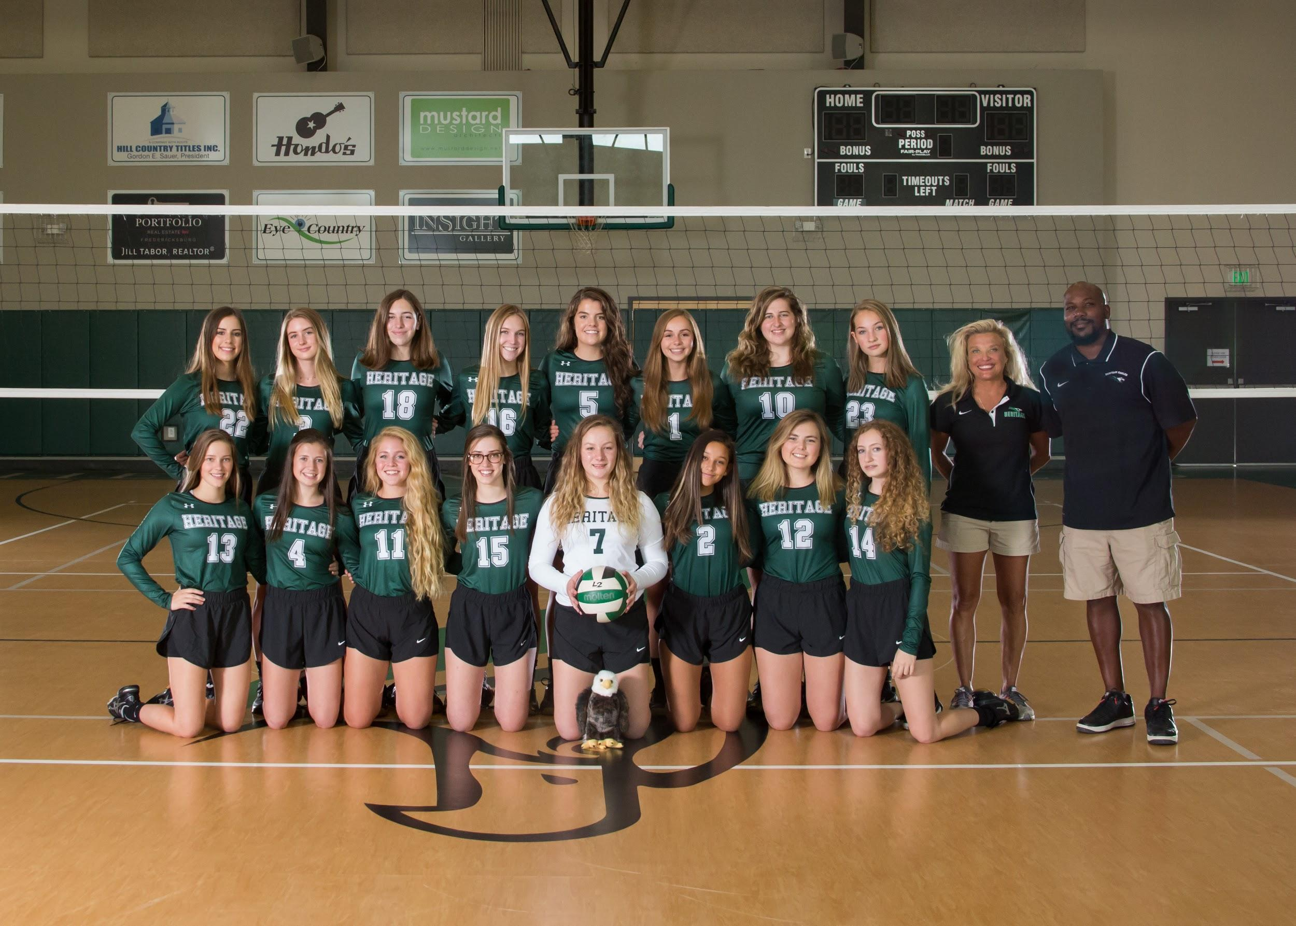
Standing L to R -Faith Lindner, Ellie Faucheux, Erin Fritzsch, Kaitlyn Evans, Celia Ashley, Hannah Bray,Olivia Loggie,Brooke Chastain, Head Coach Tonya Morrow, Asst. Coach Clarence Stewart
Front row l to r Caroline Abel, Madison Brantley, Cora Elliott, Kate Abel, Lilah Brillhart, Hannah Briley, Alivia Jons, Katie Chastain

District Runner Up
Bi District Champs

First team All District
Celia Ashley
Cora Elliott

Second Team All District
Alivia Jons
Kate Abel
Caroline Abel

Honorable Mention
Faith Lindner
Madison Brantley

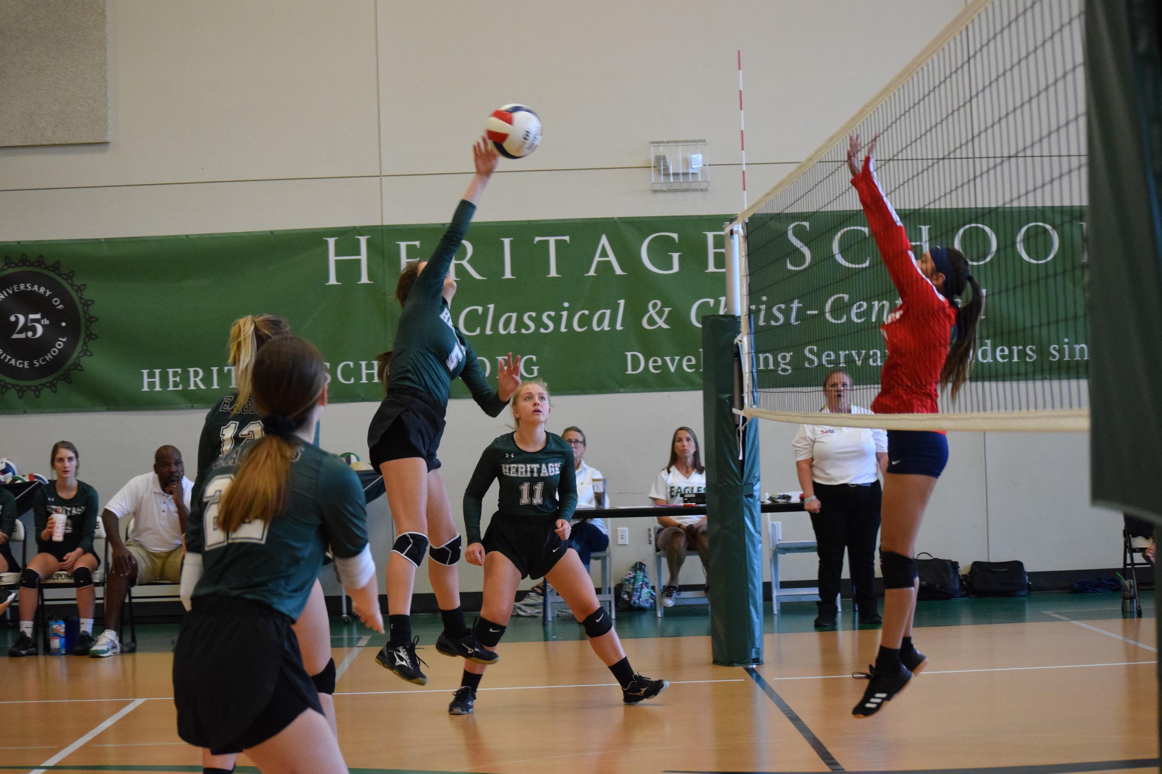
Second Team All State
Celia Ashley

Honorable Mention All State
Cora Elliott

Academic All State
Celia Ashley
Alivia Jons

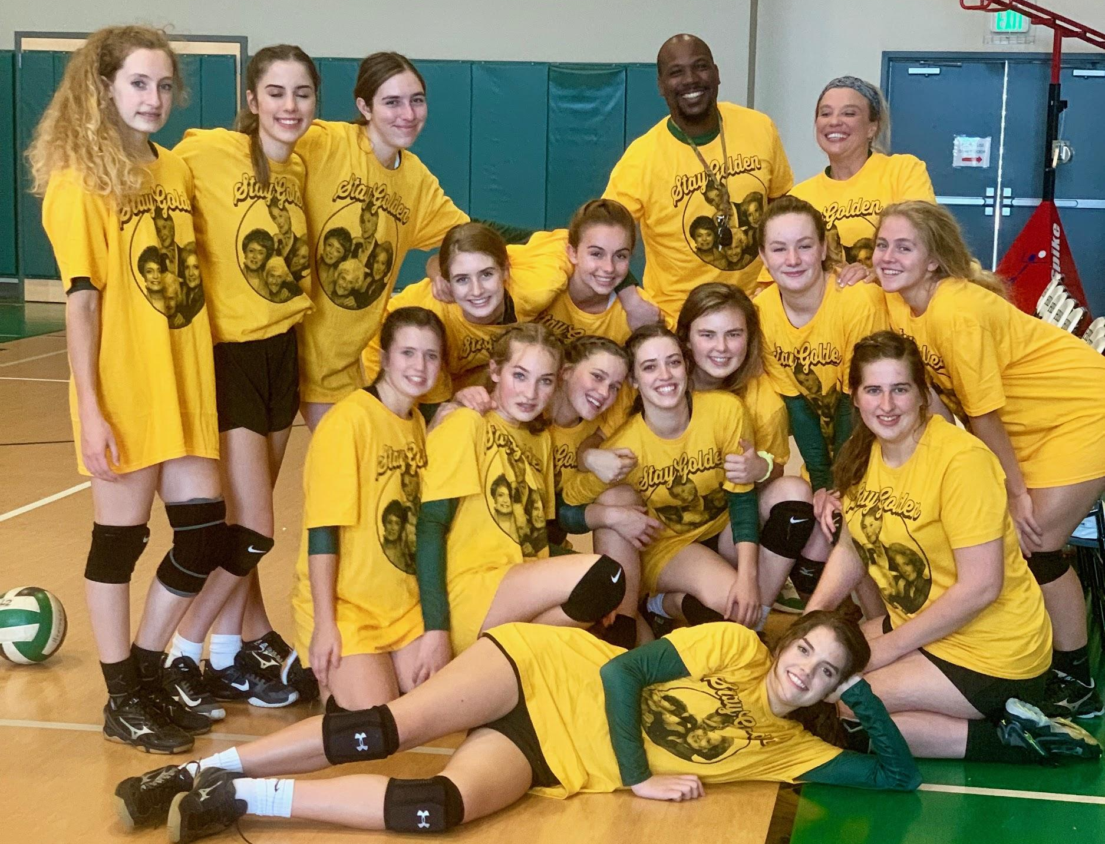
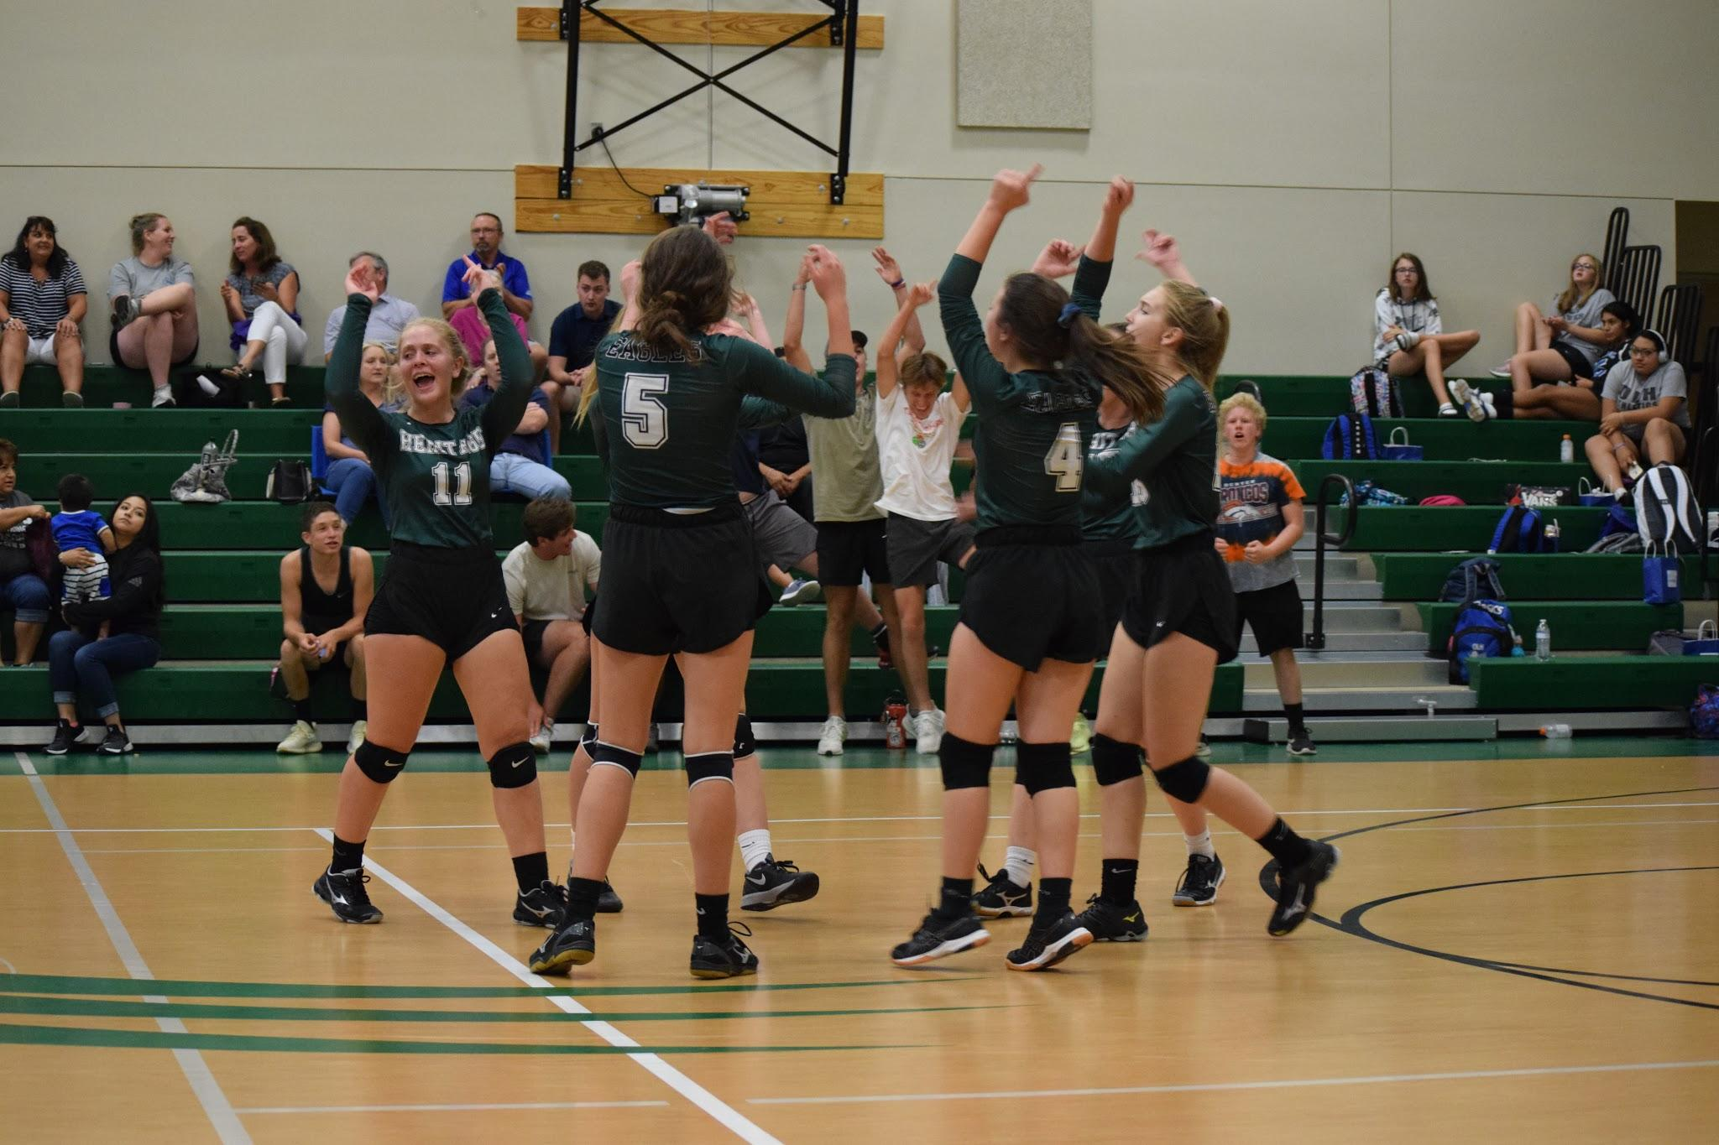
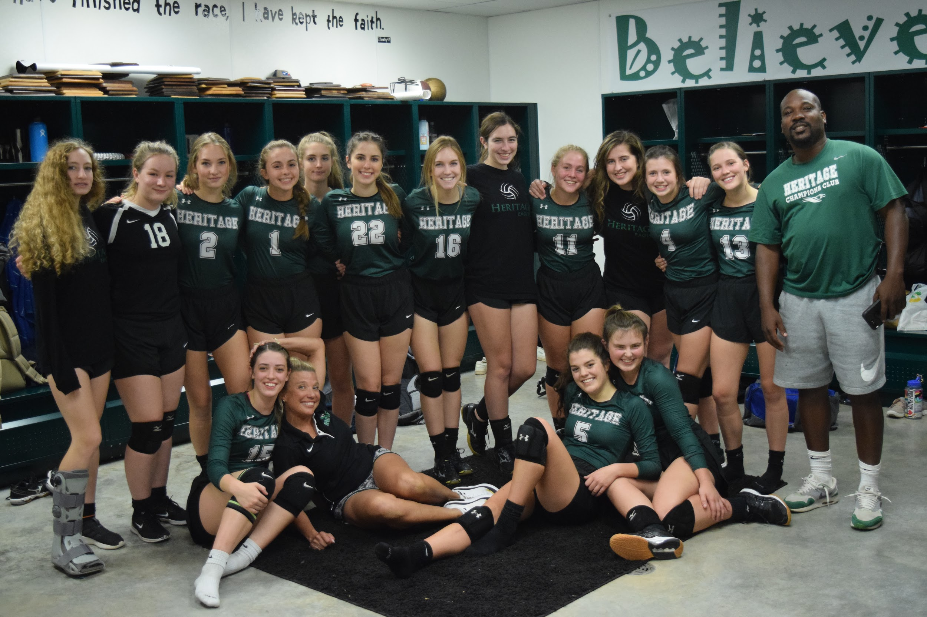

Logic Volleyball

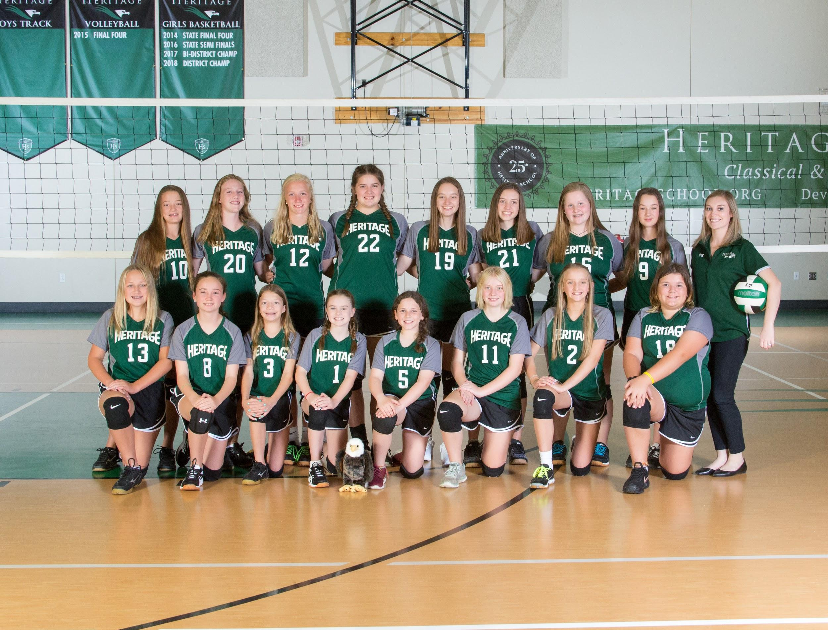

Standing L to R Ellison Keller, Bree Franklin, Ellie Shipman, Eleanor Loggie, Jadan Edwards, Sophia Shelton,Acelynn Thomson,Ella Rose Brillhart, Head Coach Kat Cole
Front row L to R Jailee Goodman, Reece Harris, Terah Tucker, Aubrey Roberts, Annabelle Holster, E.B. Stollenwerck, Lilli Bray, Sofia Janc

CALSA League Volleyball Champions

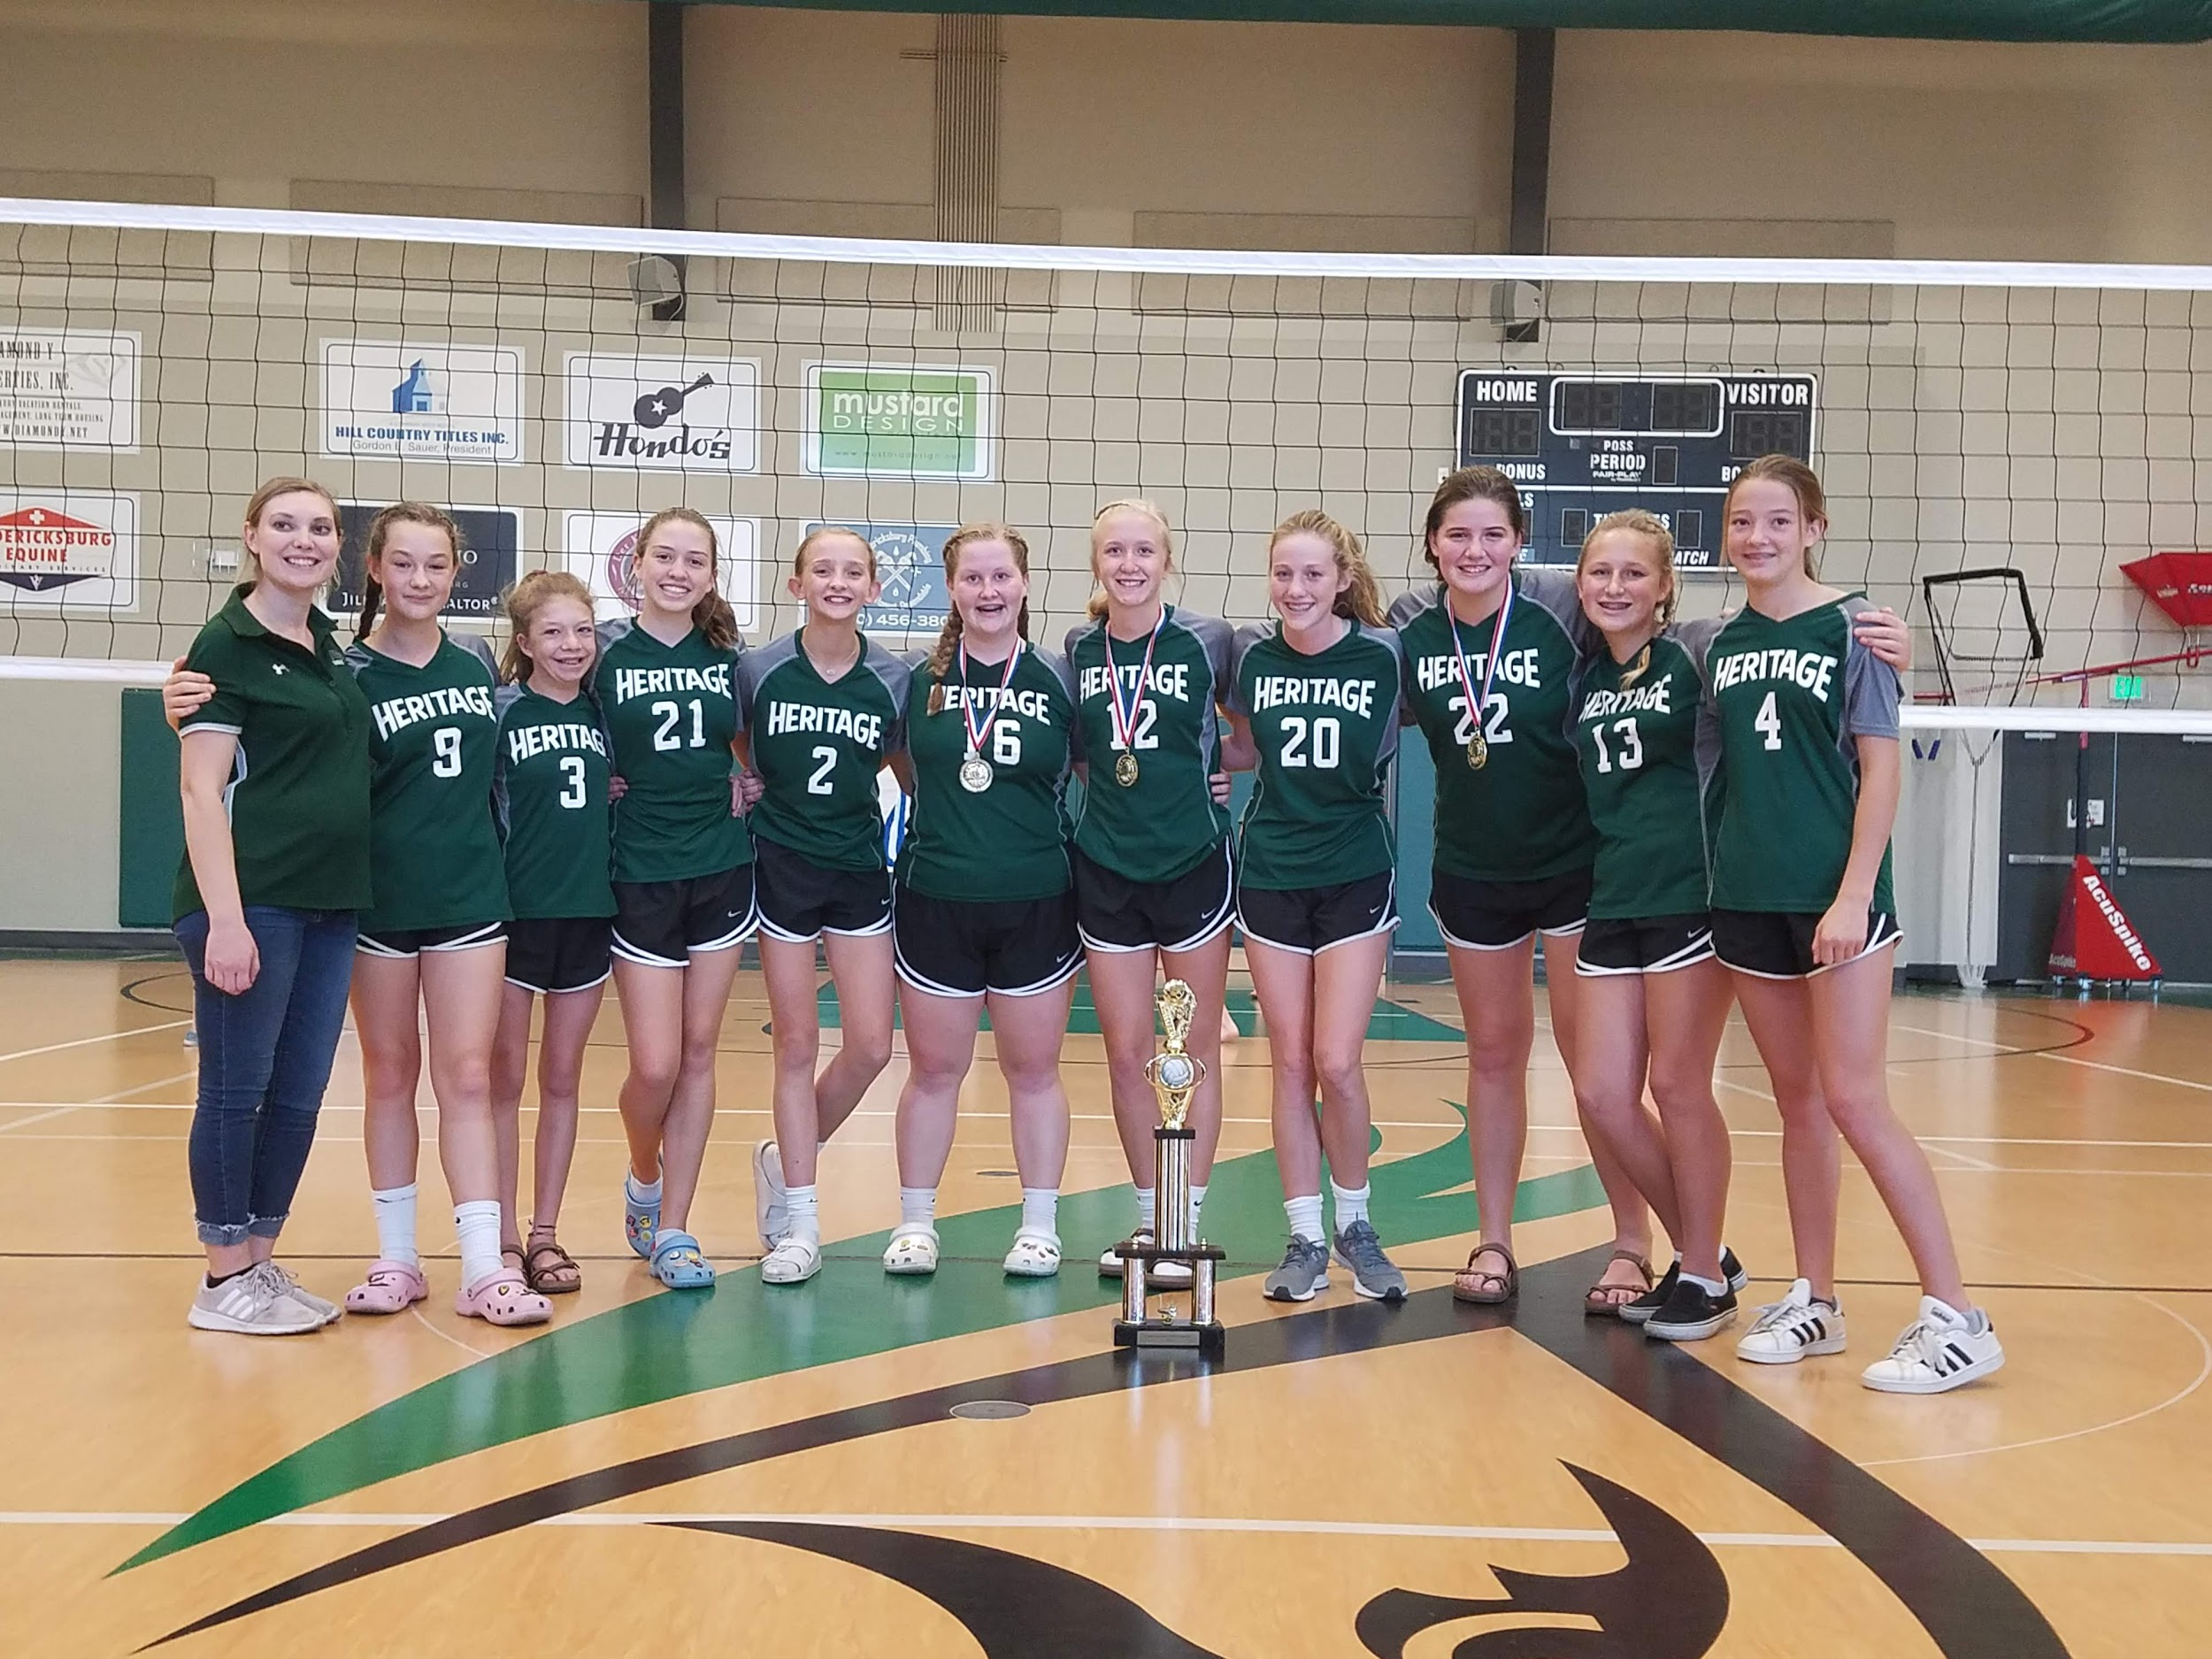

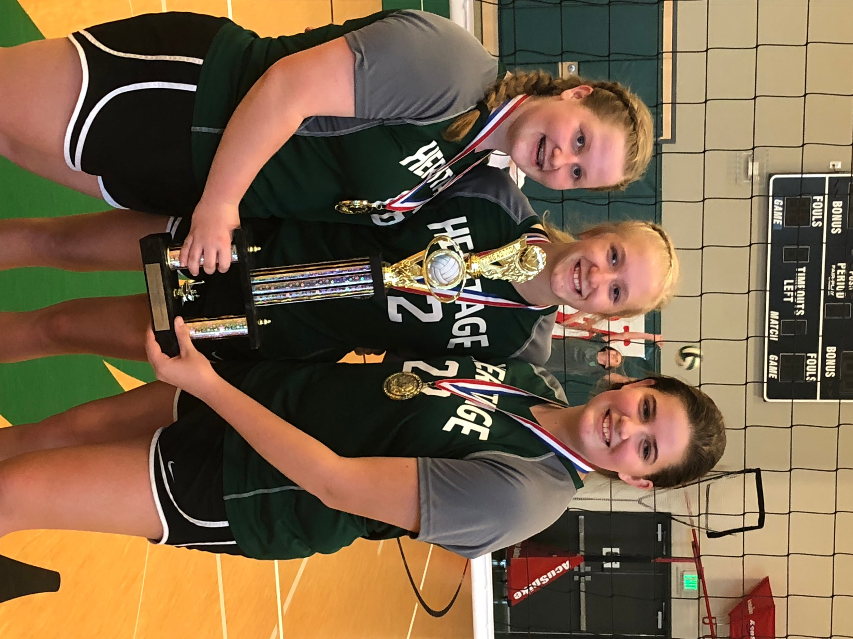

All Tournament
Ellie Shipman
Eleanor Loggie
Acelynn Thomson

Varsity & Logic Cross Country

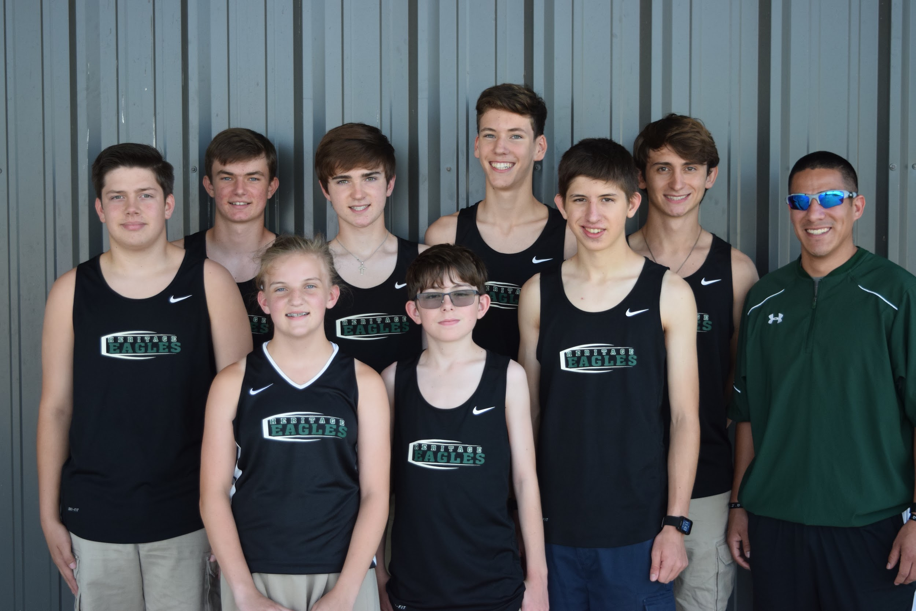

L to R- Andrew Chapa, Joshua Tabor, Maddie Smith, Benjamin Lohmeyer, Wyatt Burnett, Alex Ludwig, Wes Burnett, Daniel Sauer, Head Coach Kevin Perez

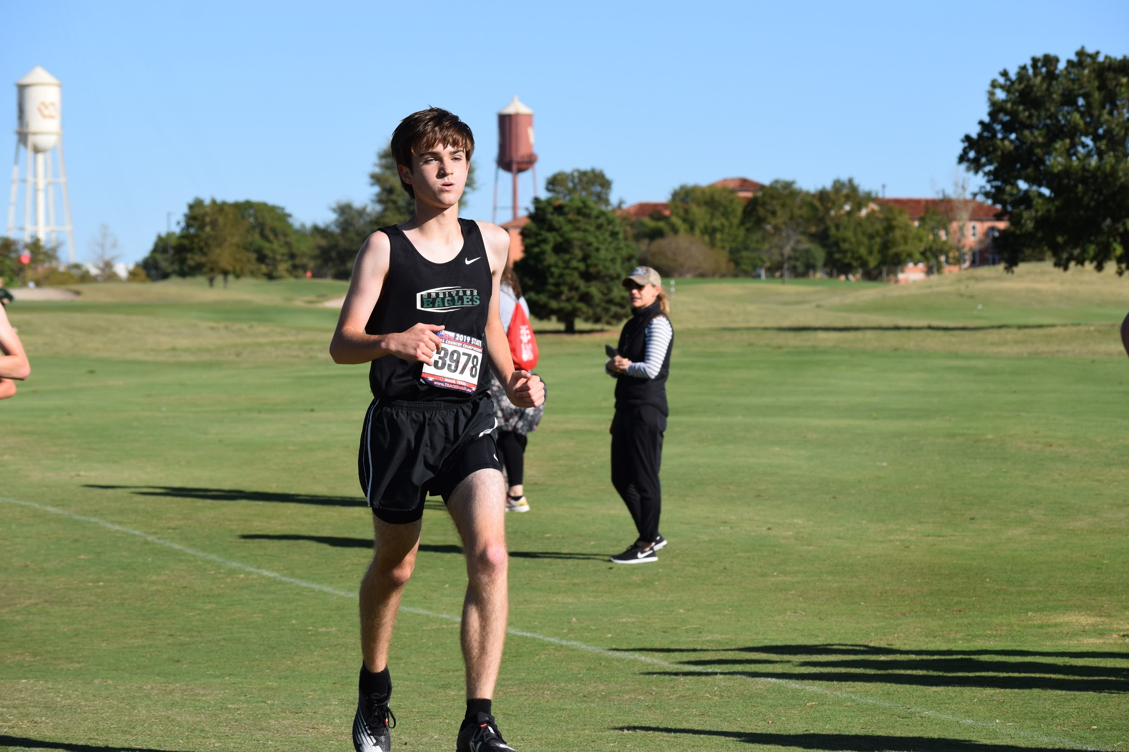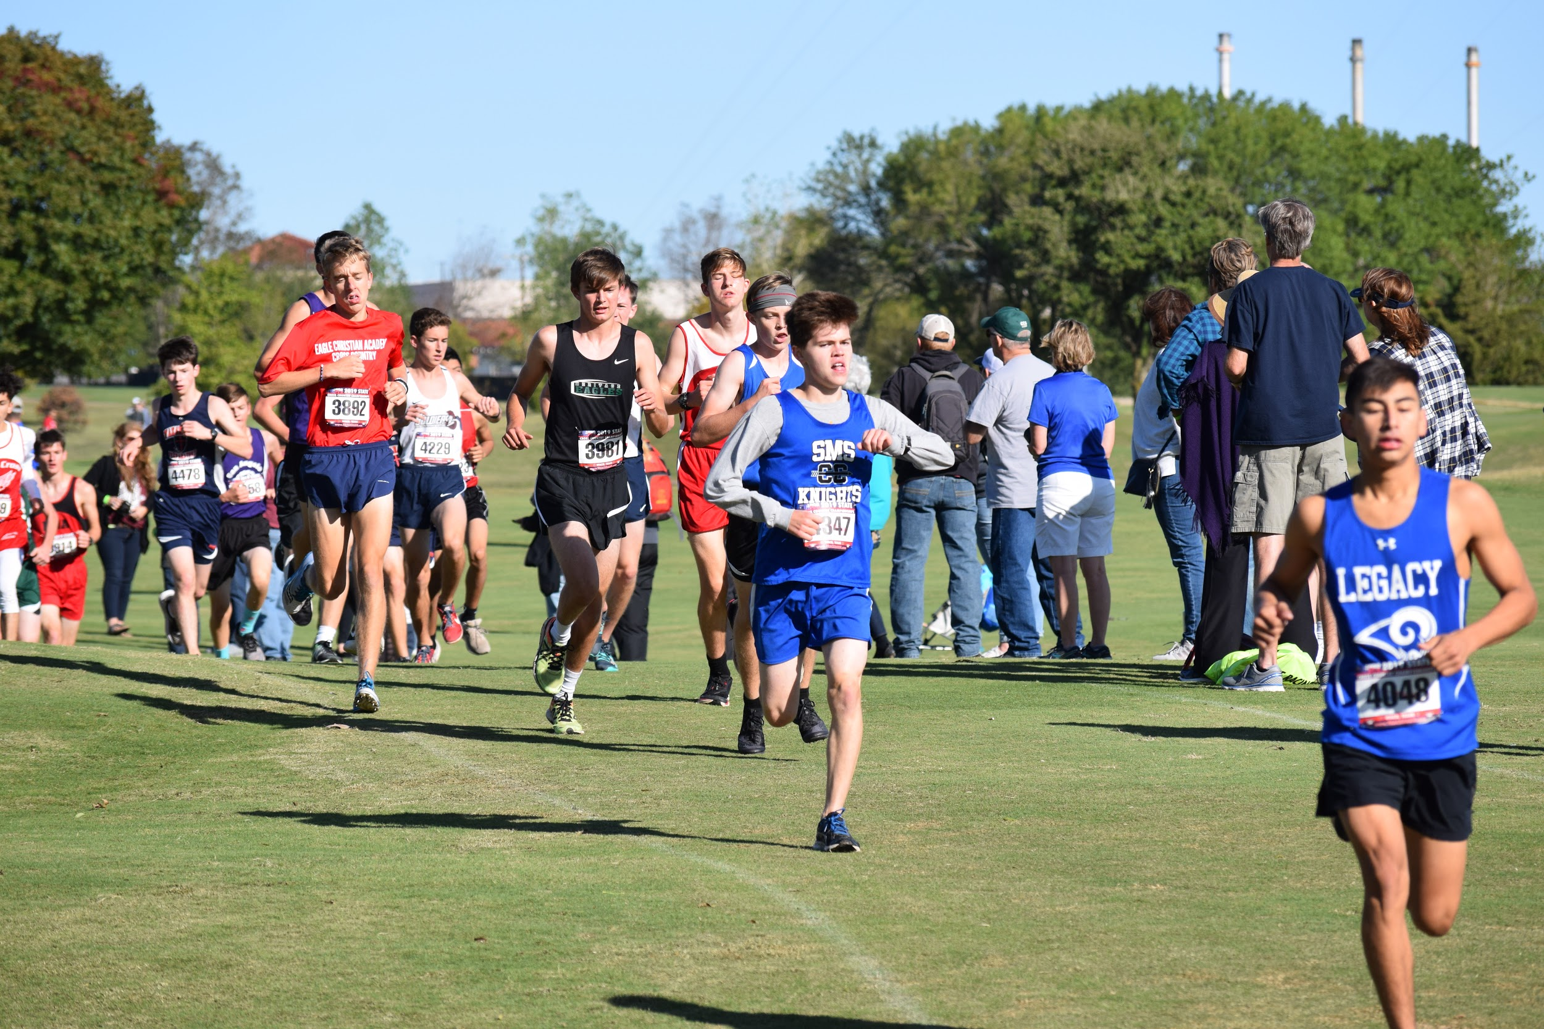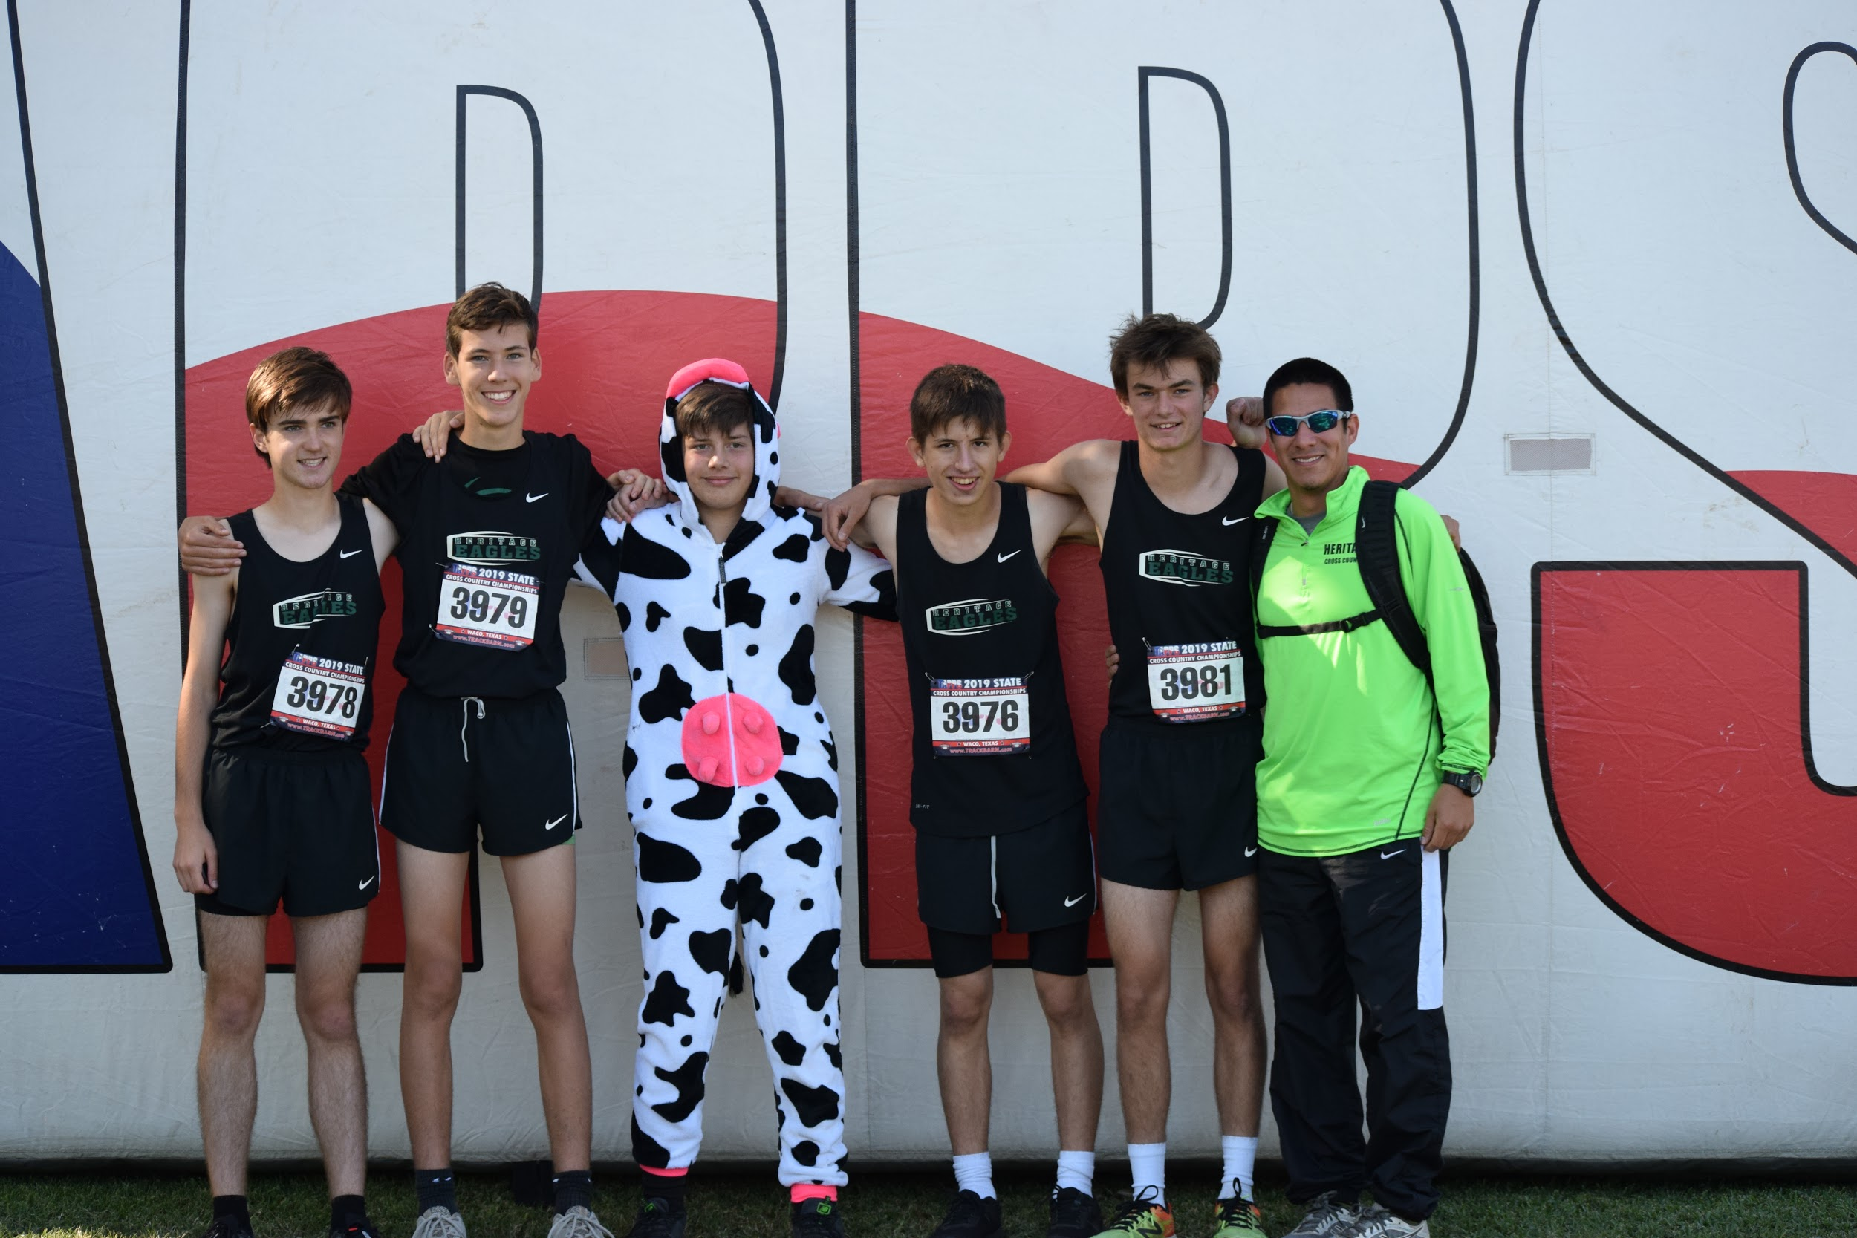

CALSA Girls Champion- Maddie Smith

Varsity Football
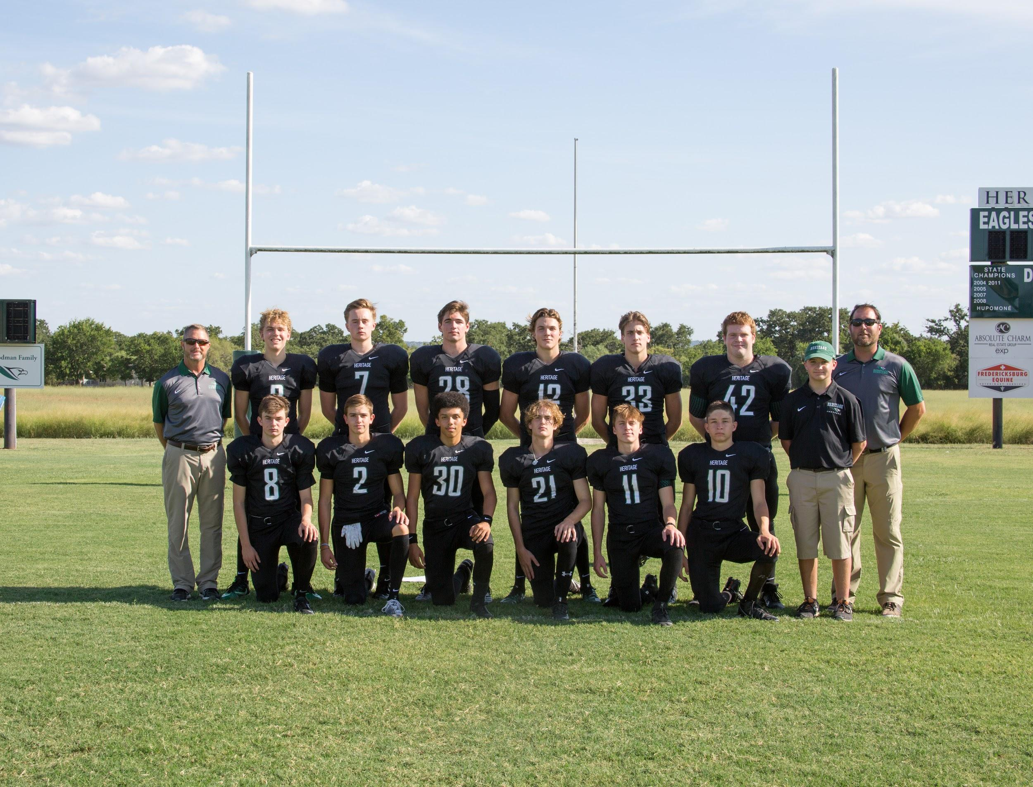

Standing L to R Head Coach Tim Shipman, Luke Roberts, John Fritzsch, Joshua Hoermann, Noah Given, Eli Christensen, Manager Gage Nelson, Asst. Coach Jamey Parsons
Kneeling L to R Joshua Tabor, Caden Bray, Jack Henderson, Finn Sawtelle, Sam Richburg, Rory Shelton
Not pictured Filmer Sam Cowsar

State Champions- Undefeated 13-0
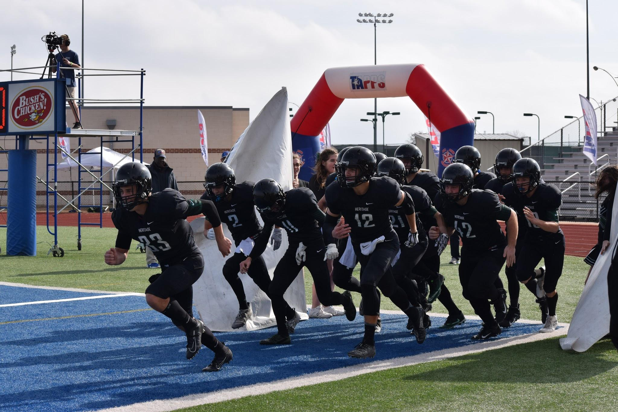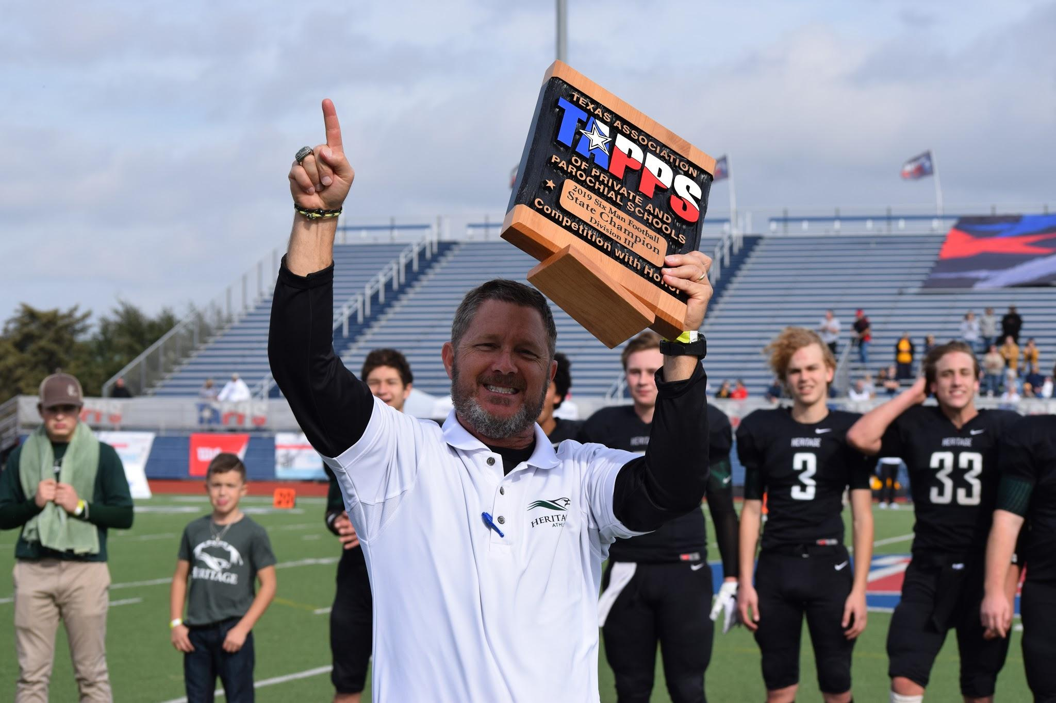

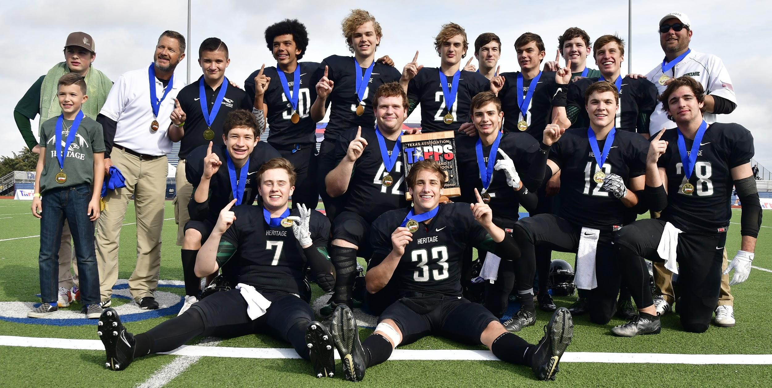

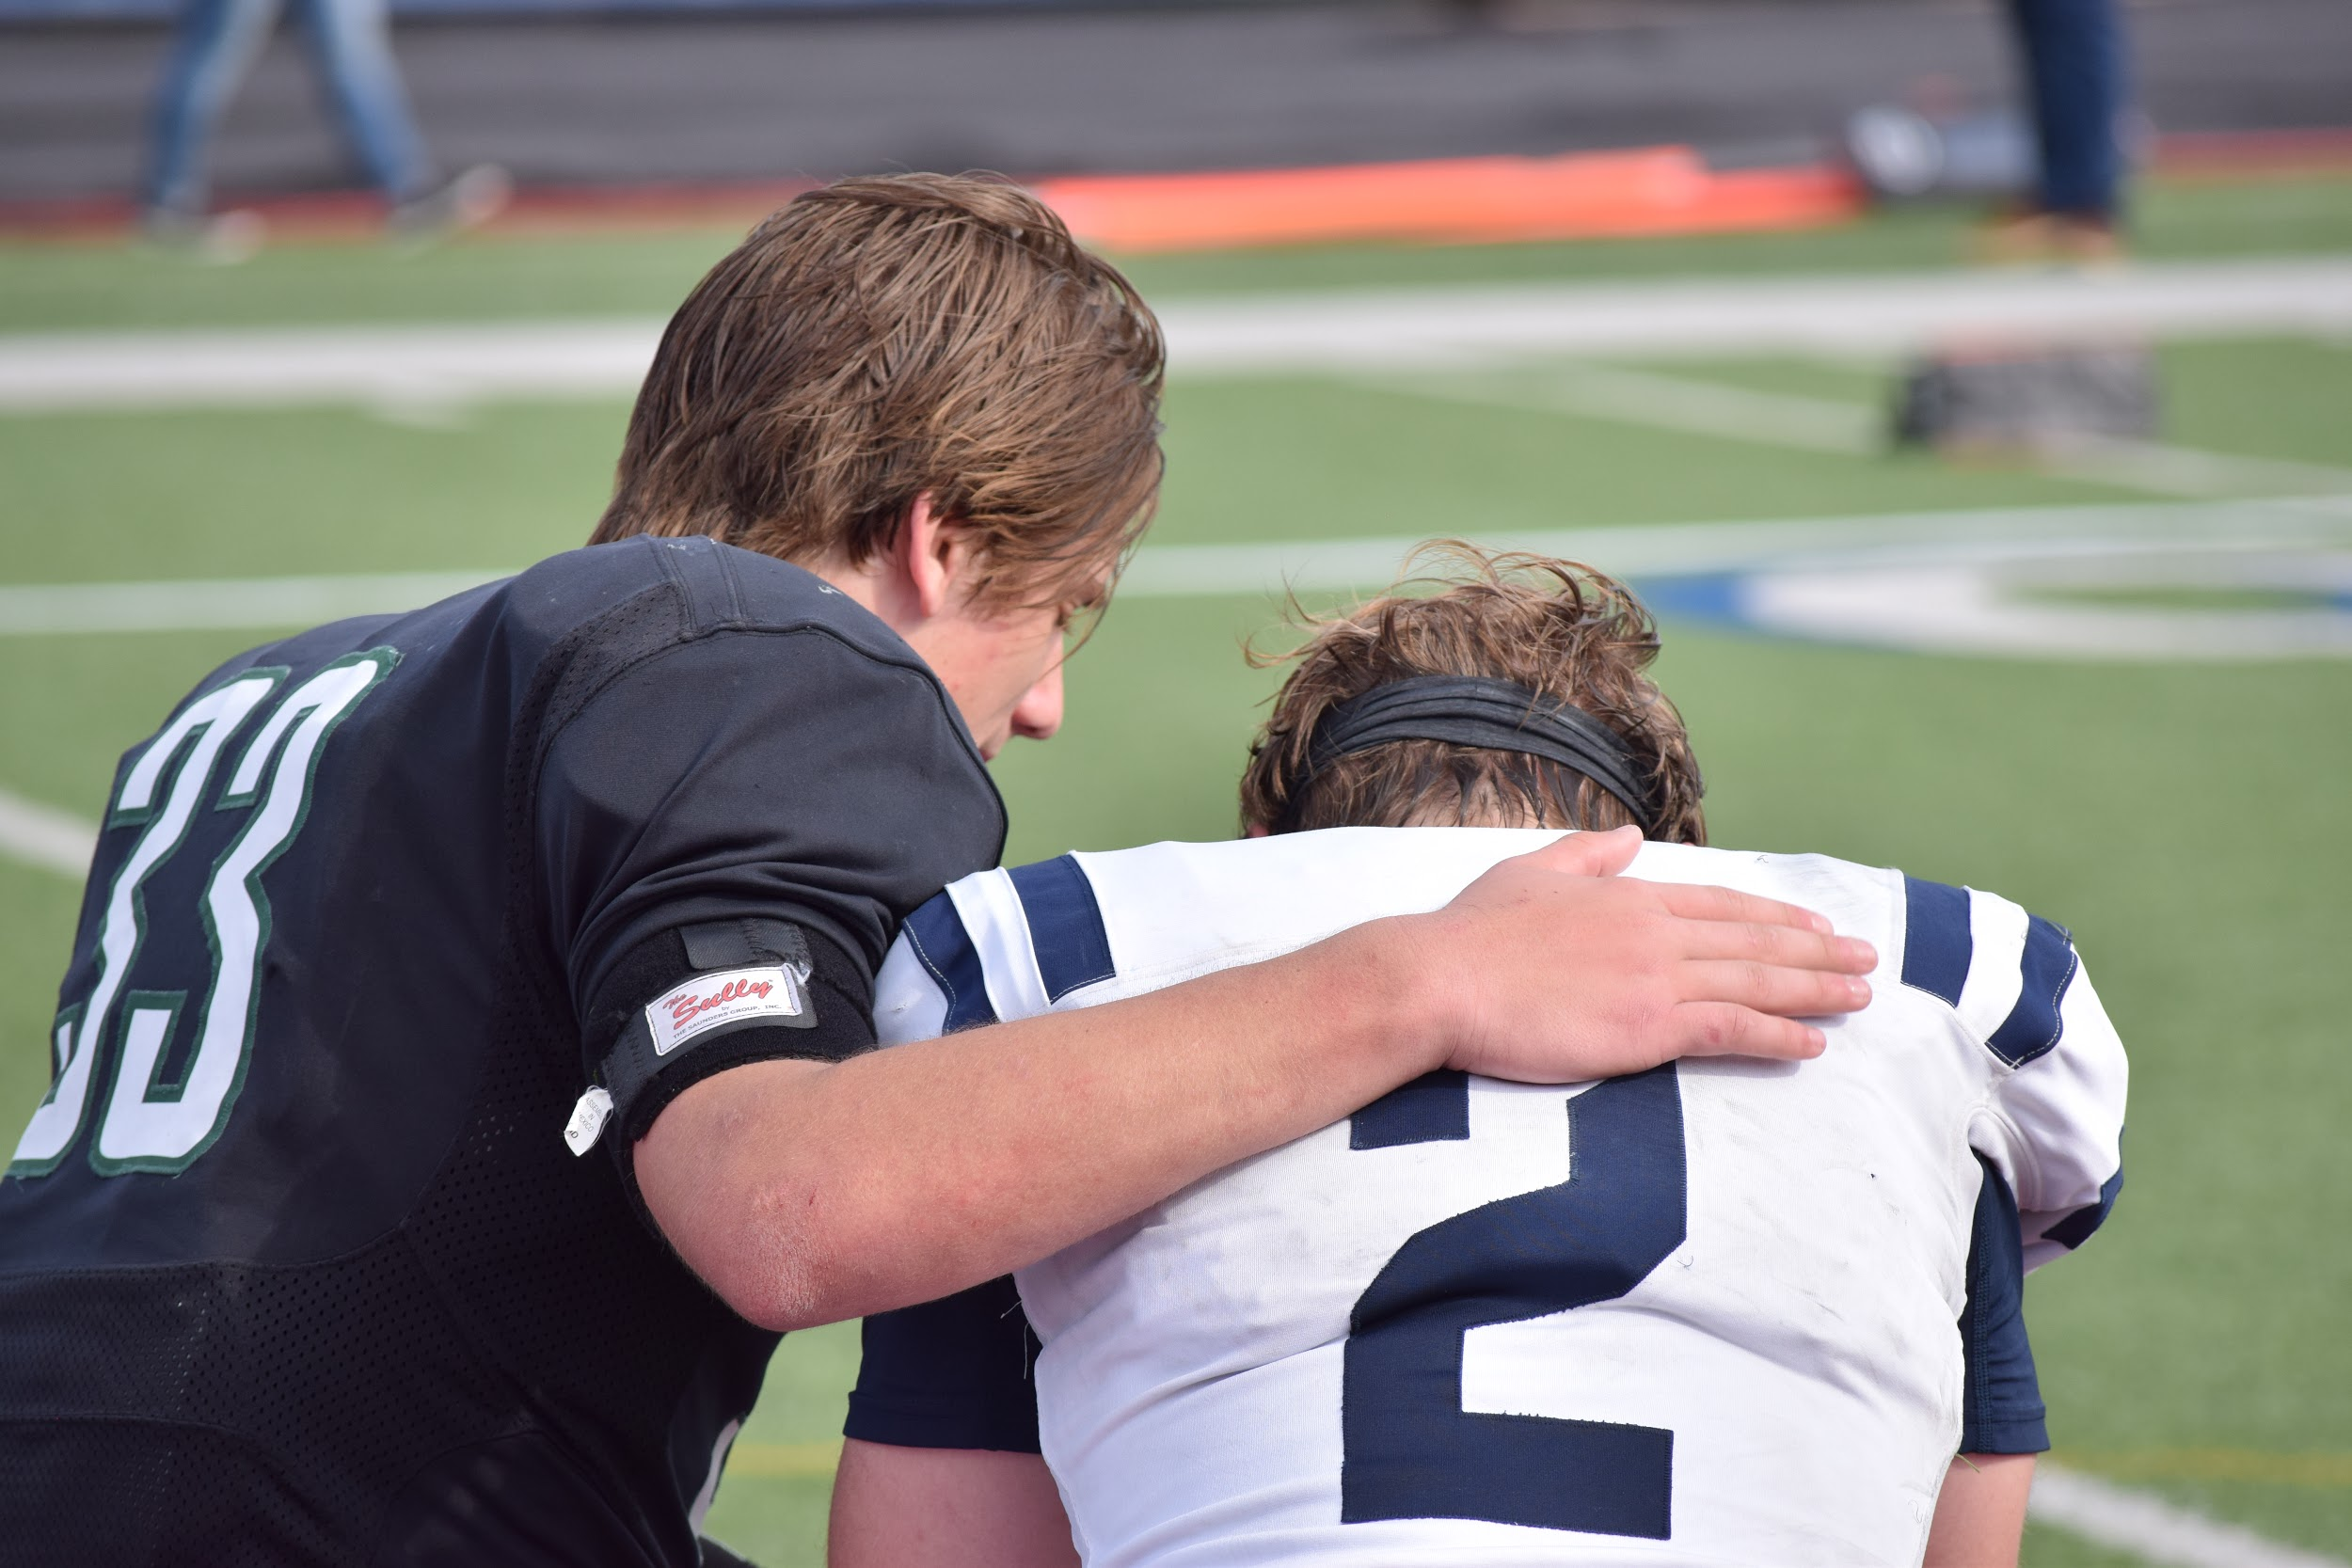
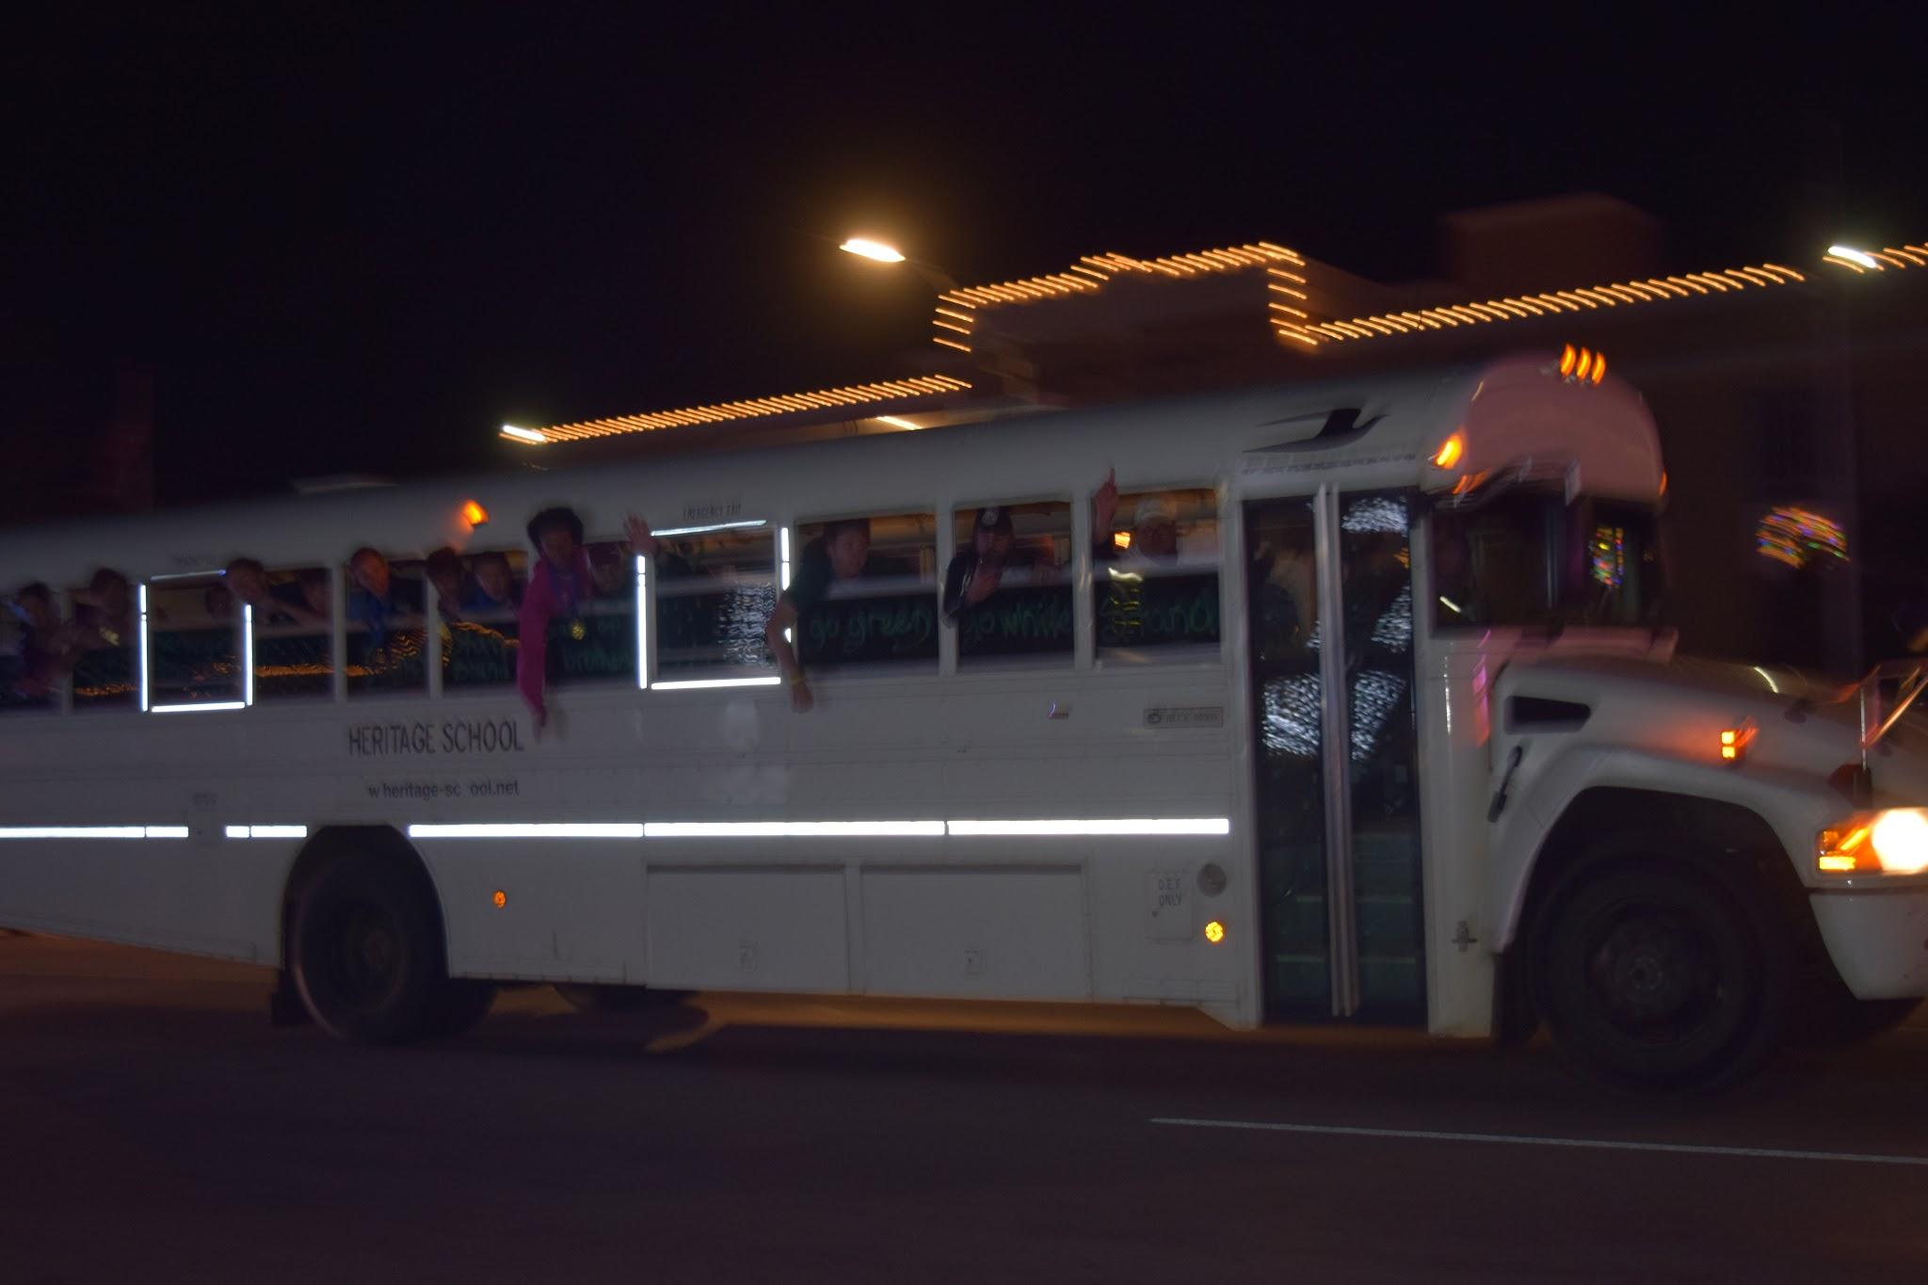

First Team All District
Aidan Hickey- Offensive Lineman
Eli Christensen- Center
John Fritzsch -Running Back,Linebacker
Joshua Hoermann- Utility Back,Defensive Back
Noah Given- Tide End,Defensive Line
Sam Richburg- Kicker,Defensive Line
Jack Henderson- Defensive Back
Caden Bray- Defensive Back

Second Team All District
Finn Sawtelle- Receiver, Defensive Back
Sam Richburg- Quarterback
Caden Bray- Spread Back
Joshua Hoermann- Punter

First Team All State

Aidan Hickey- Offensive Lineman
Eli Christensen -Center
John Fritzsch -Running Back, Linebacker
Joshua Hoermann -Utility Back, Defensive Back
Noah Given -Tide End, Defensive Line
Sam Richburg- Defensive Line
Jack Henderson -Defensive Back
Caden Bray- Defensive Back

Academic All State

Noah Given
Eli Christensen
Joshua Hoermann
Sam Richburg
Finn Sawtelle

Logic Football
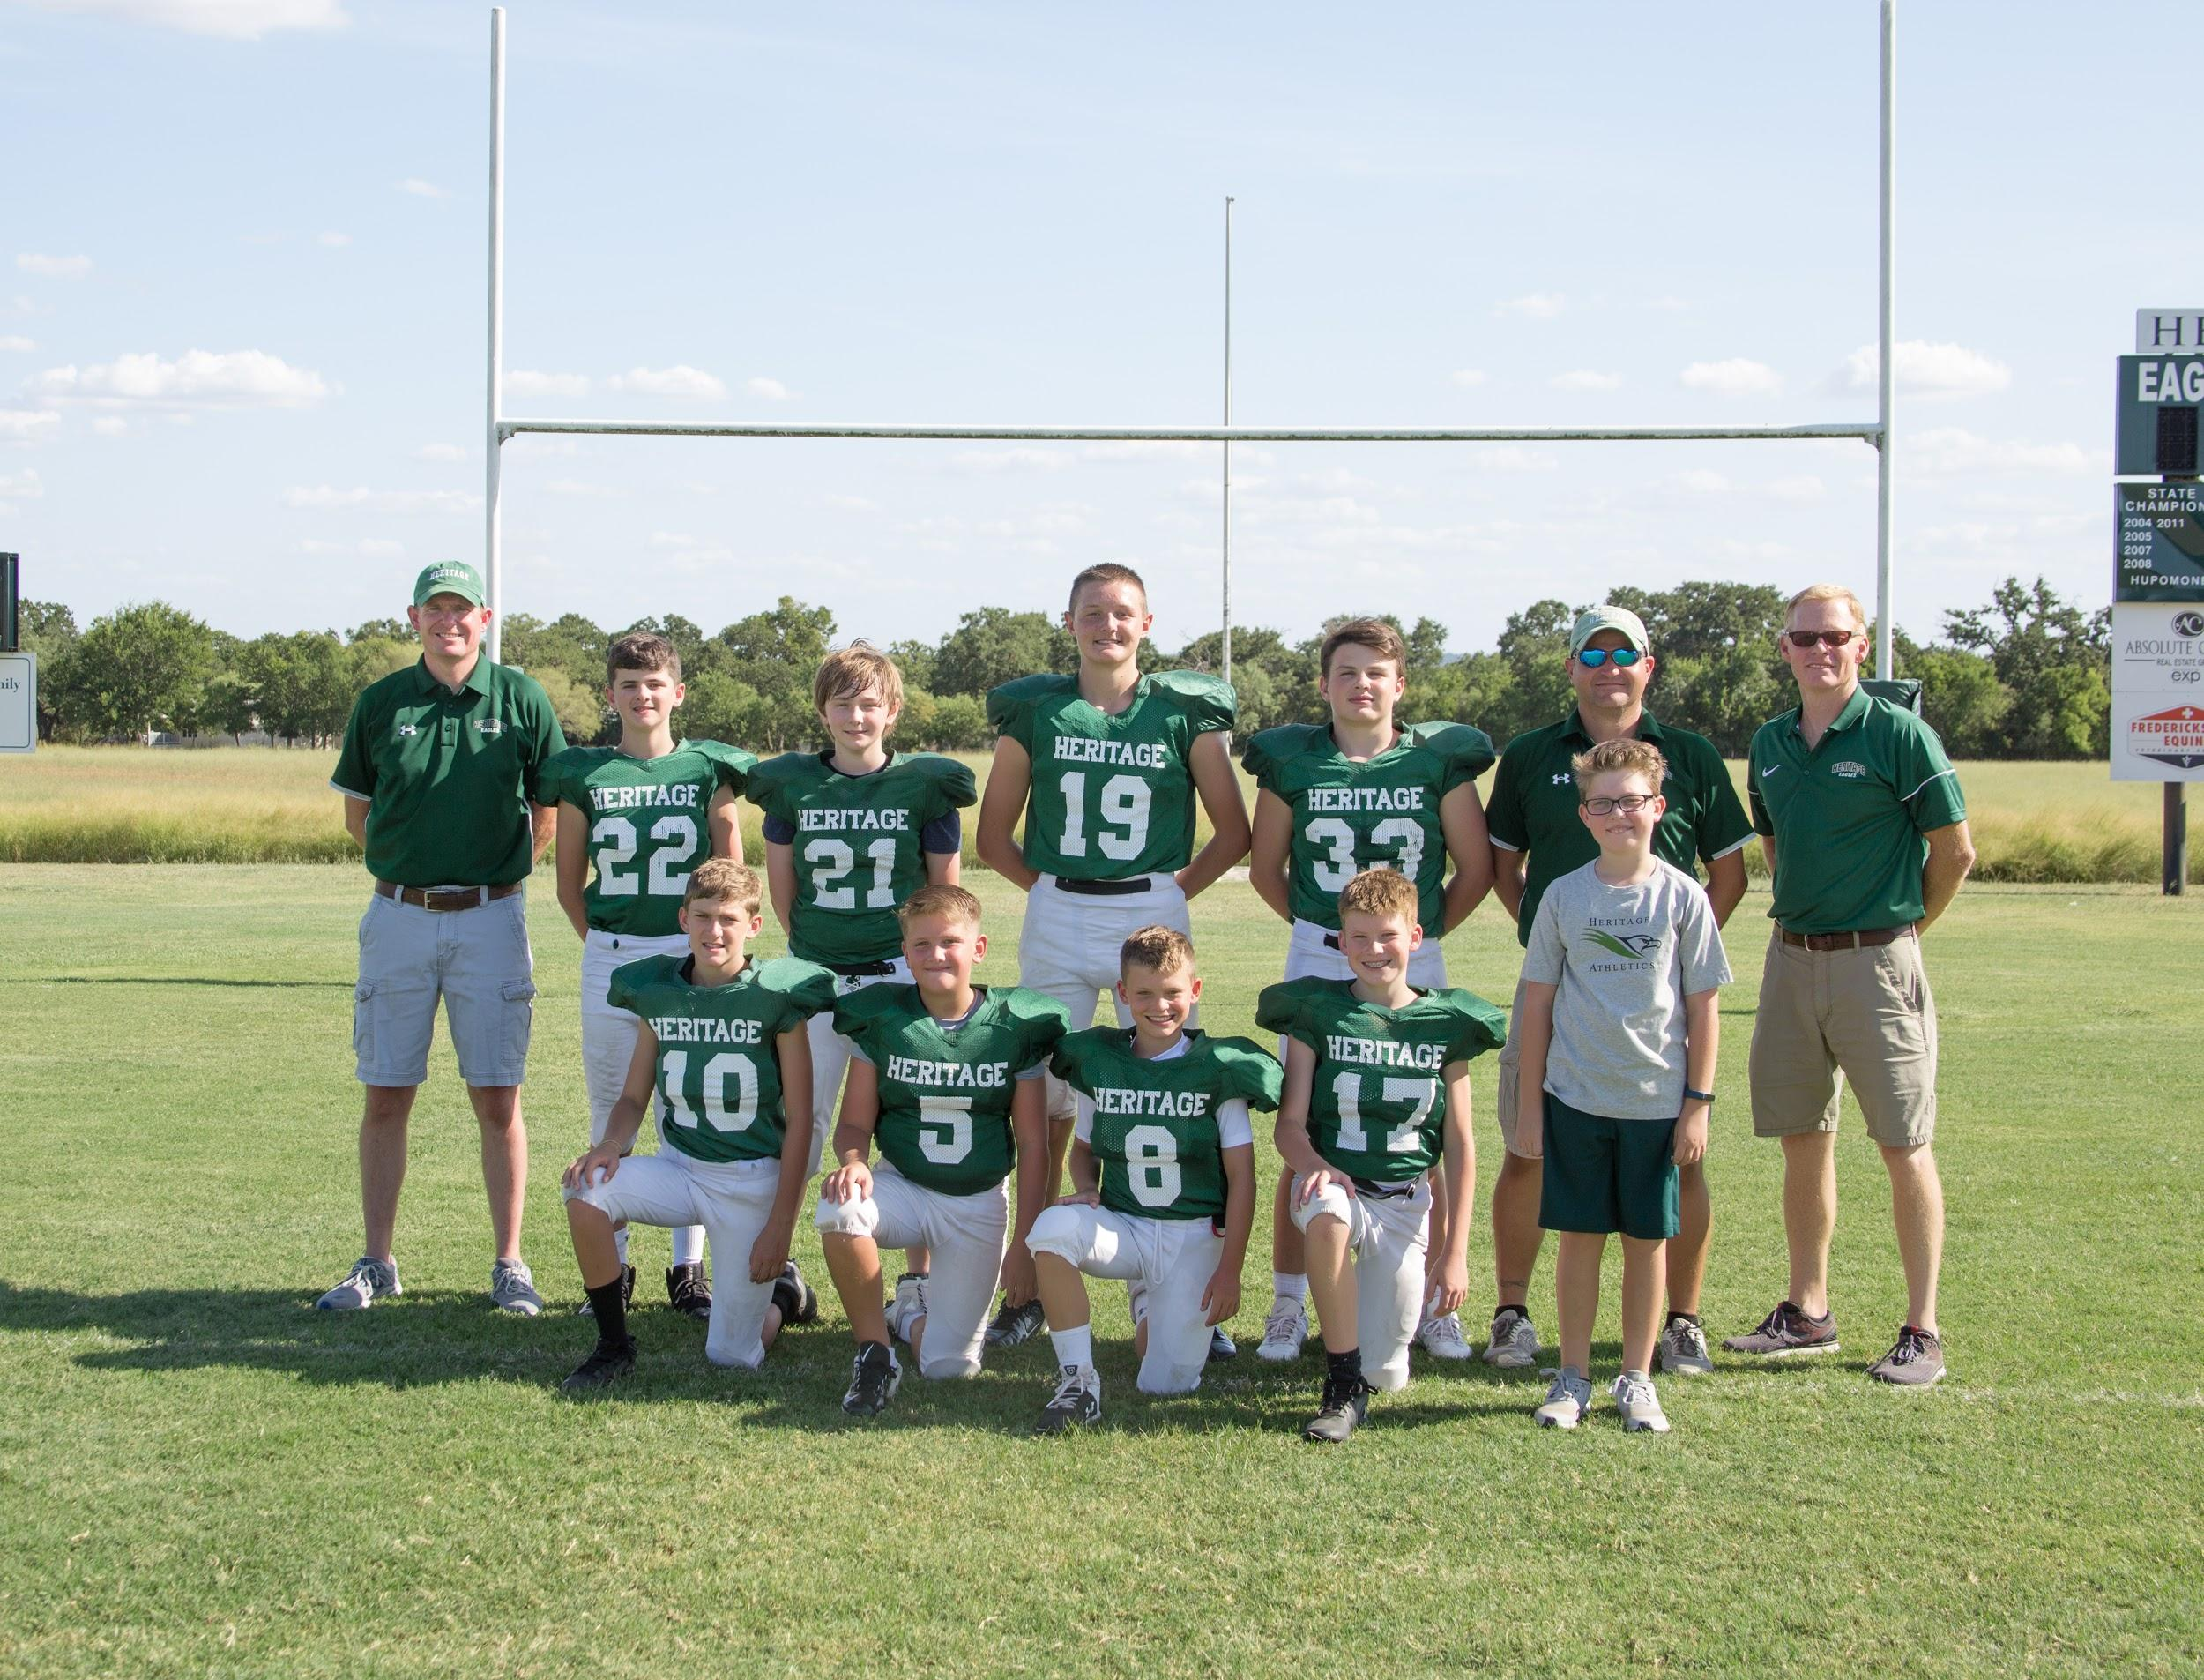
Head Coach Matt Roberts, Trace Atkinson, Vincent Hickey, C.J. Barnett, Tres Jons, Asst. Coach Chris Moldenhauer, Asst. Coach Roy Gentry
Front row L to R Benjamin Tabor, Gage Varwig, Drake McKinney, Tristan Roberts, Manager Garrett Gentry

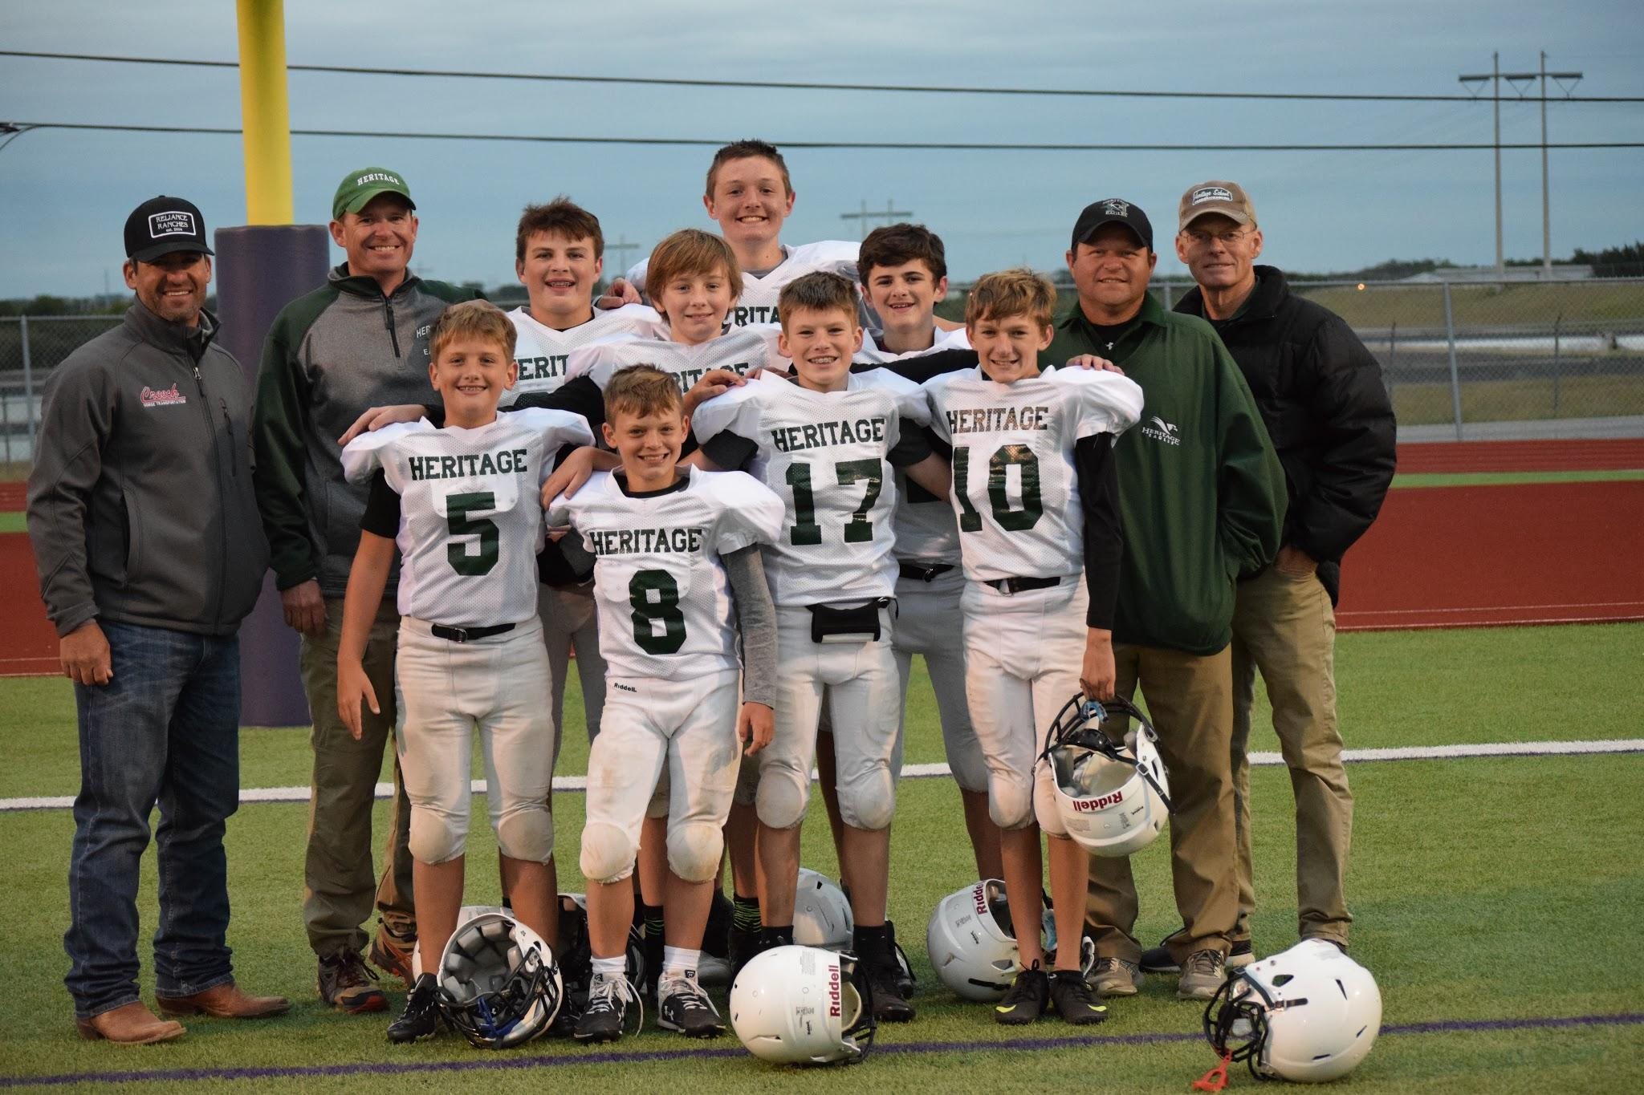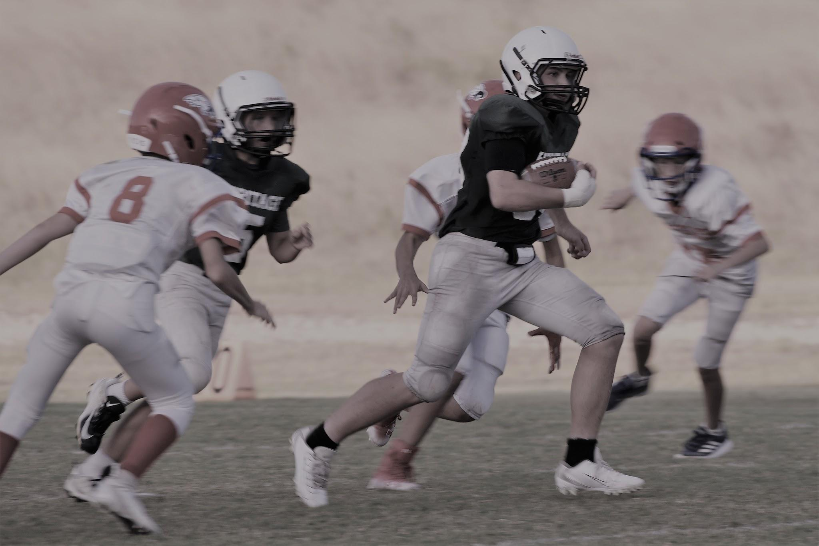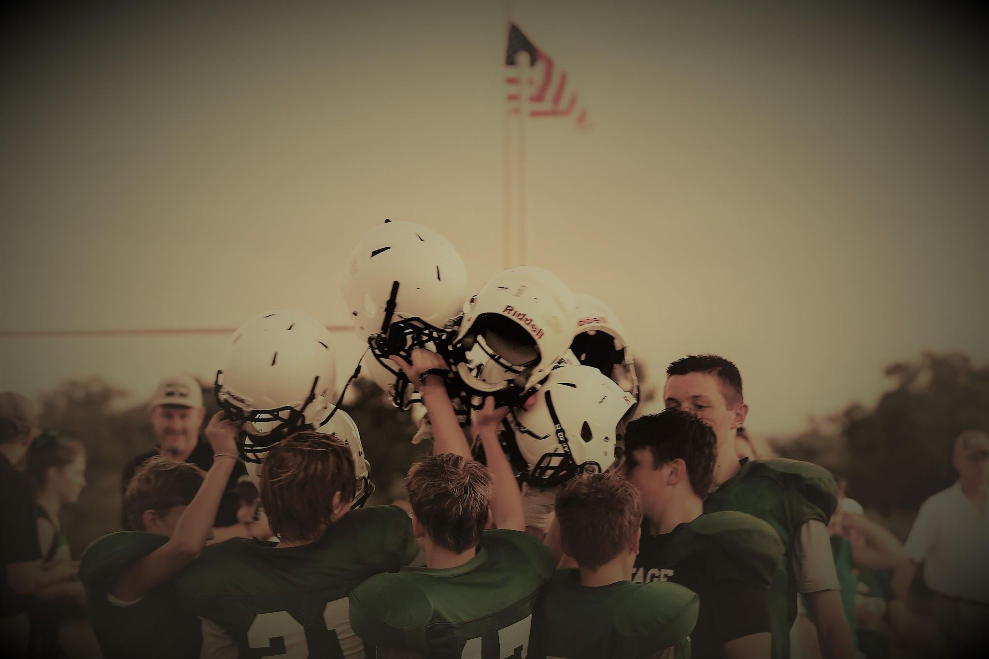

Varsity Girls Basketball

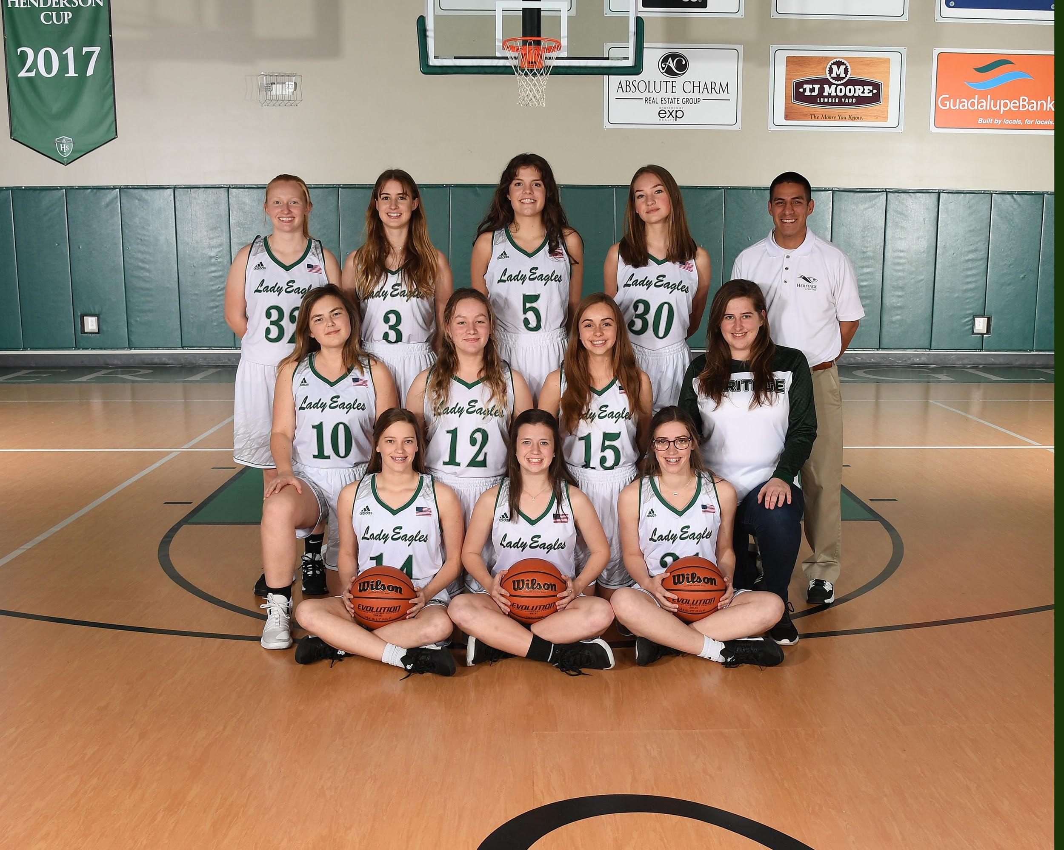
Standing L to R Josie Fevig, Ellie Faucheux, Celia Ashley, Brooke Chastain, Head Coach Kevin Perez
Kneeling L to R Alivia Jons, Lilah Brillhart, Hannah Bray, Olivia Loggie
Sitting L to R Caroline Abel, Madison Brantley, Kate Abel

District Runner Up
Bi District Champs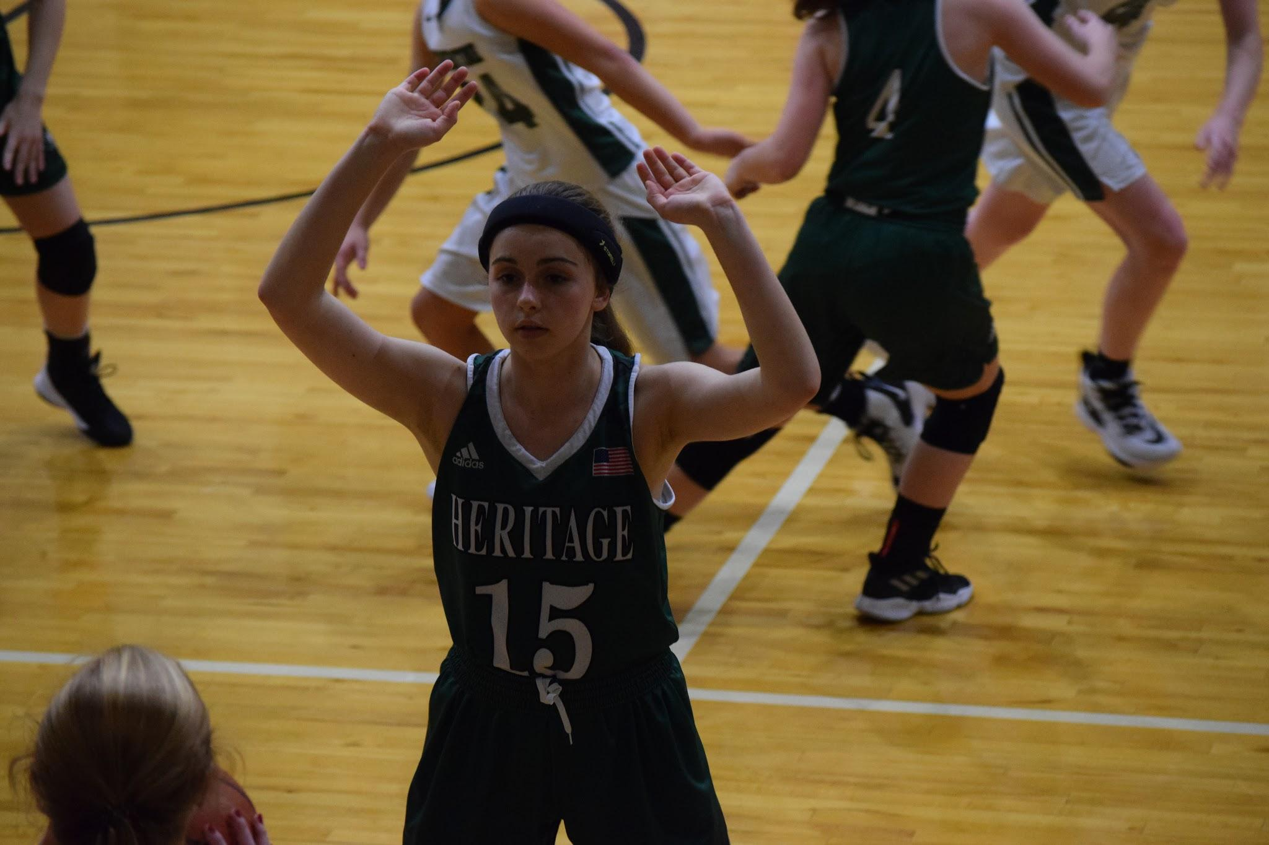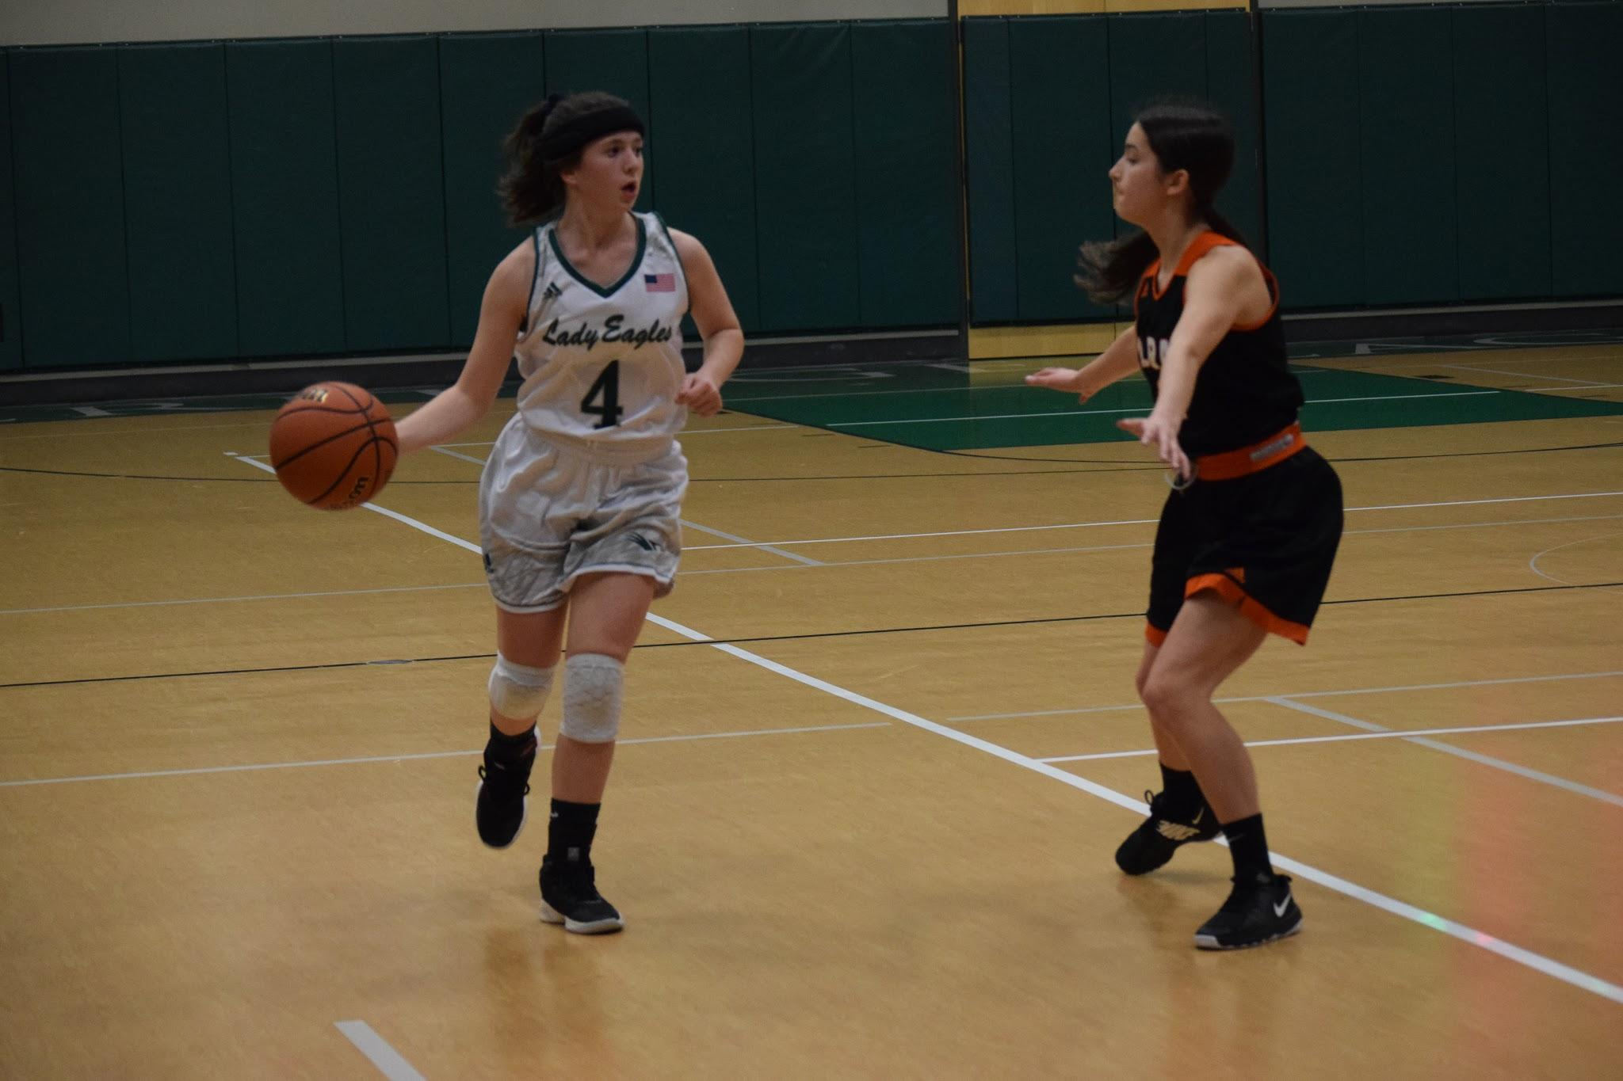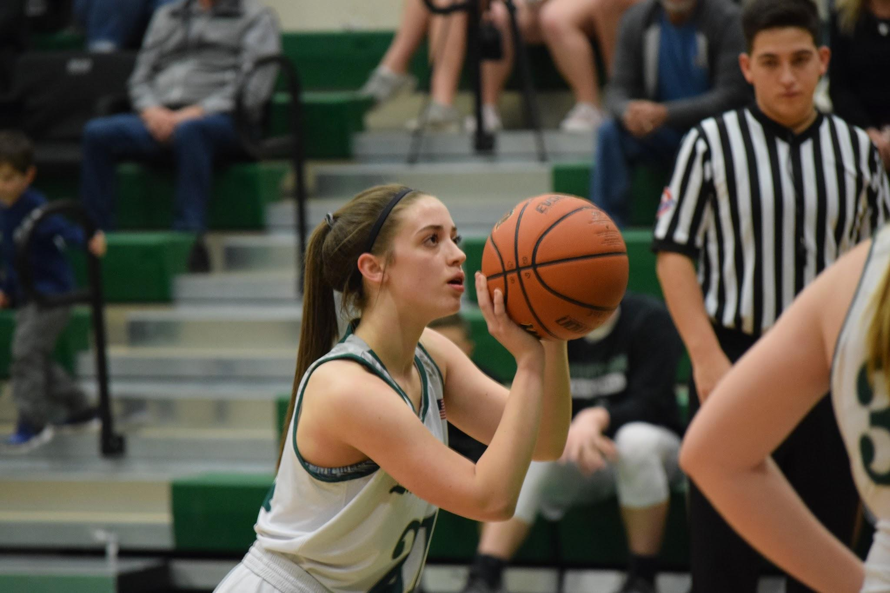

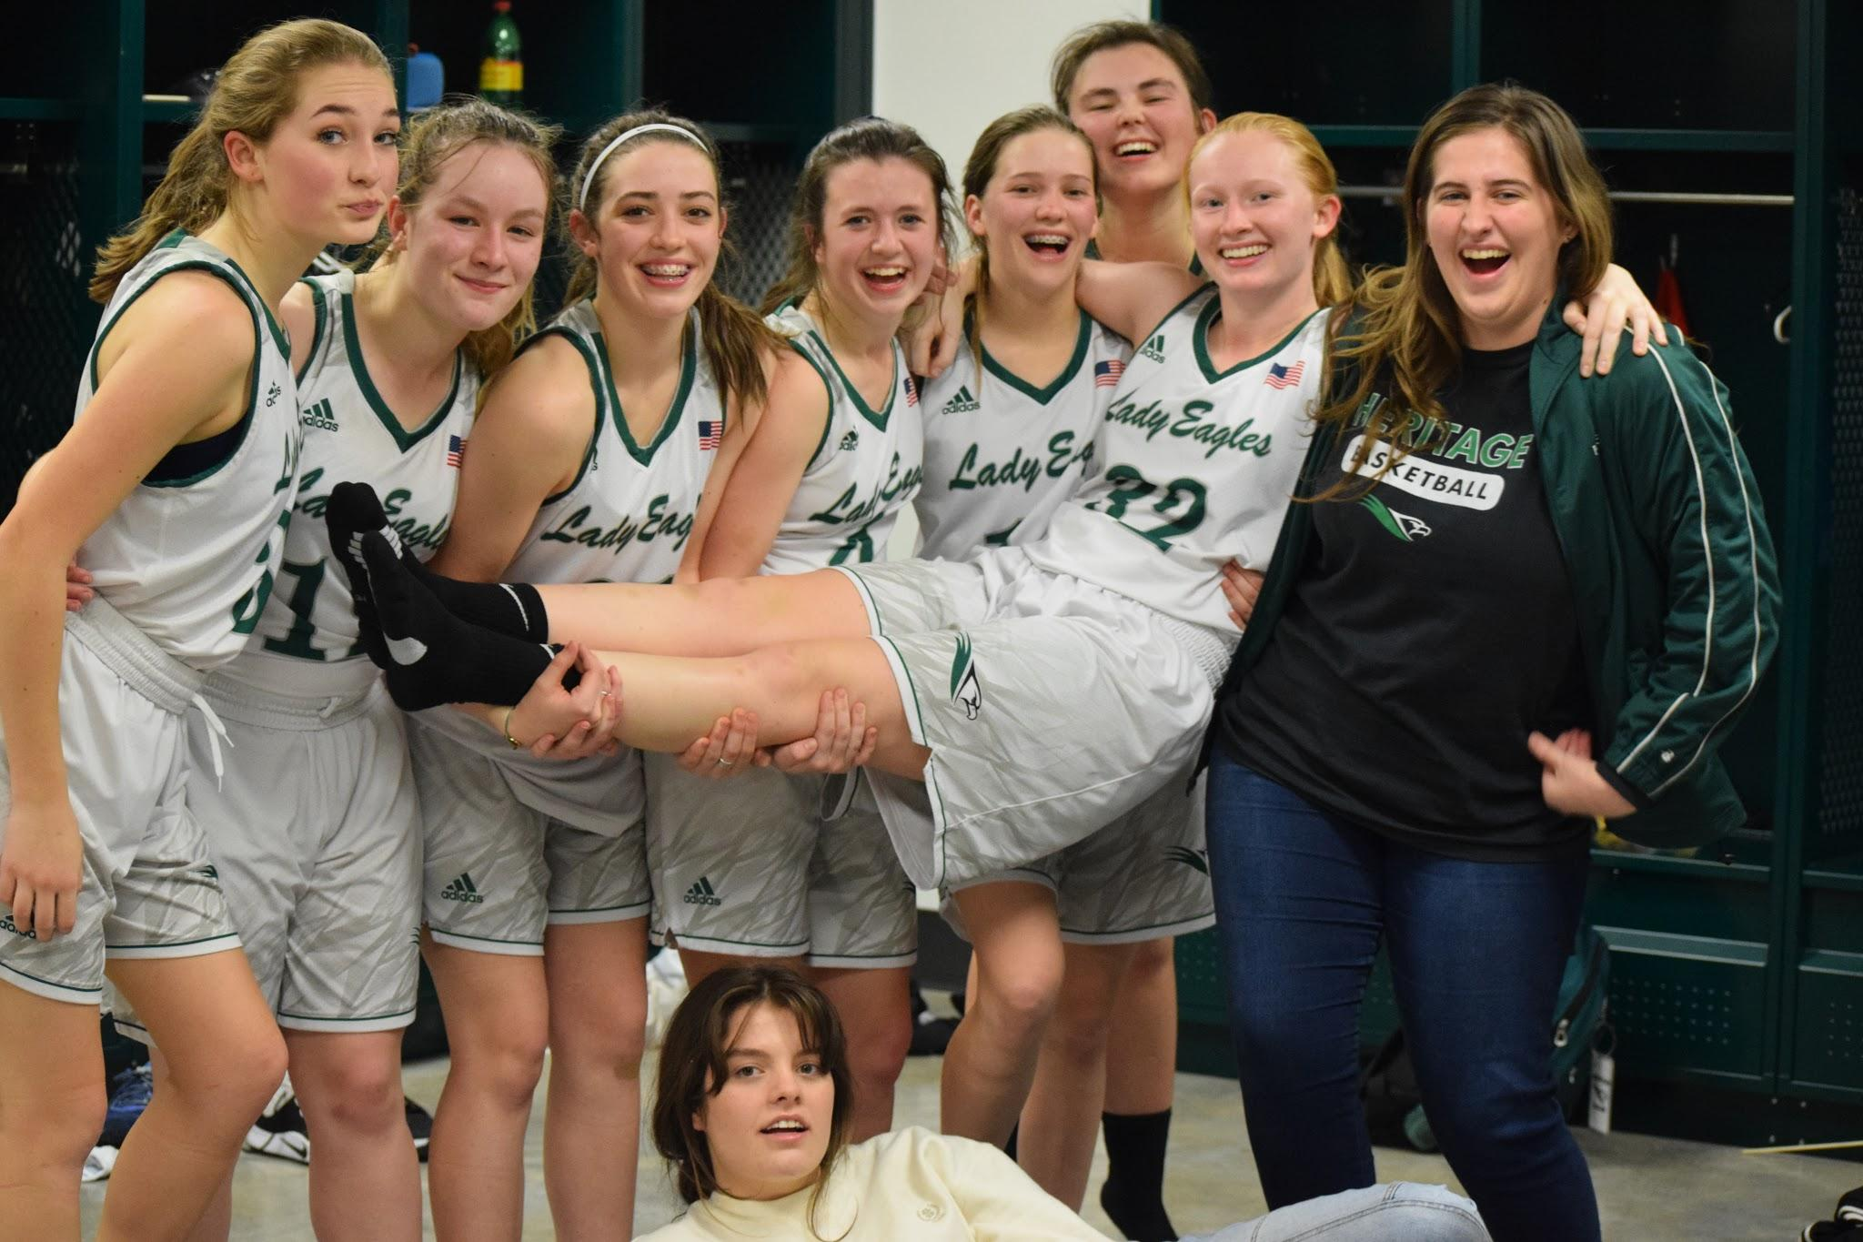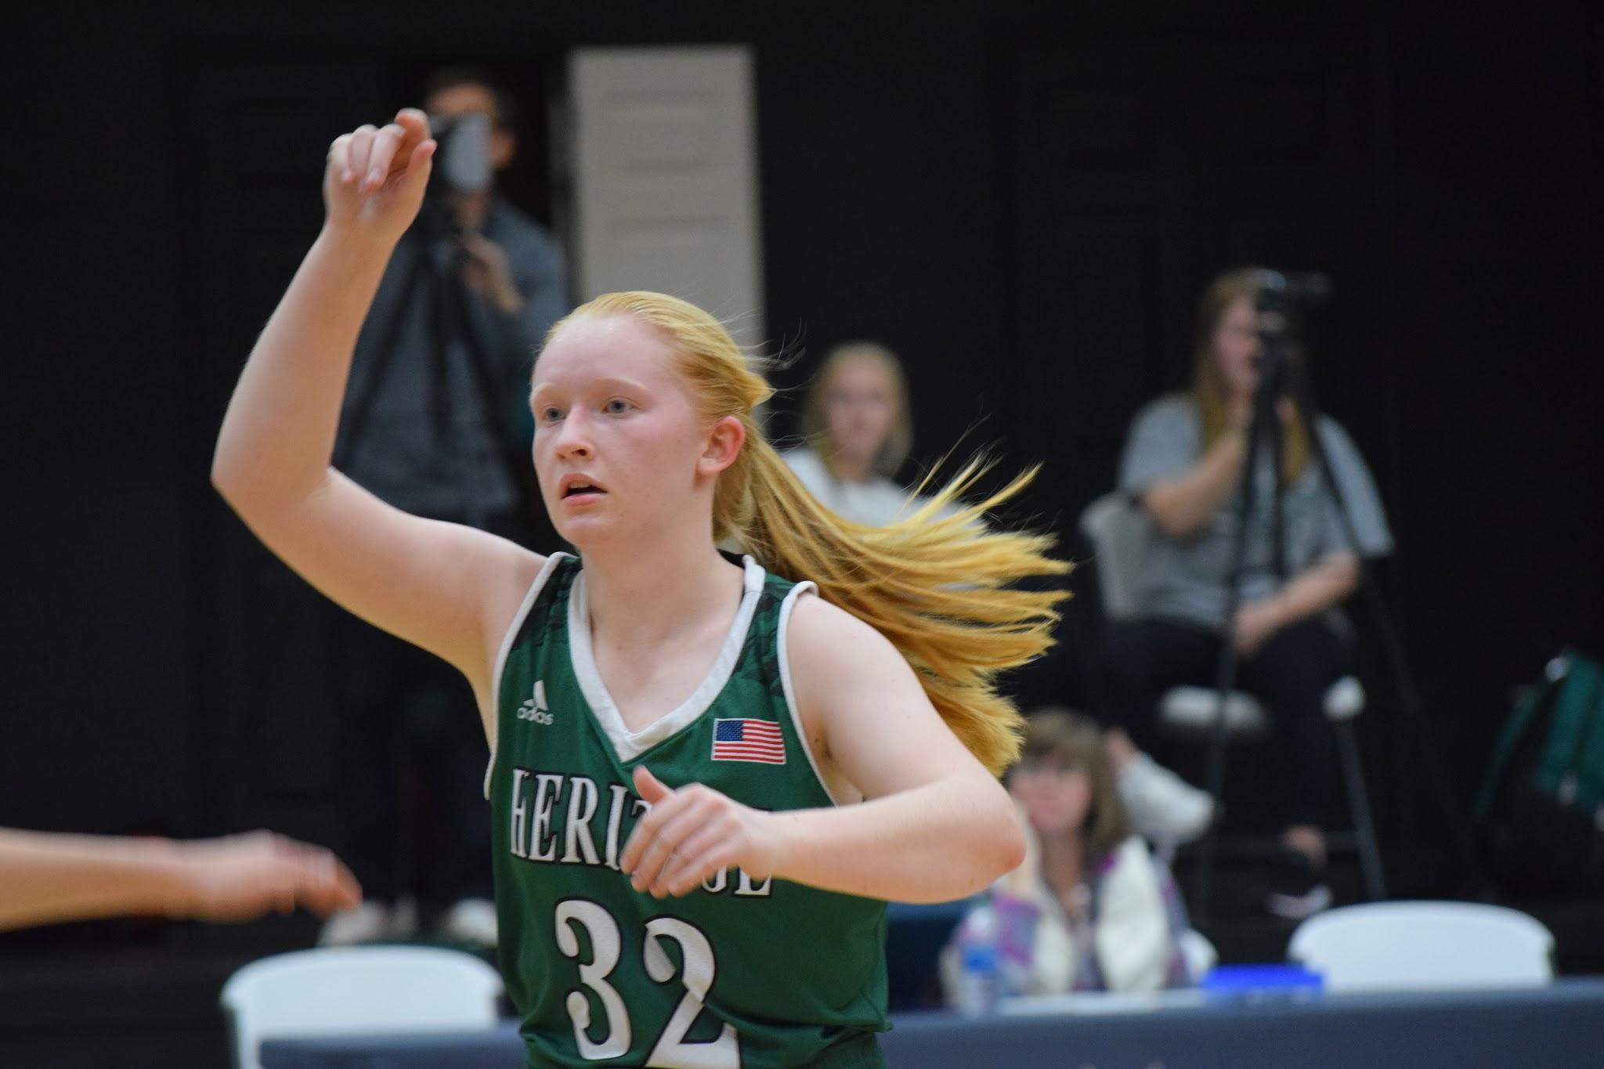

District Most Valuable Player
Josie Fevig

1st team All District
Madison Brantley
Caroline Abel
Kate Abel

2nd team All District
Alivia Jons
Lilah Brillhart

Honorable Mention
Hannah Bray
Brooke Chastain

2nd team All State
Josie Fevig

Academic All State
Josie Fevig
Alivia Jons

Logic Girls Basketball

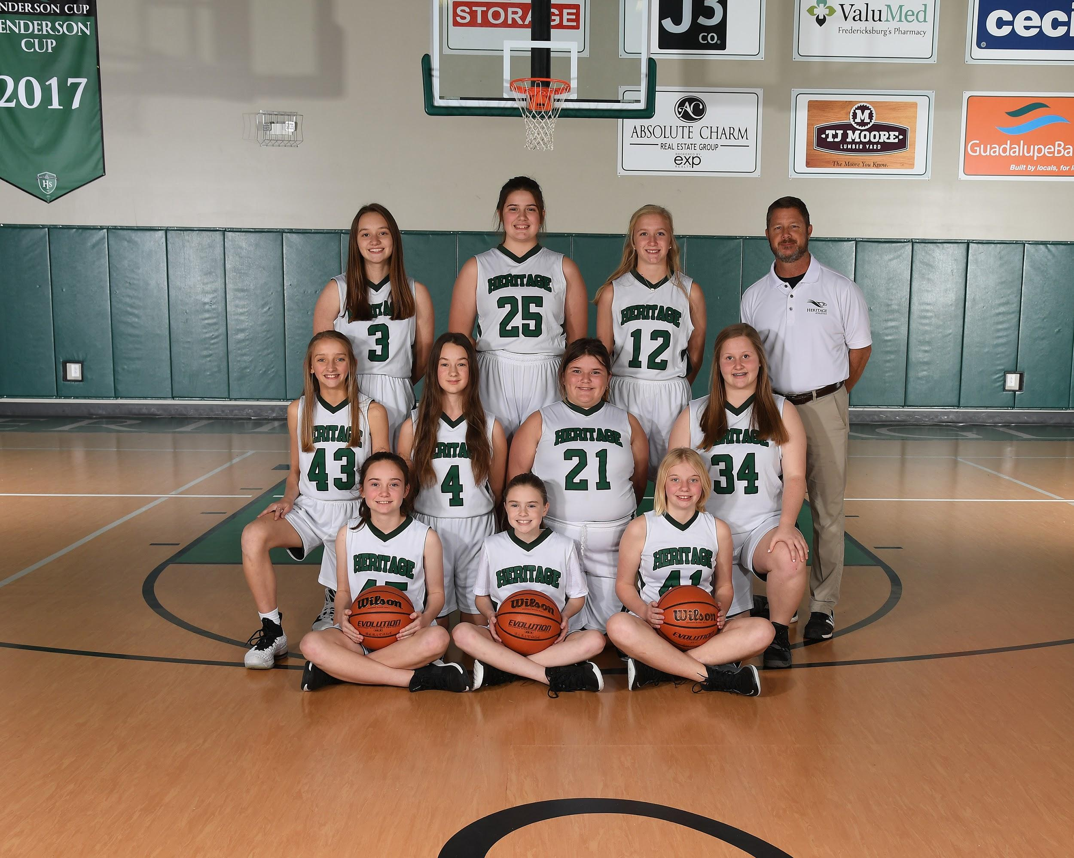
Standing L to R Jadan Edwards, Eleanor Loggie , Ellie Shipman, Head Coach Tim Shipman
Kneeling L to R Lilli Bray, Ella Rose Brillhart, Sofia Janc, Acelynn Thomson
Sitting L to R Reece Harris, Aubrey Roberts, E. B. Stollenwerck
not pictured Co-Head Coach Kevin Perez

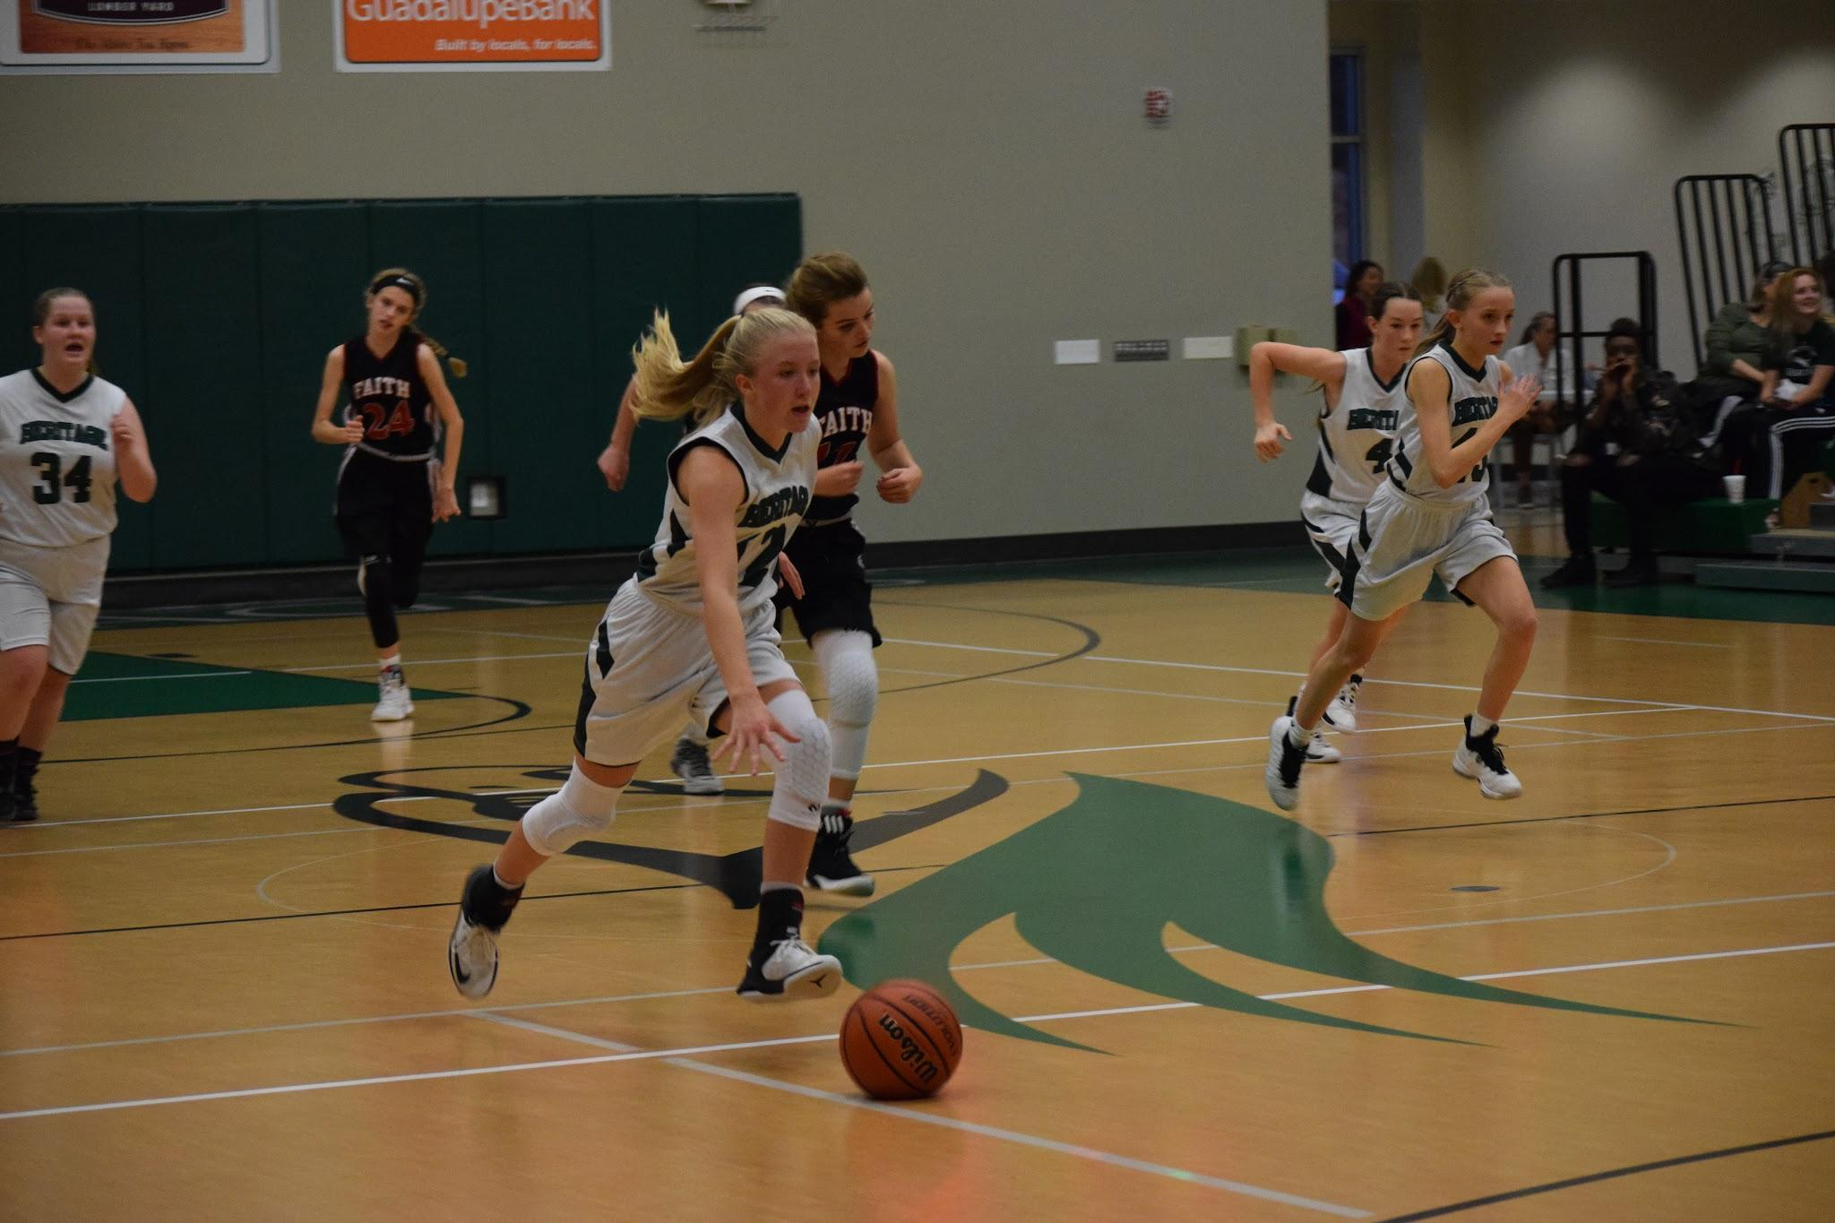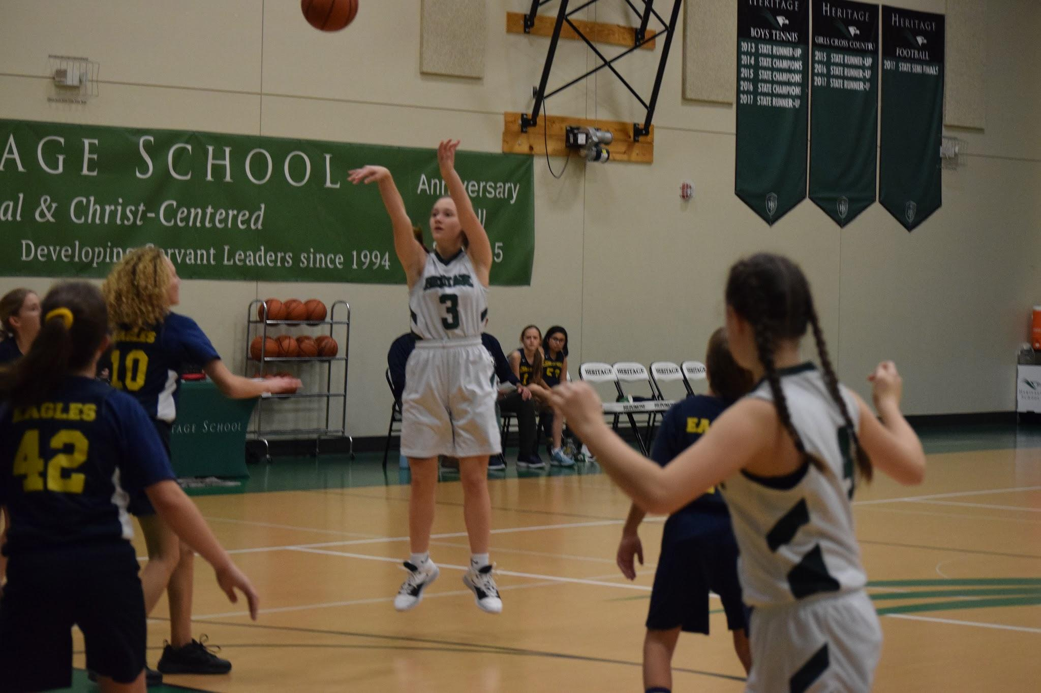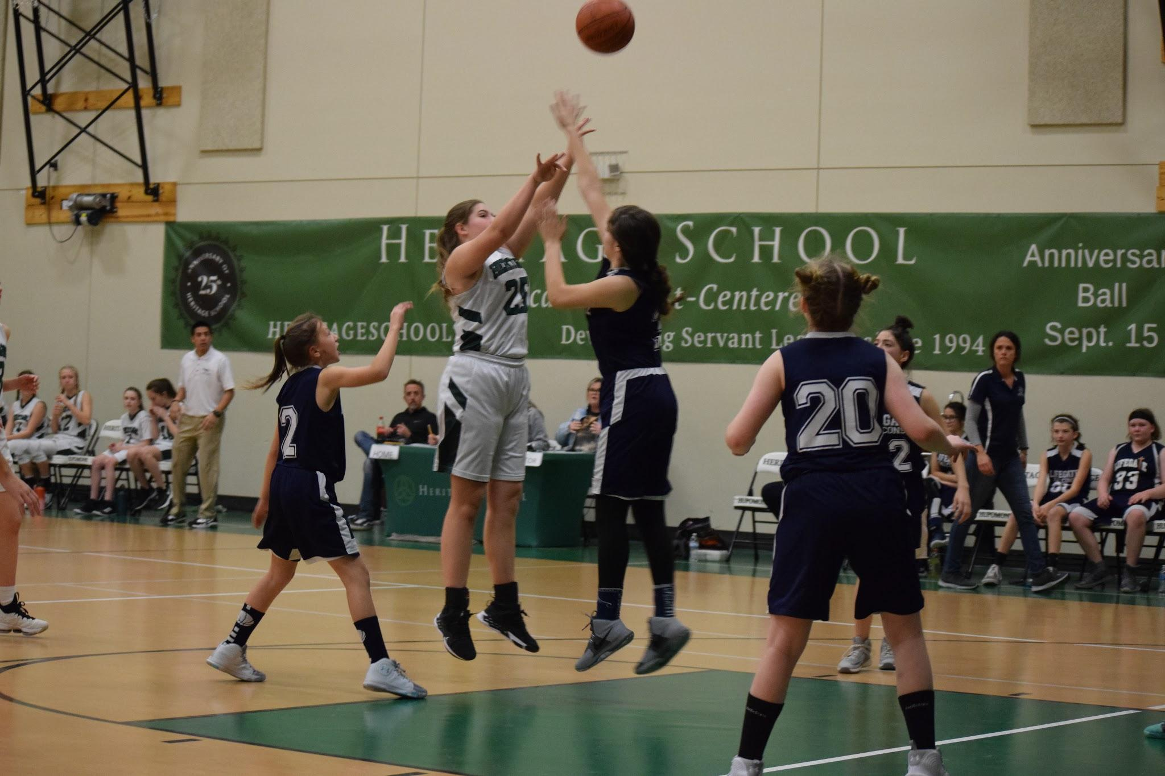

CALSA Girls Basketball CHAMPIONS
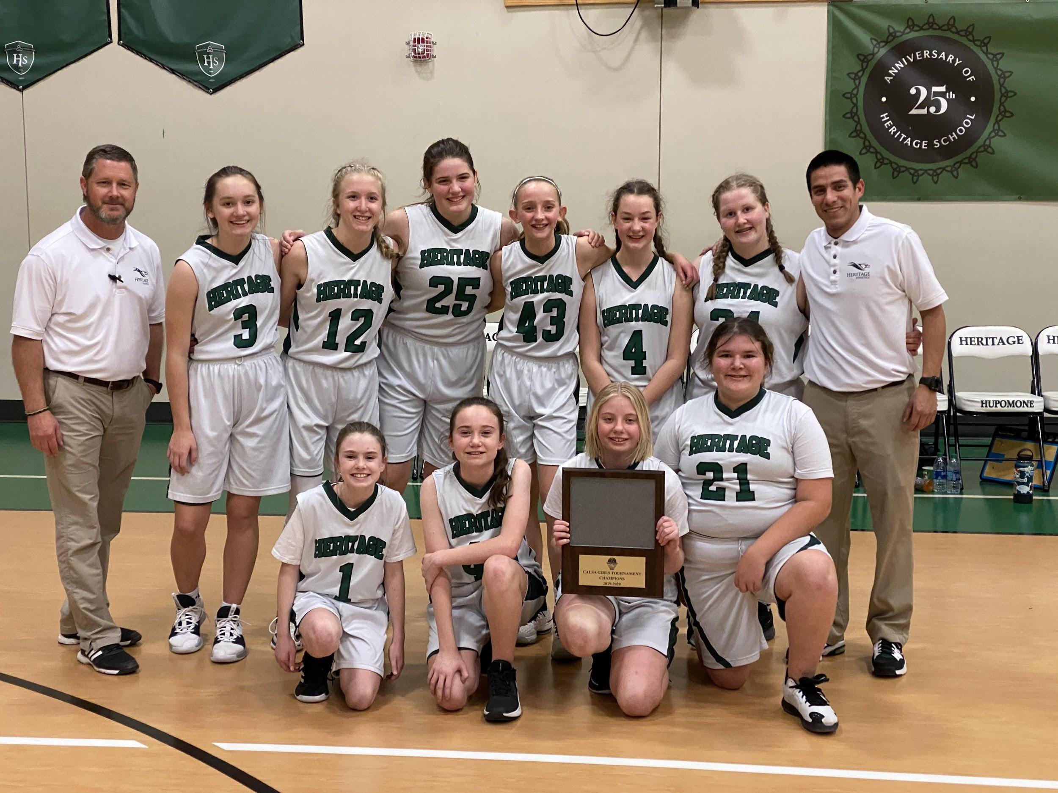

CALSA All Tournament Players
Ellie Shipman
Lilli Bray
Eleanor Loggie

Varsity Boys Basketball

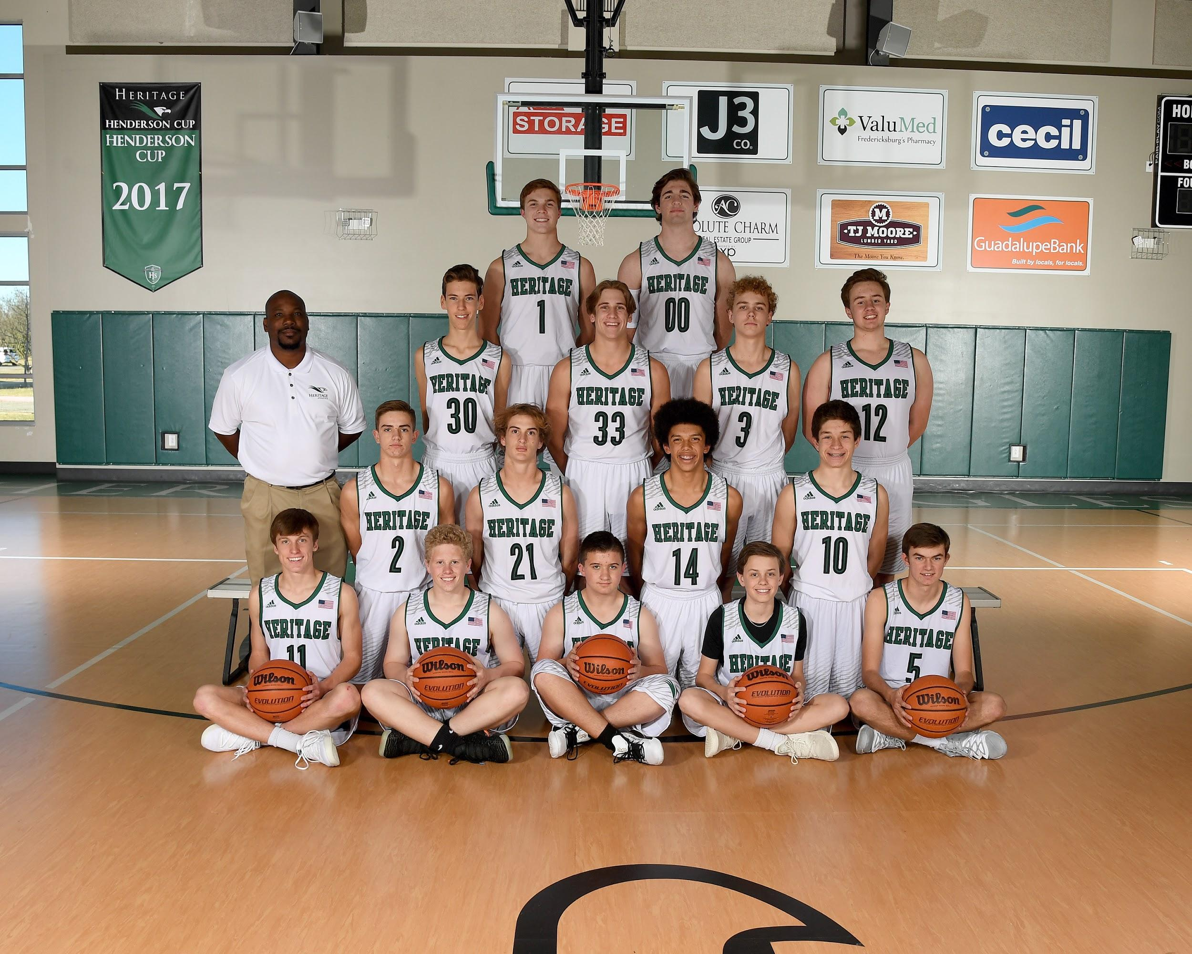
Sitting L to R Sam Richburg, Reece Thomson, Gage Nelson, Jake Roberts, Joshua Tabor
Kneeling L to R Caden Bray, Finn Sawtelle, Jack Henderson, Rory Shelton
Standing L to R Head Coach Clarence Stewart, Alex Ludwig, Noah Given, Luke Roberts, Aidan Hickey
Top Row Joshua Hoermann, John Fritzsch

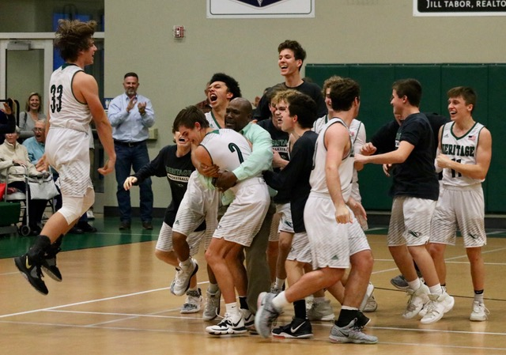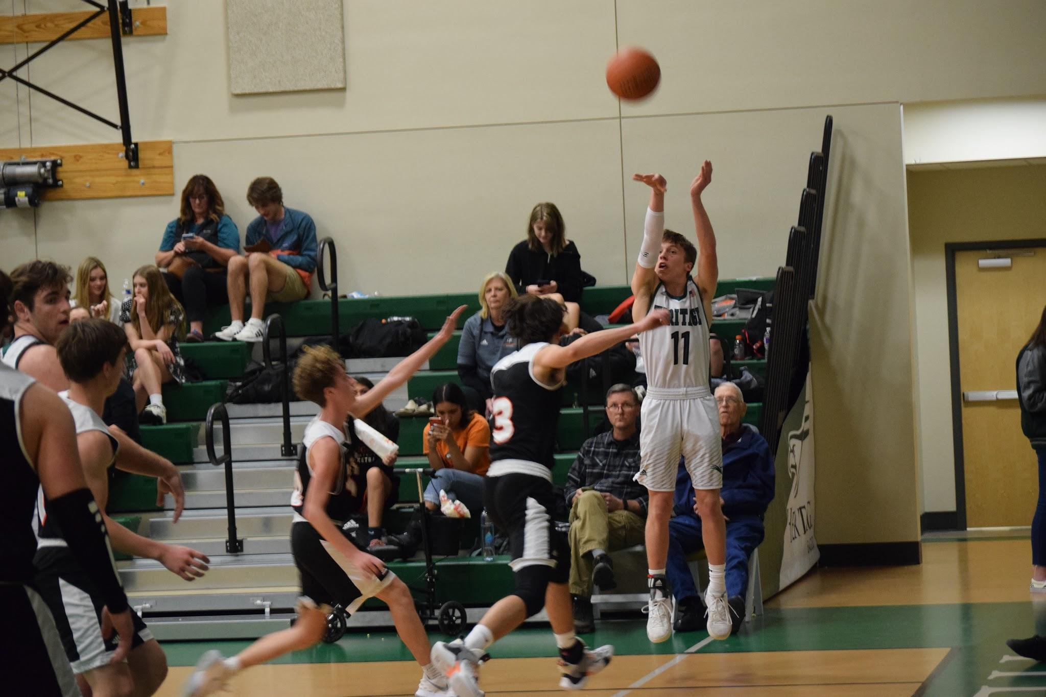

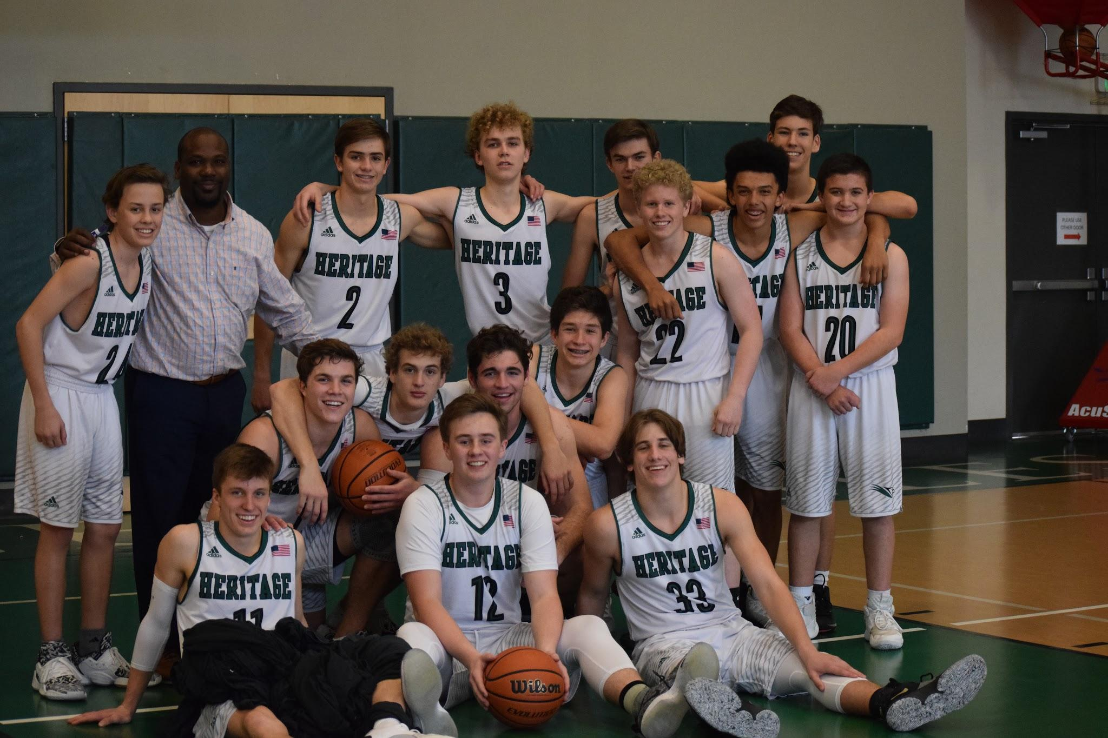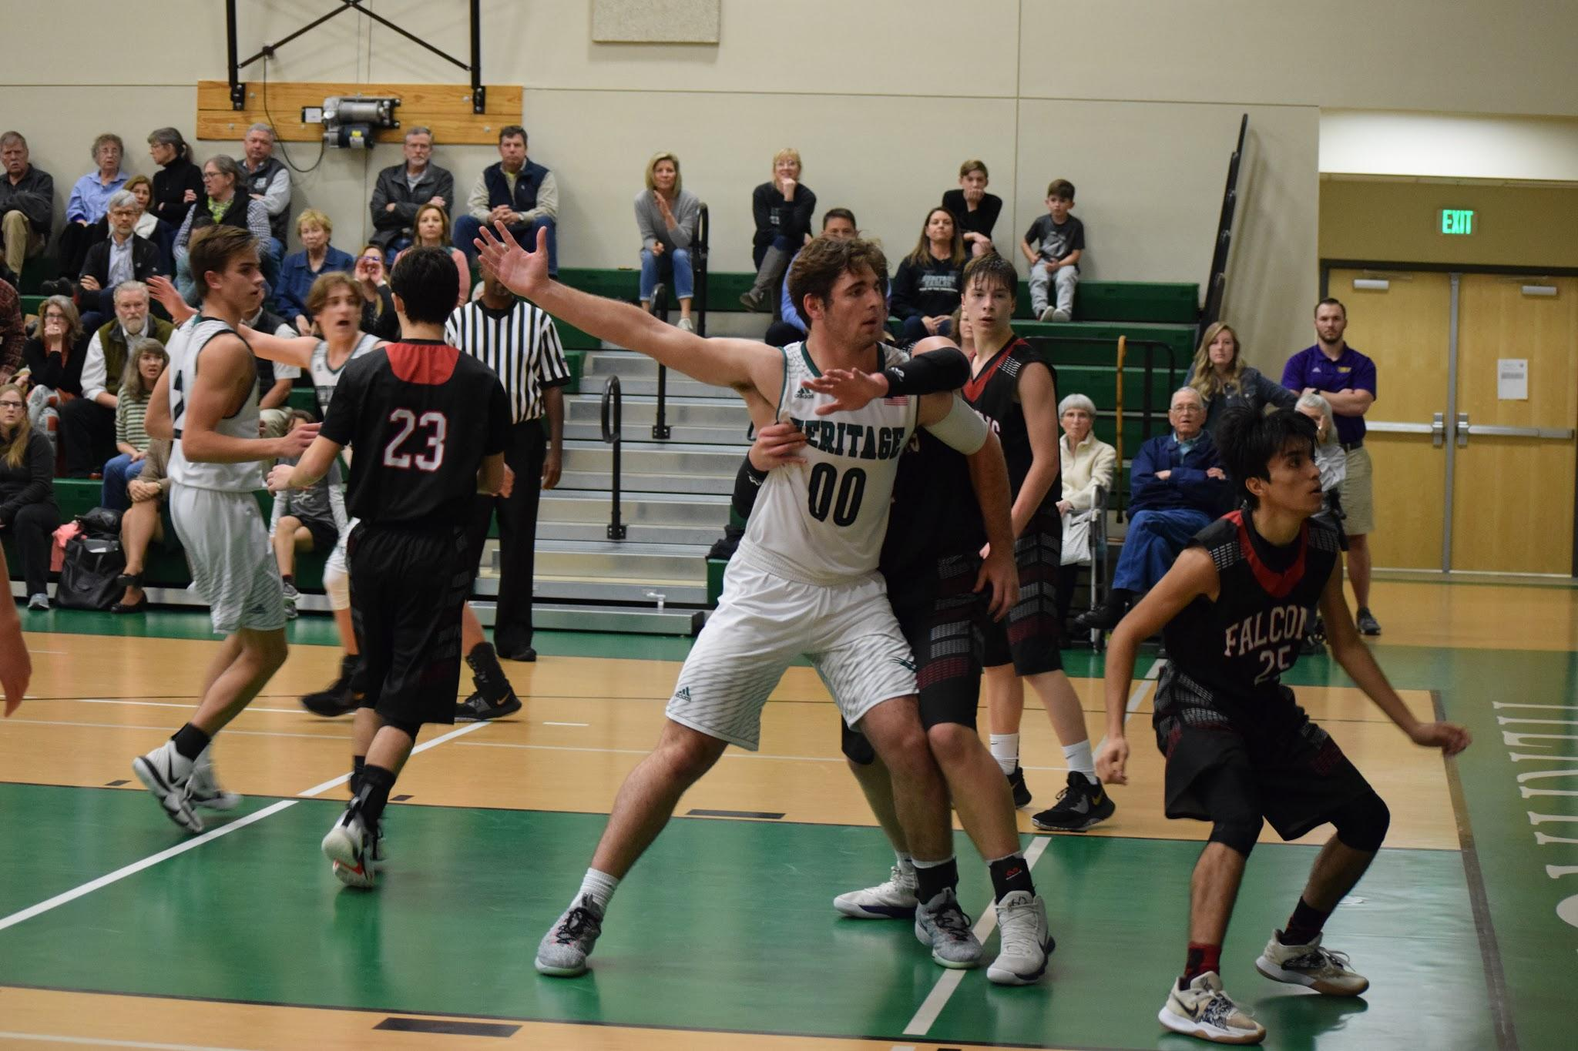

District Champs
Area Champs

1st team All District
Joshua Hoermann
John Fritzsch
Sam Richburg

2nd team All District
Noah Given
Luke Roberts
Finn Sawtelle
Caden Bray
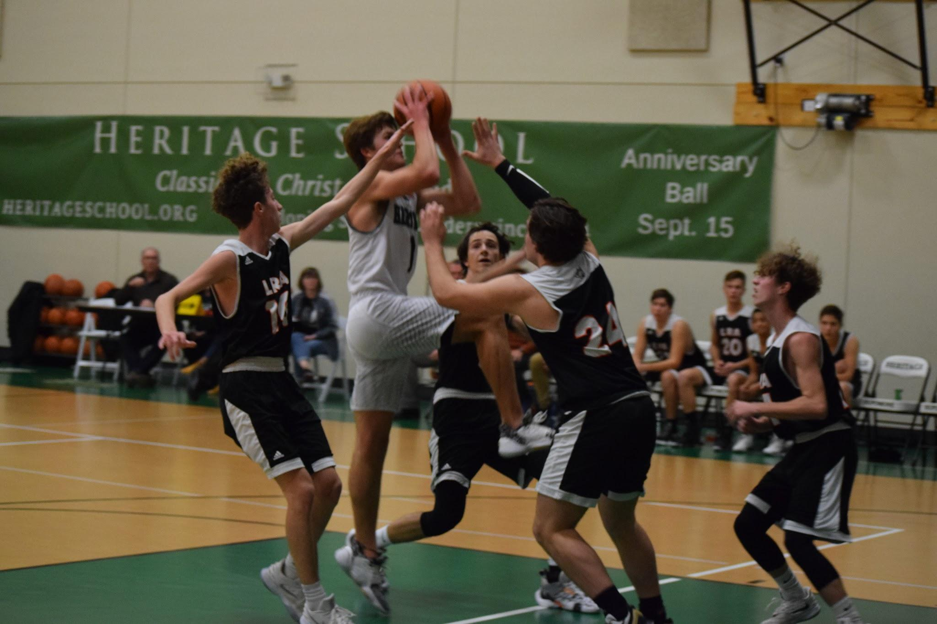
2nd Team All State
Joshua Hoermann

Academic All State
Noah Given
Luke Roberts
Sam Richburg
Joshua Hoermann
Finn Sawtelle

Logic Boys Basketball

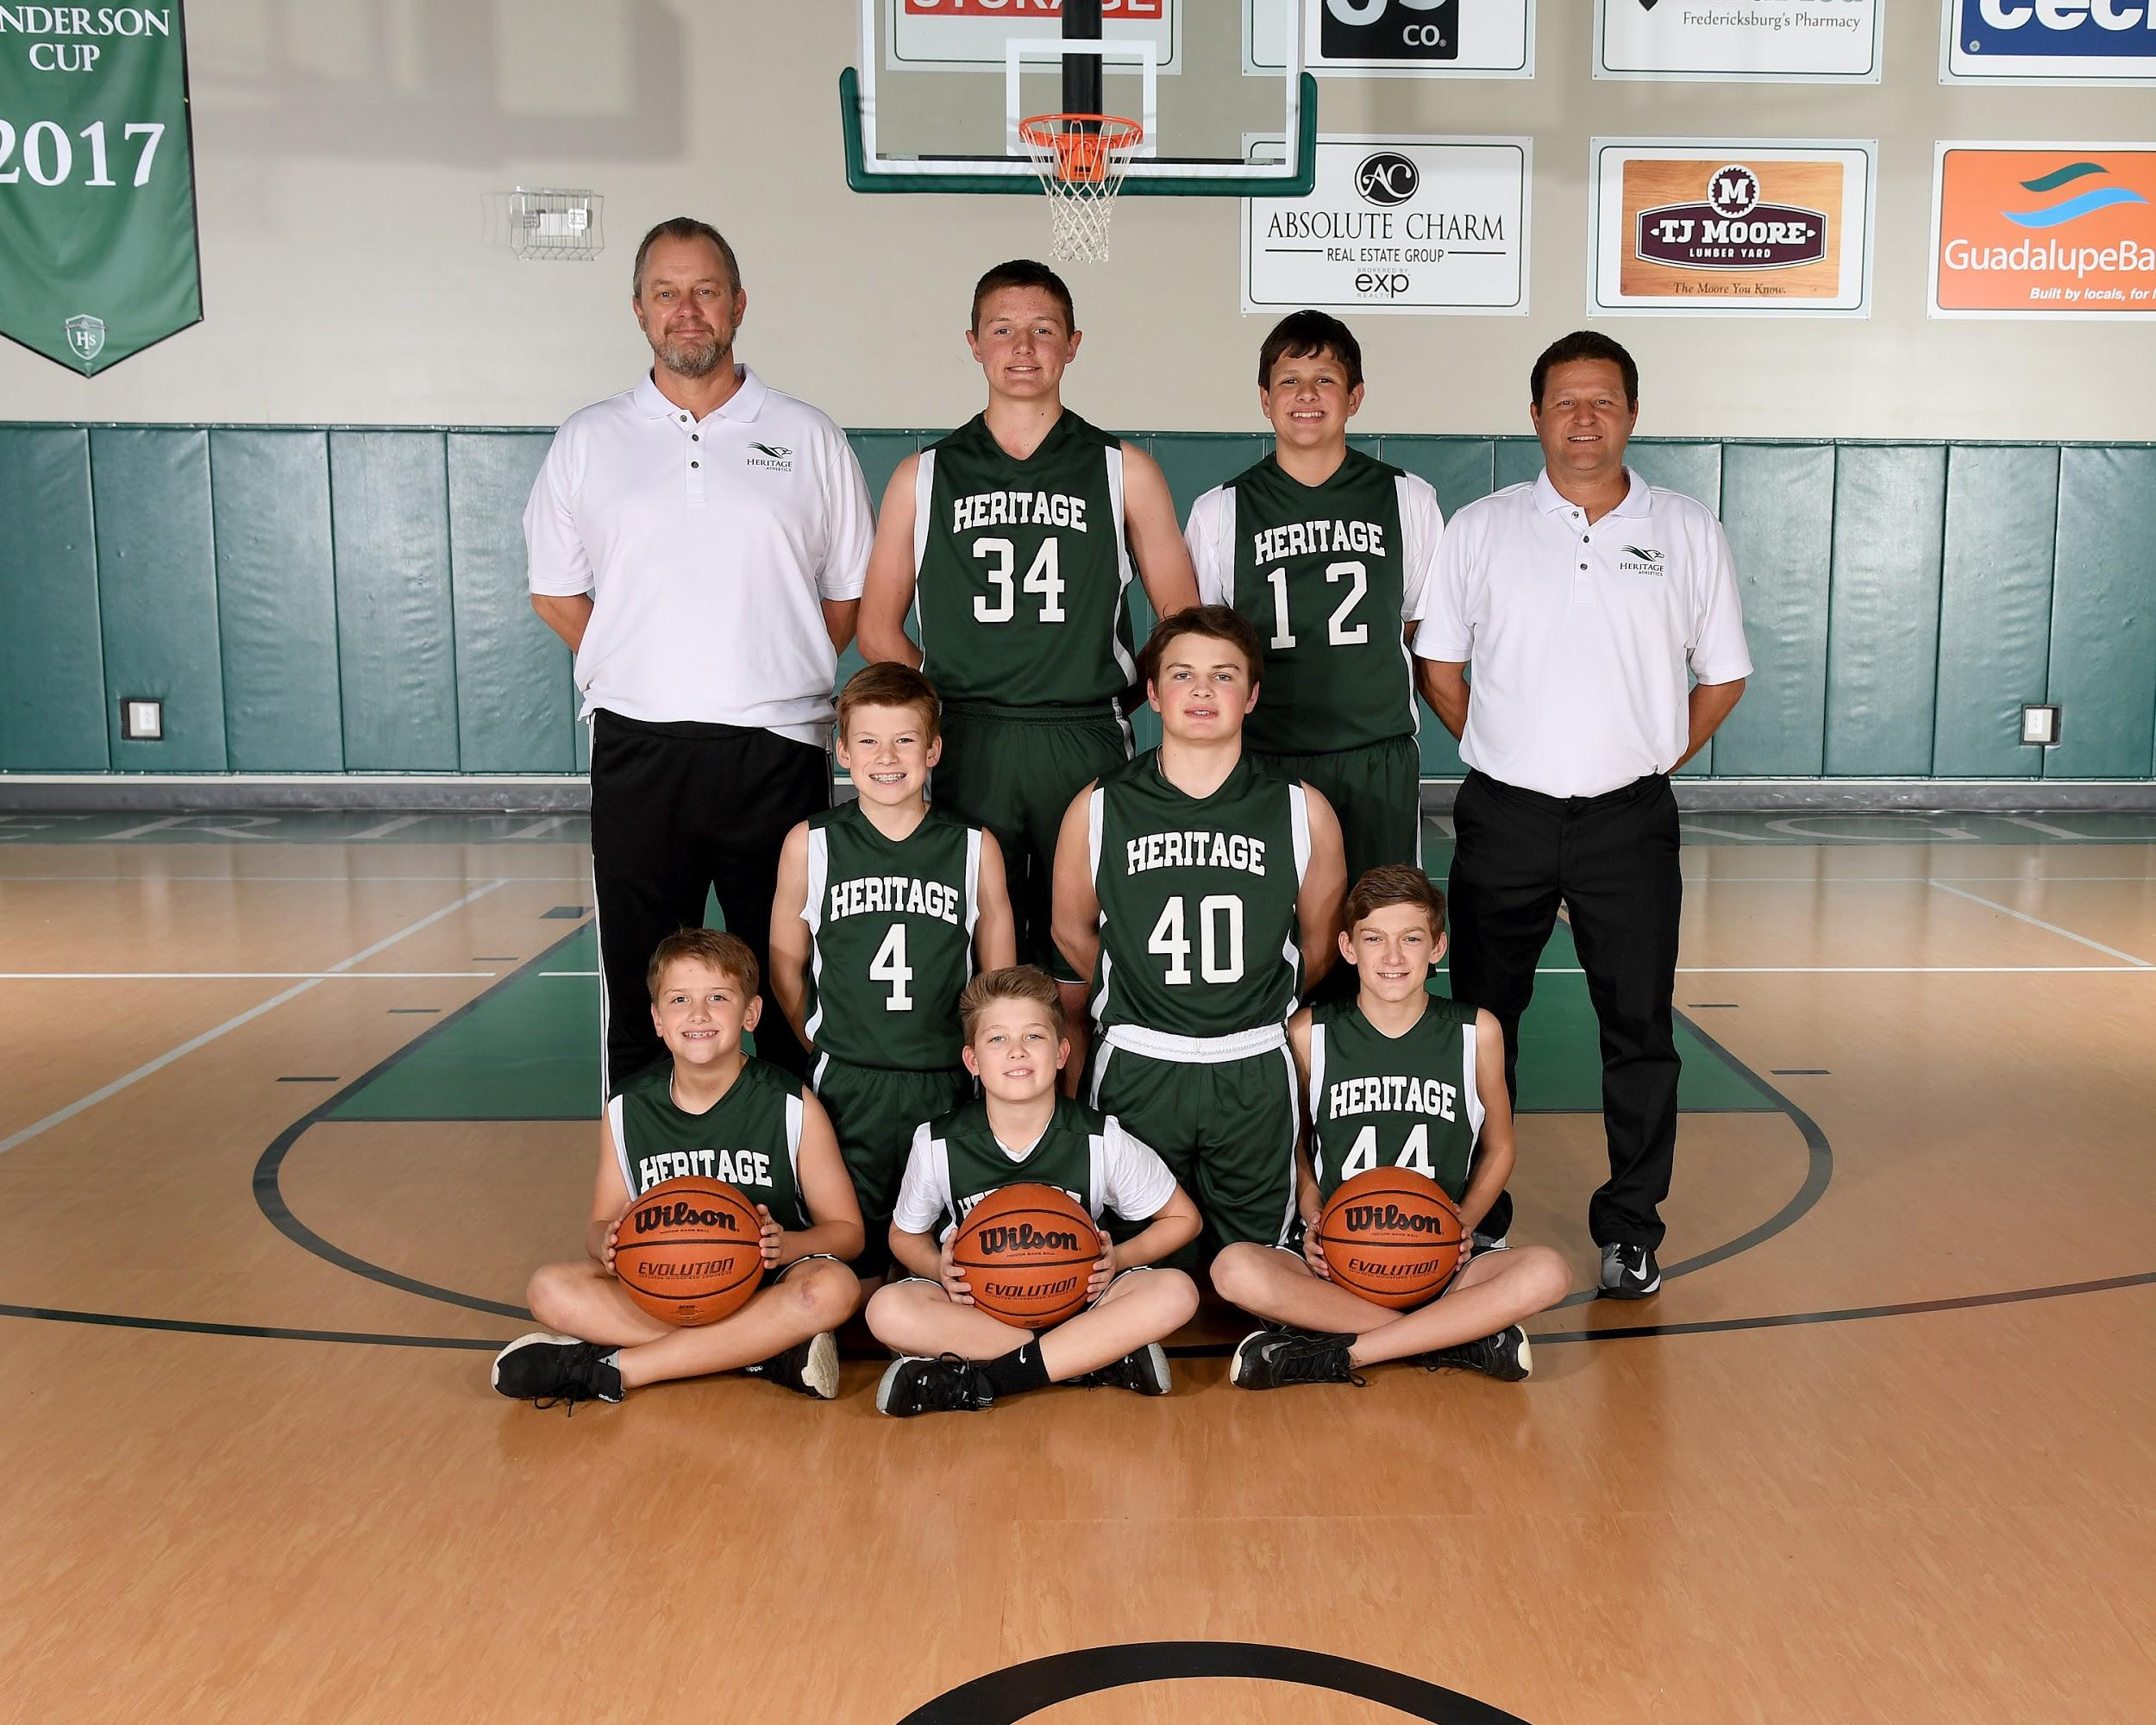

Sitting L to R Gage Varwig, Garrett Gentry, Benjamin Tabor
Kneeling Tristan Roberts, Tres Jons
Standing Asst. Coach Jim Hickey, C. J. Barnett, Tanner Tippens, Head Coach Chris Moldenhauer
Not Pictured Trace Atkinson

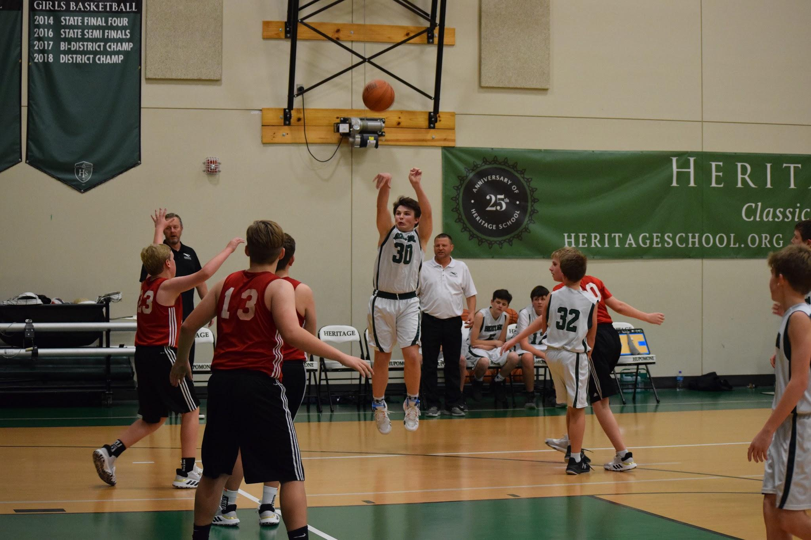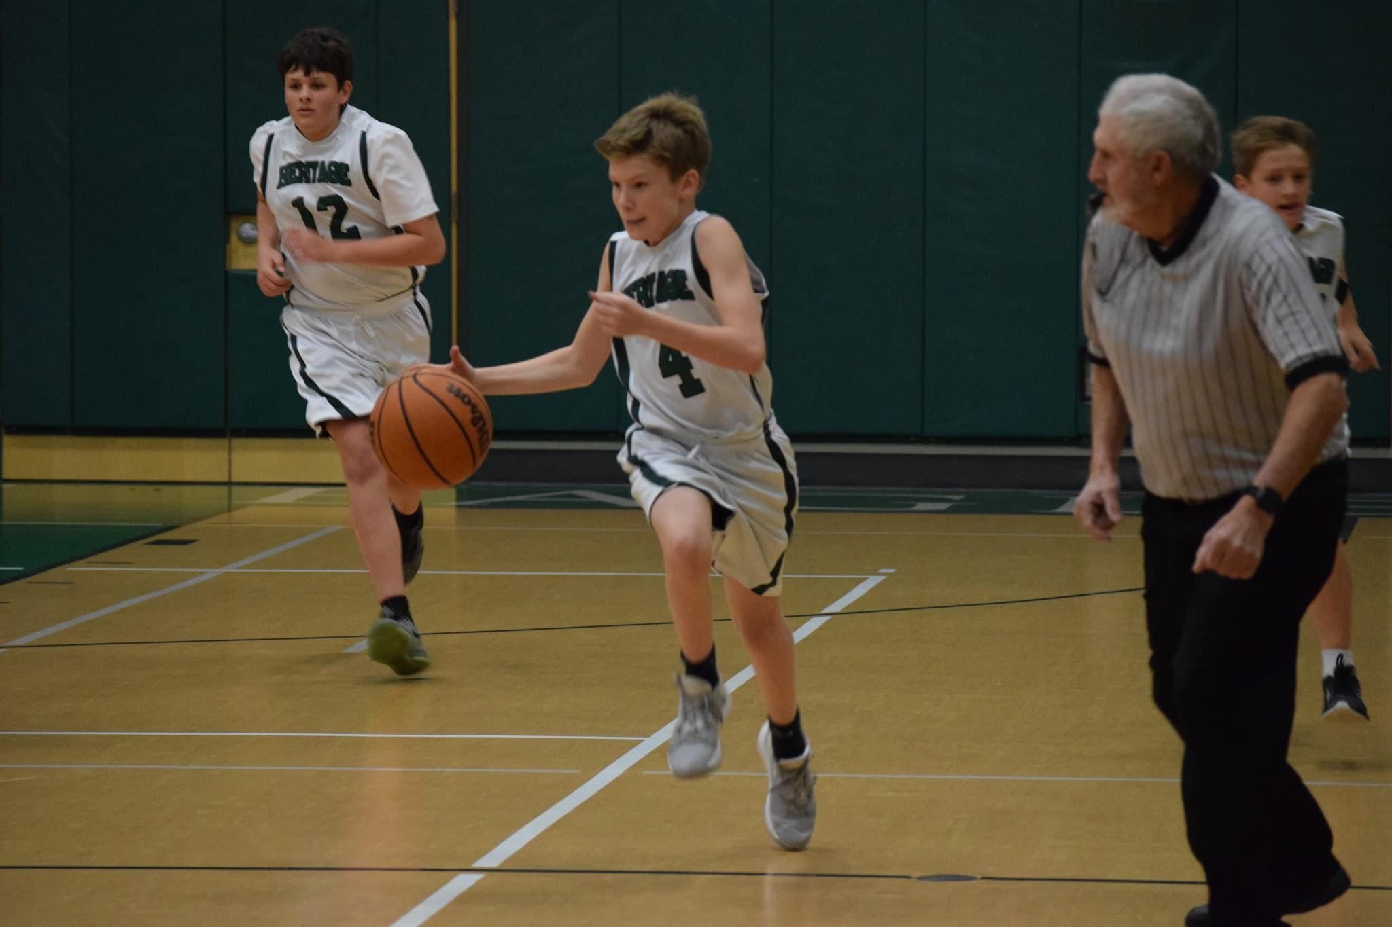

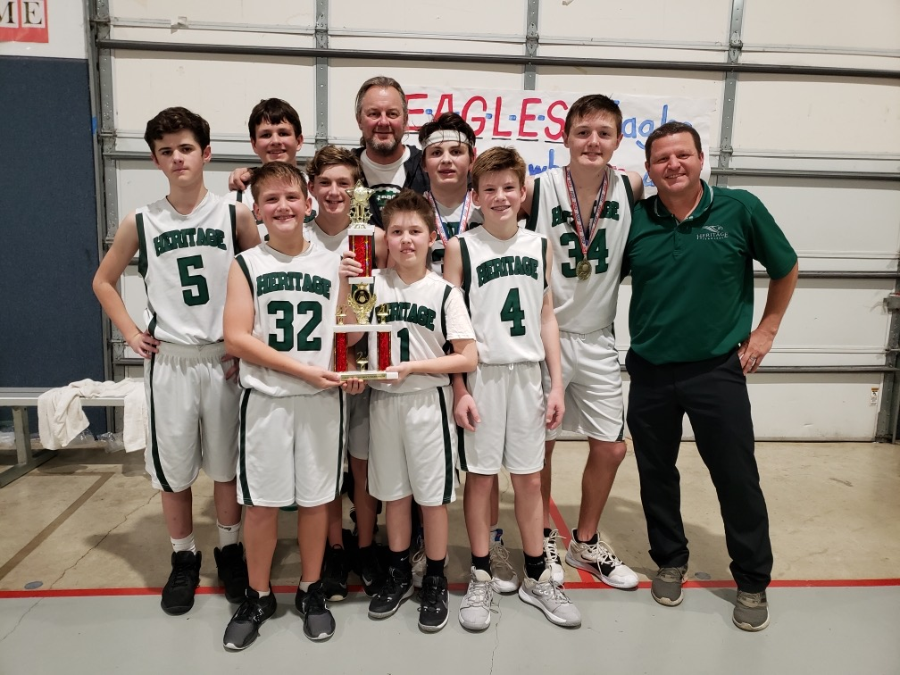

CALSA Division 1 Boys Runner Up
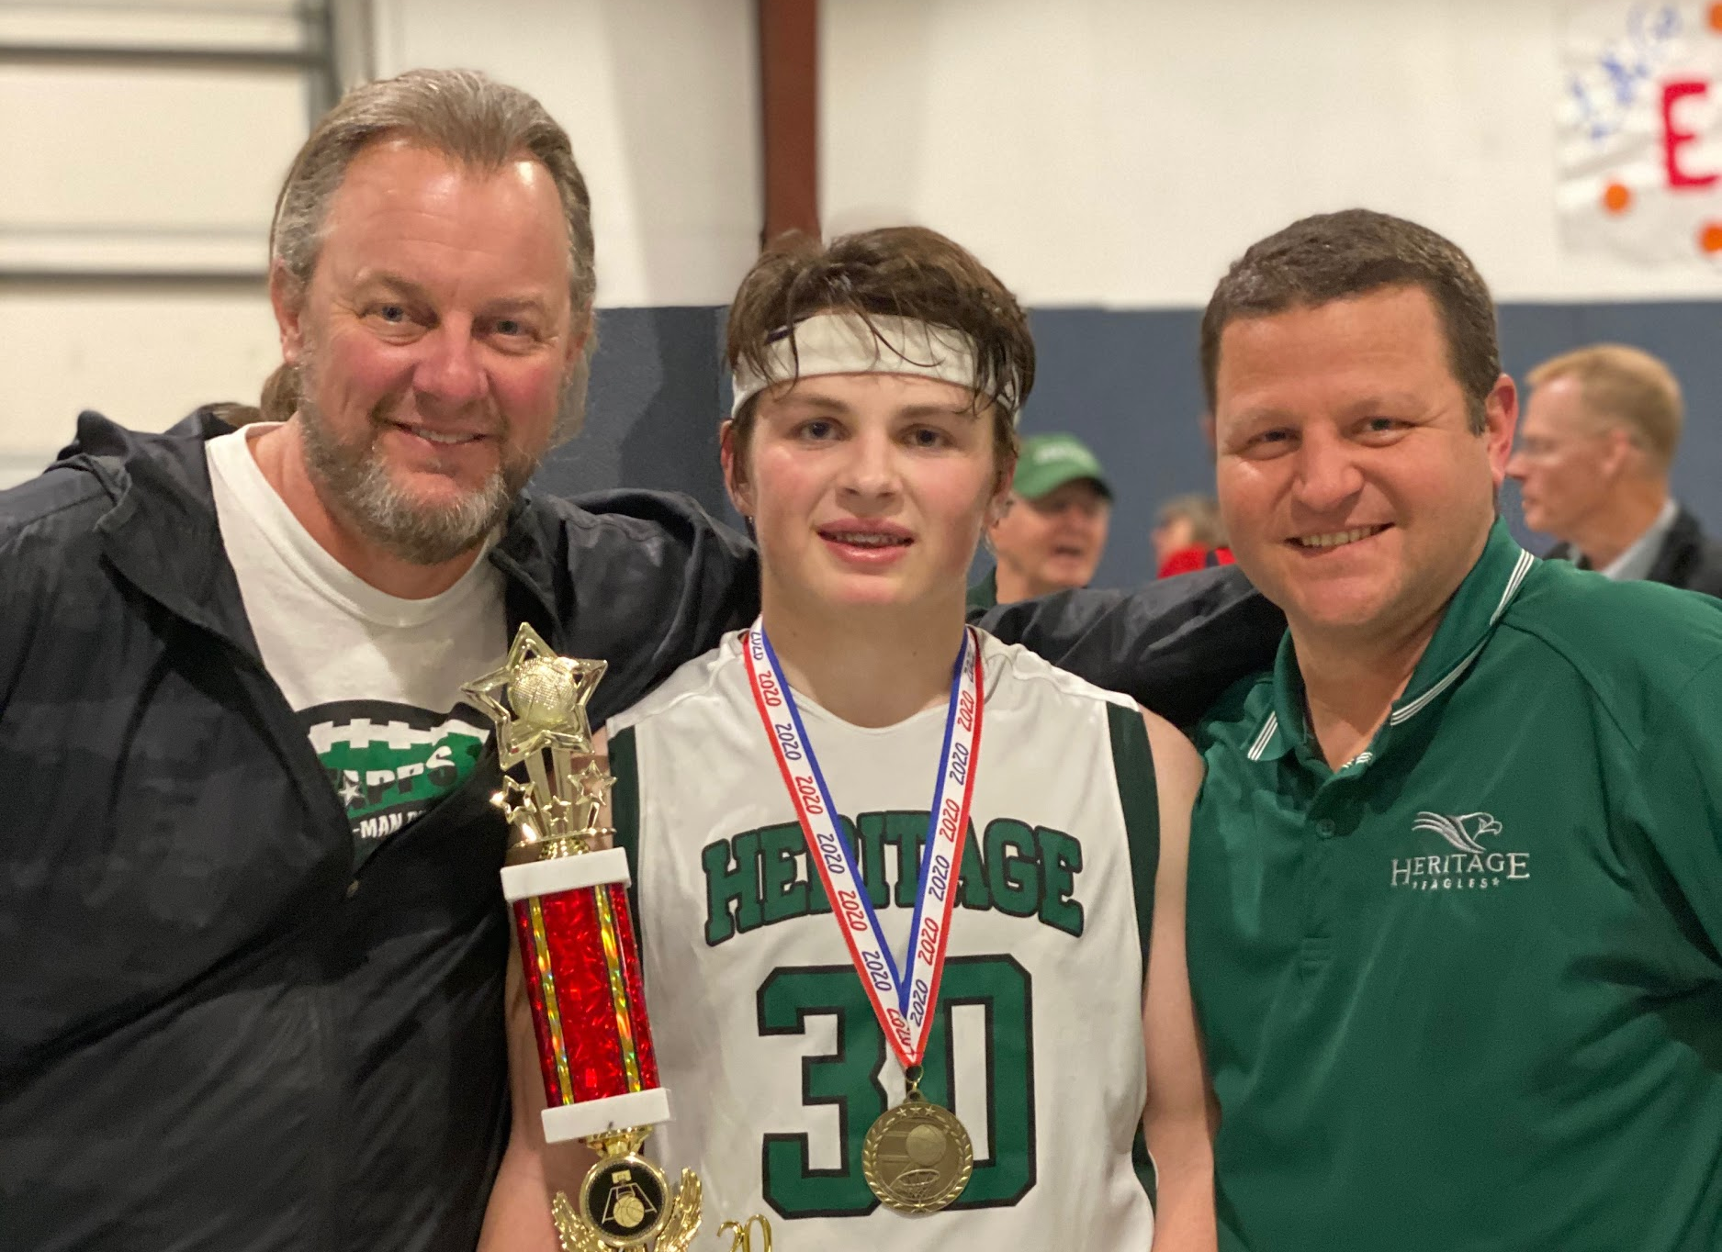 CALSA All tournament Players
C. J. Barnett
Tres Jons (shown)

Spring Sports disrupted by Covid 19

Logic Tennis
Head Coach Kyler Stephens
Asst. Coach Levi Wilkins

Bree Franklin
Grace Roeder
Izzy Pair
Sophia Shelton
Terah Tucker
Jailee Goodman
Taylor Harris
Ellison Keller
Aubrey Roberts
Jadan Edwards
Acelynn Thomson

EB Stollenwerck
Reece Harris
Eleanor Loggie
Ella Rose Brillhart
Jack Pedregon
Royce Pair
Trace Atkinson
Tristan Roberts
Garrett Gentry
Benjamin Tabor
CJ Barnett

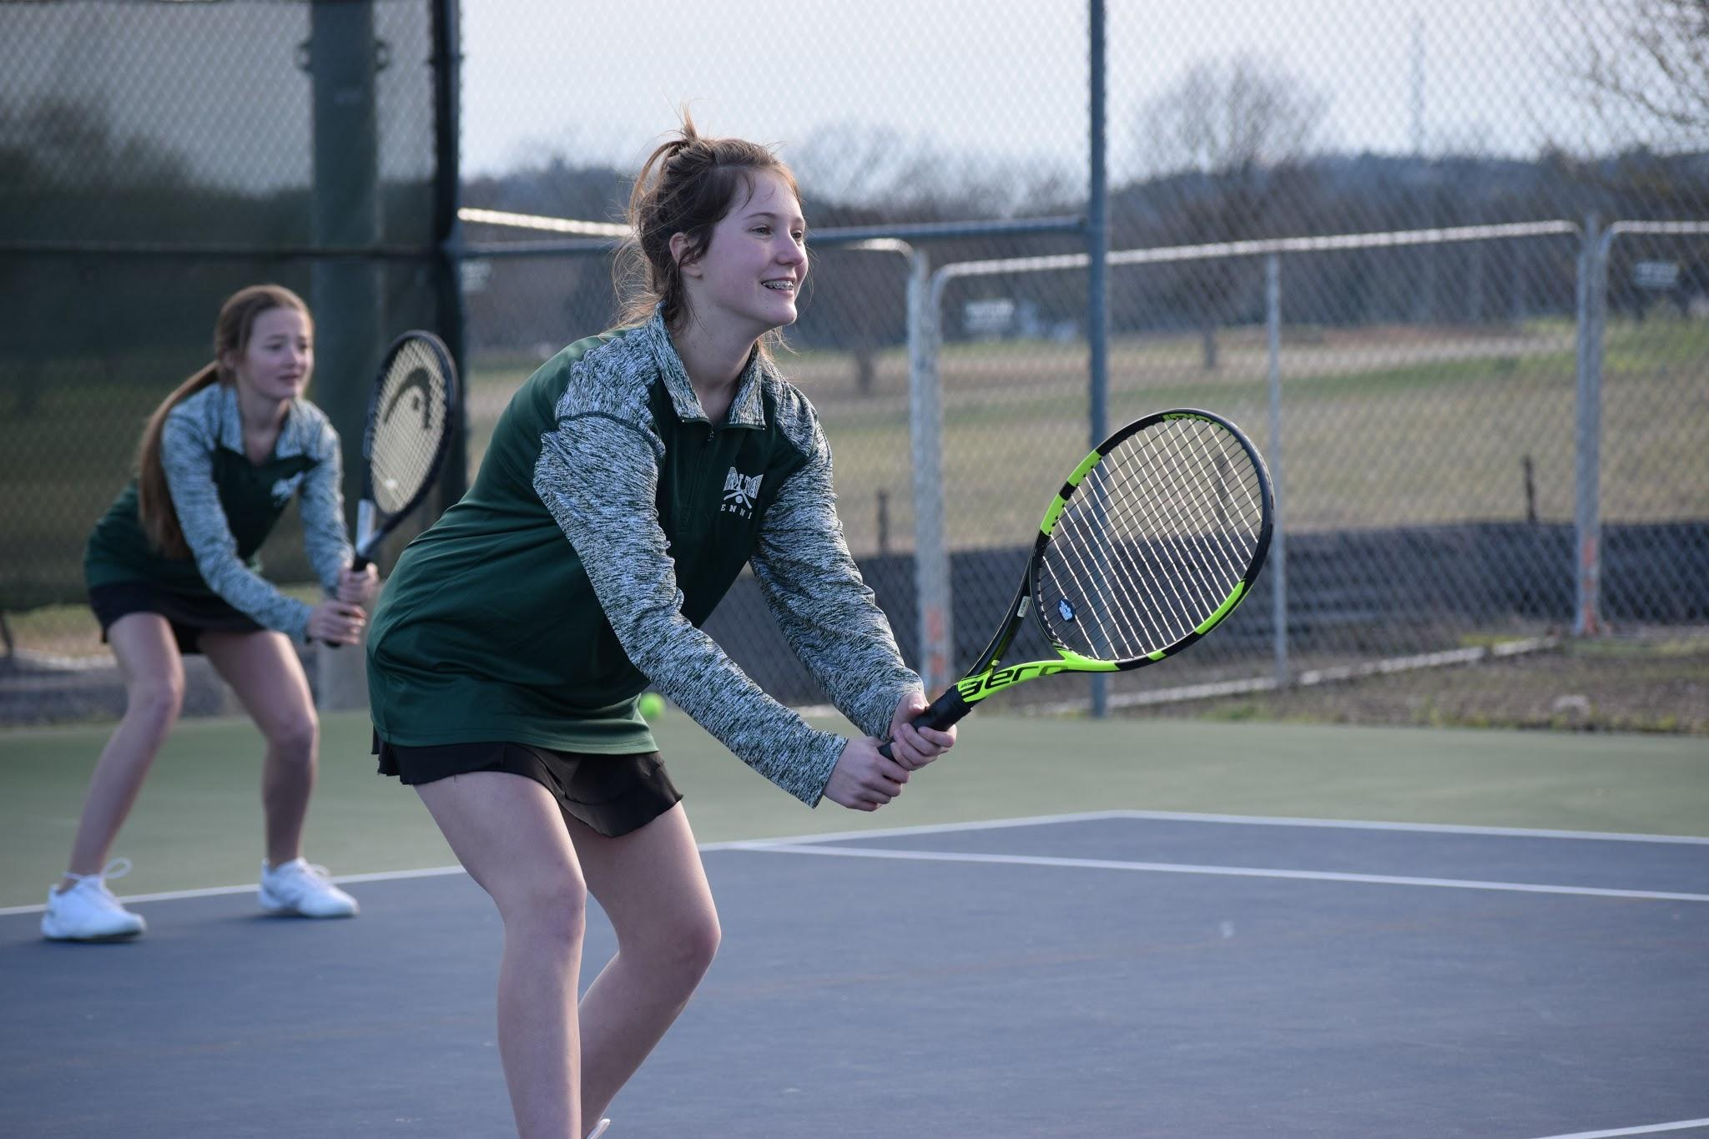

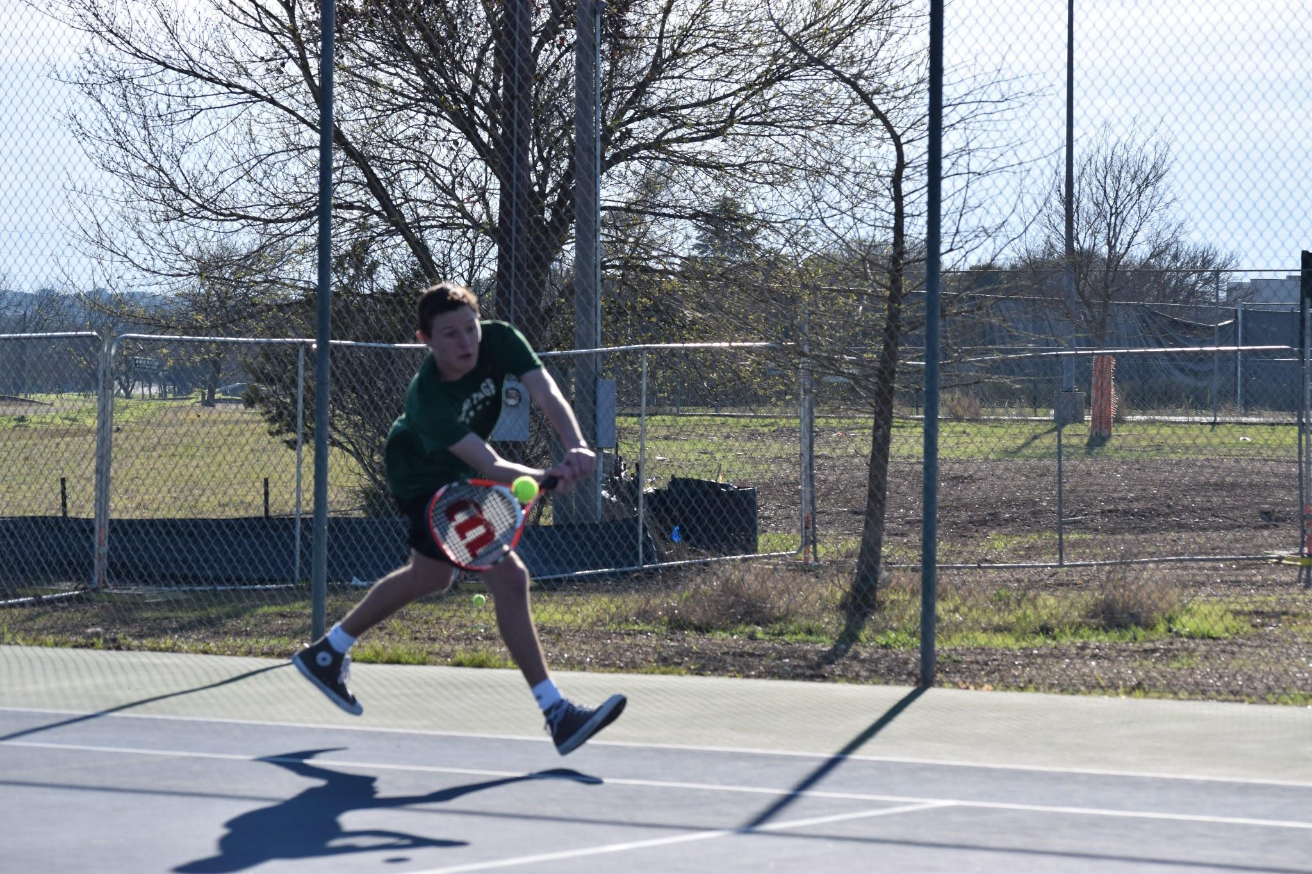

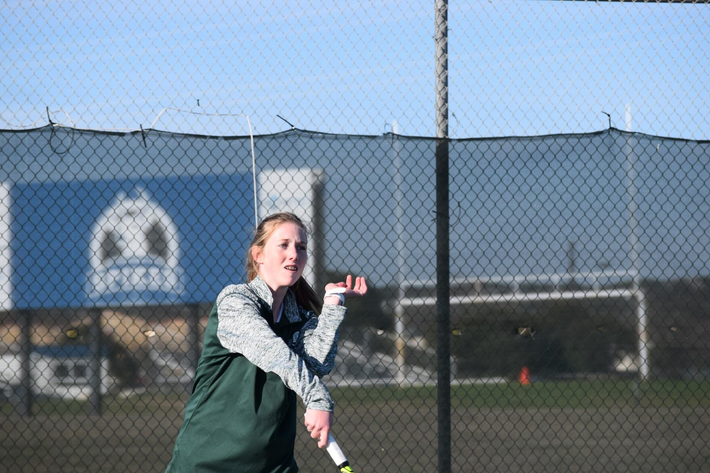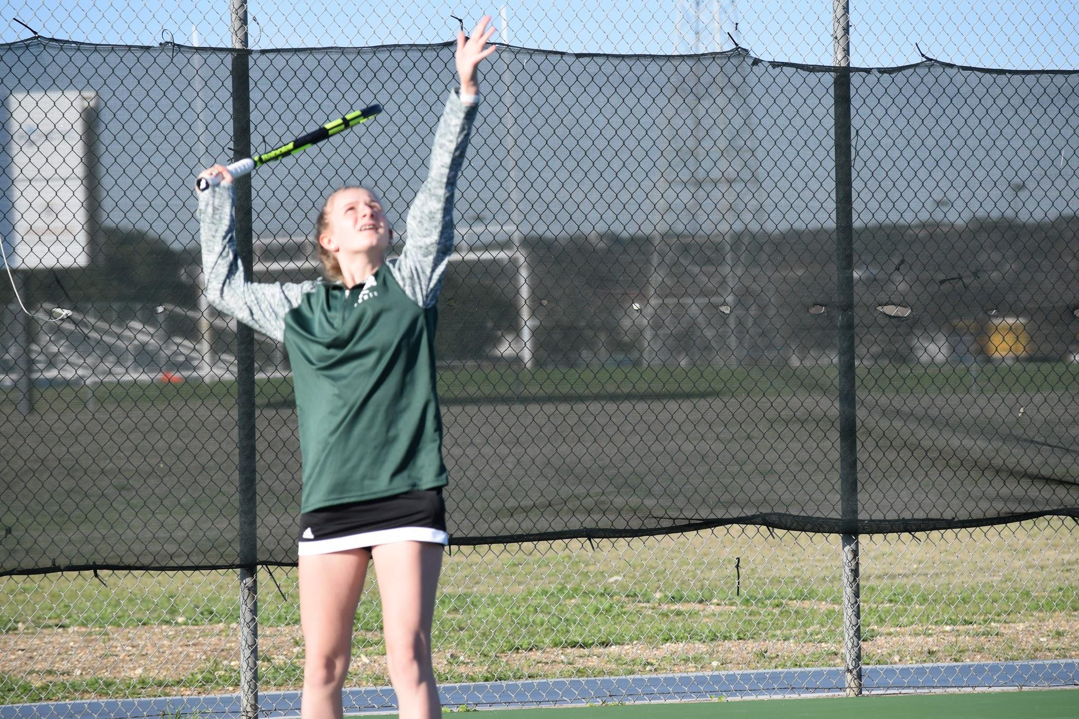
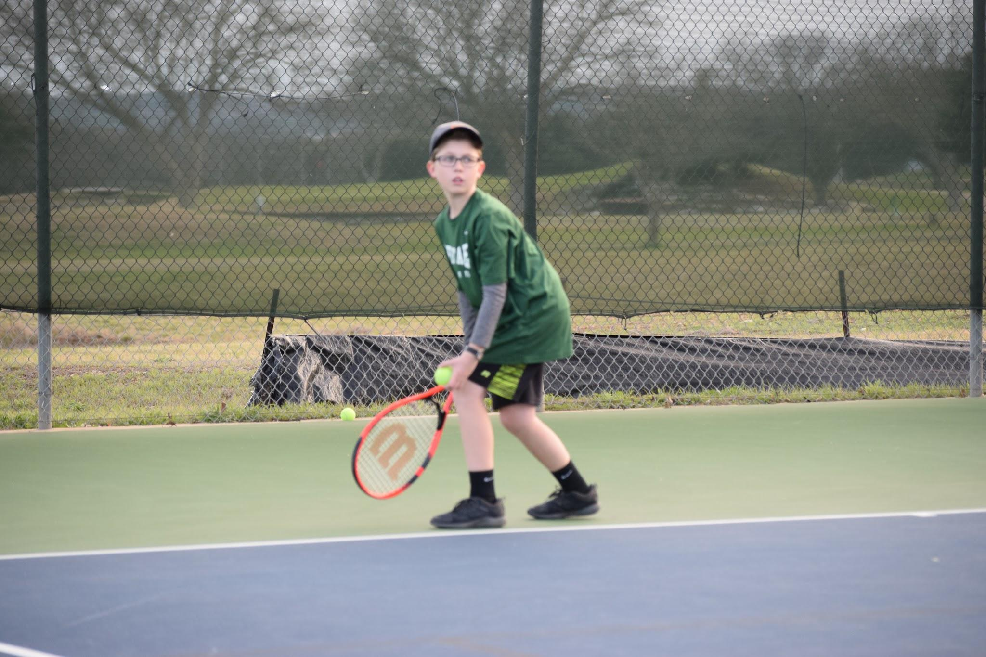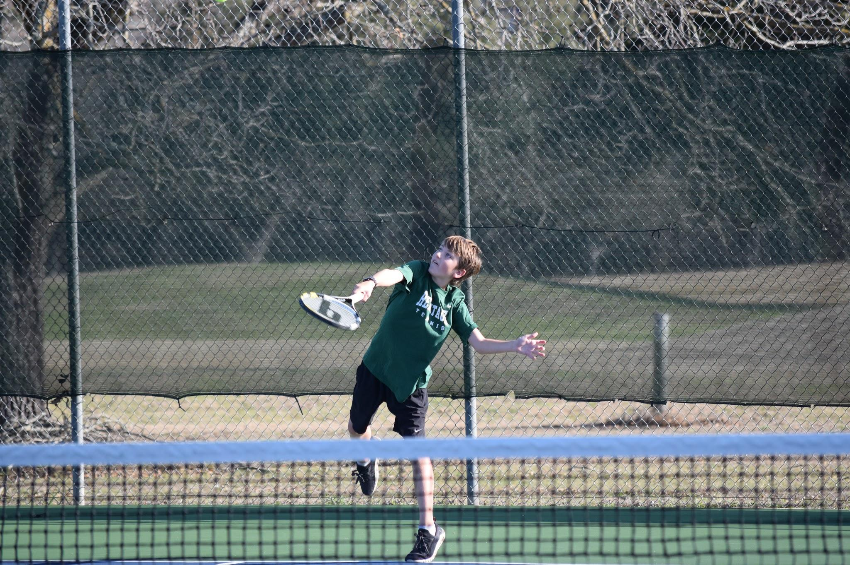

Logic competed in one dual match with Notre Dame prior to Covid

Varsity Tennis

Isabella Bourtin
Erin Fritzsch
Gage Nelson
Jake Roberts
Sam Cowsar
Andrew Chapa
Reece Thomson

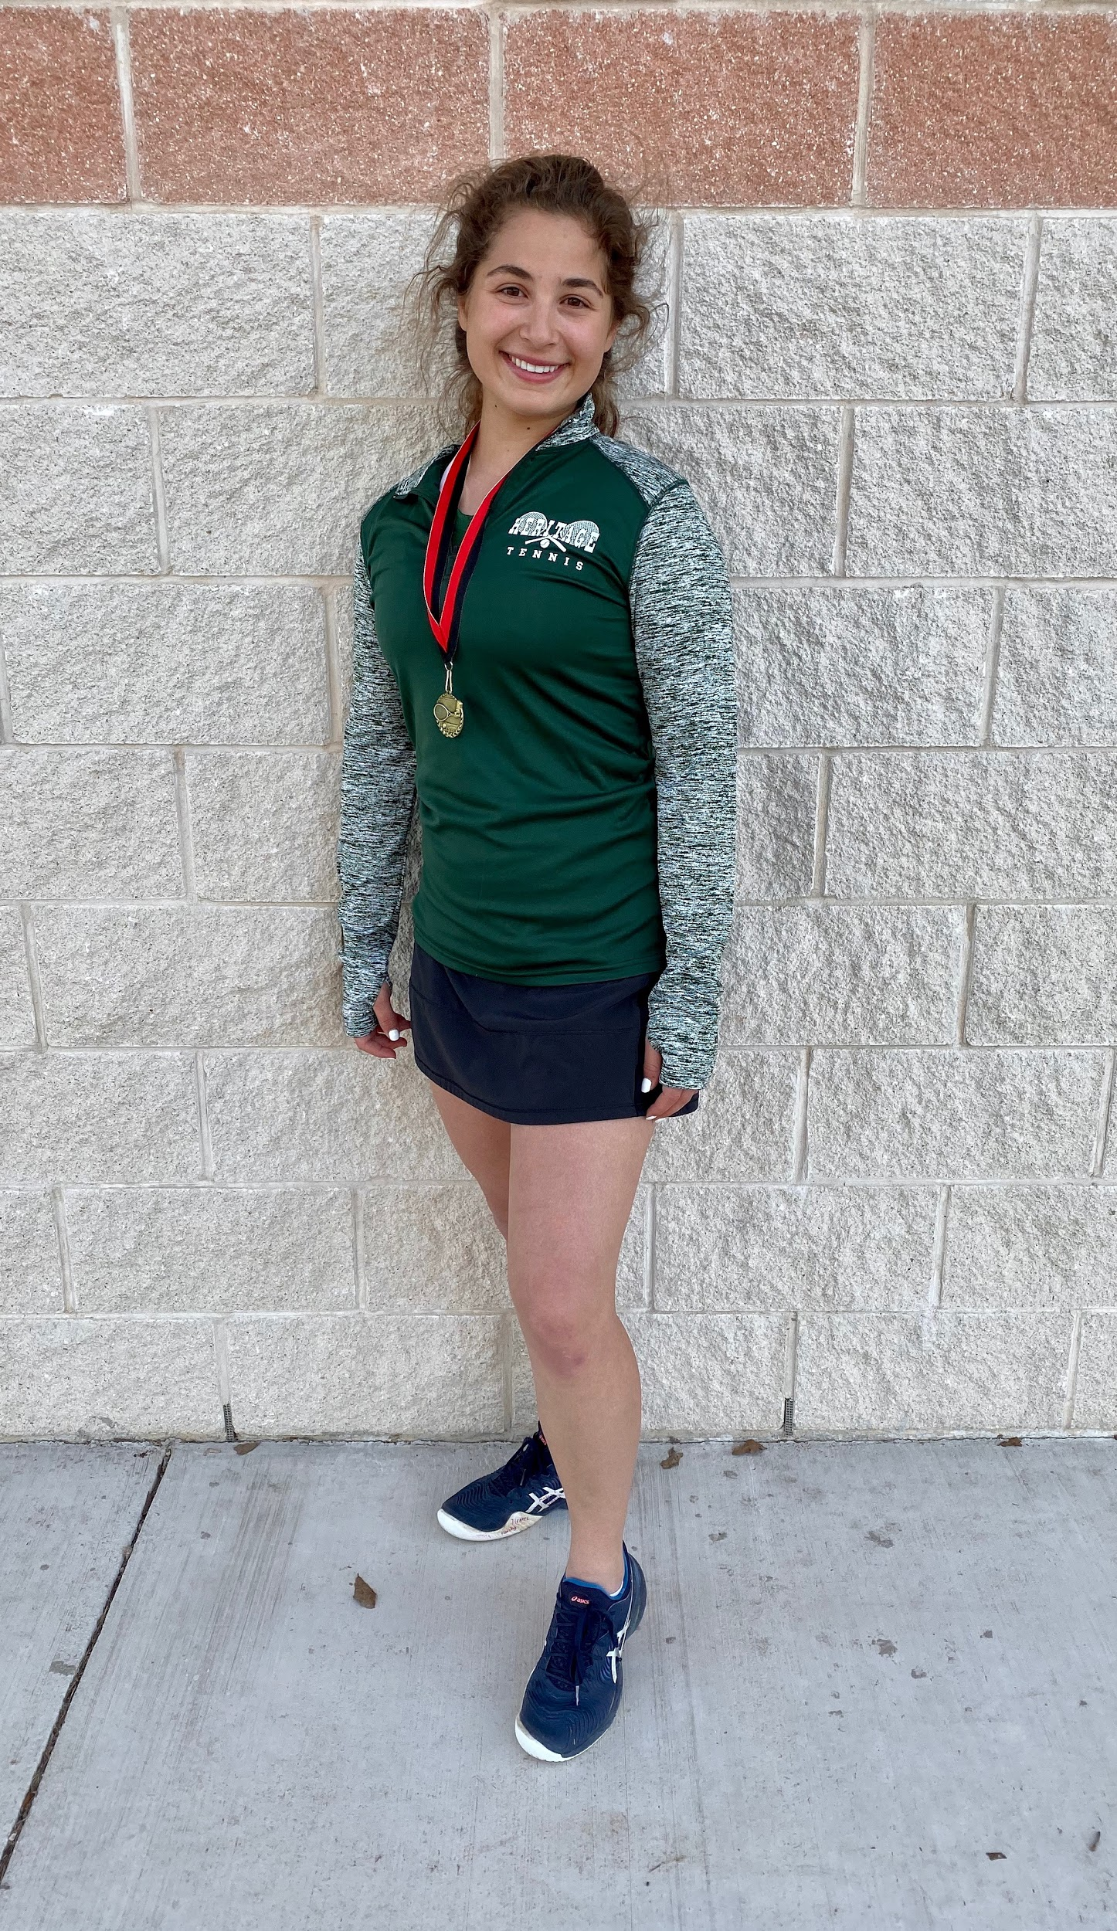
Isabella Bourtin won two early season tournaments prior to Covid

Varsity Track
Head Coach Kevin Perez
Asst. Coaches Tami Given, Tonya Morrow, Dr. Matt Hoermann, Jim Hickey

Mason Barnett
Hannah Bray
Lilah Brillhart
Livy Jons
Brooke Chastain
Kate Abel
Madison Brantley
Caroline Abel

Joshua Hoermann
Sam Richburg
Daniel Sauer
Eli Christensen
Noah Given
Aidan Hickey
Jack Henderson
John Fritzsch
Caden Bray
Rory Shelton
Alex Ludwig
Will Burnett
Joshua Tabor
Wes Burnett

Competed at Comfort Track meet prior to Covid

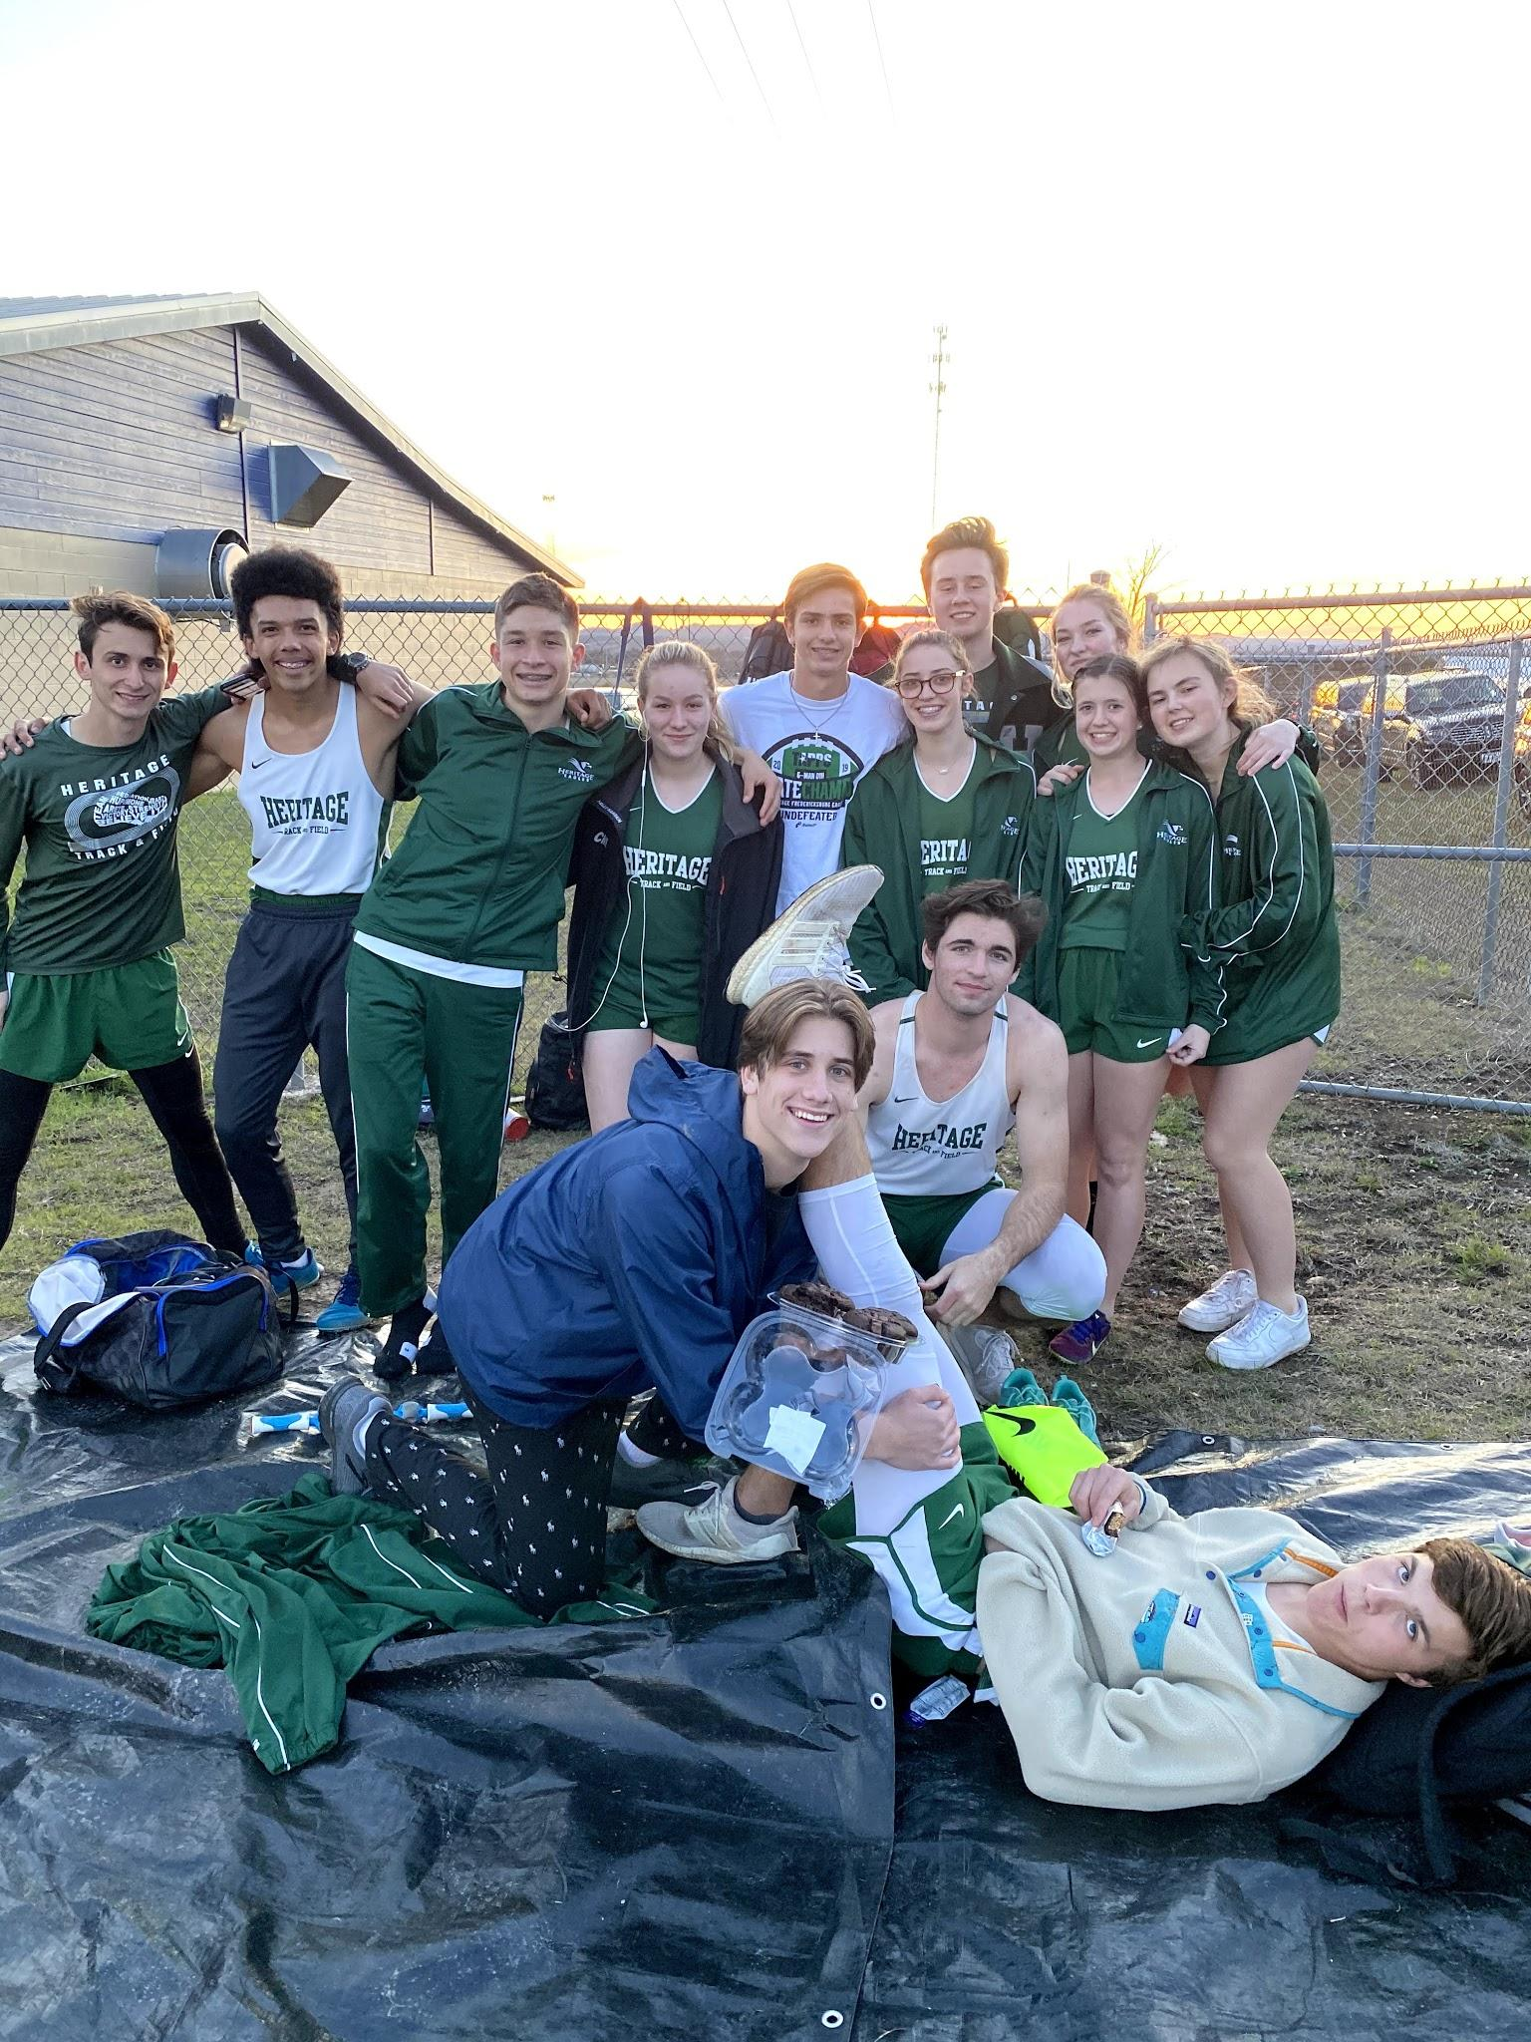

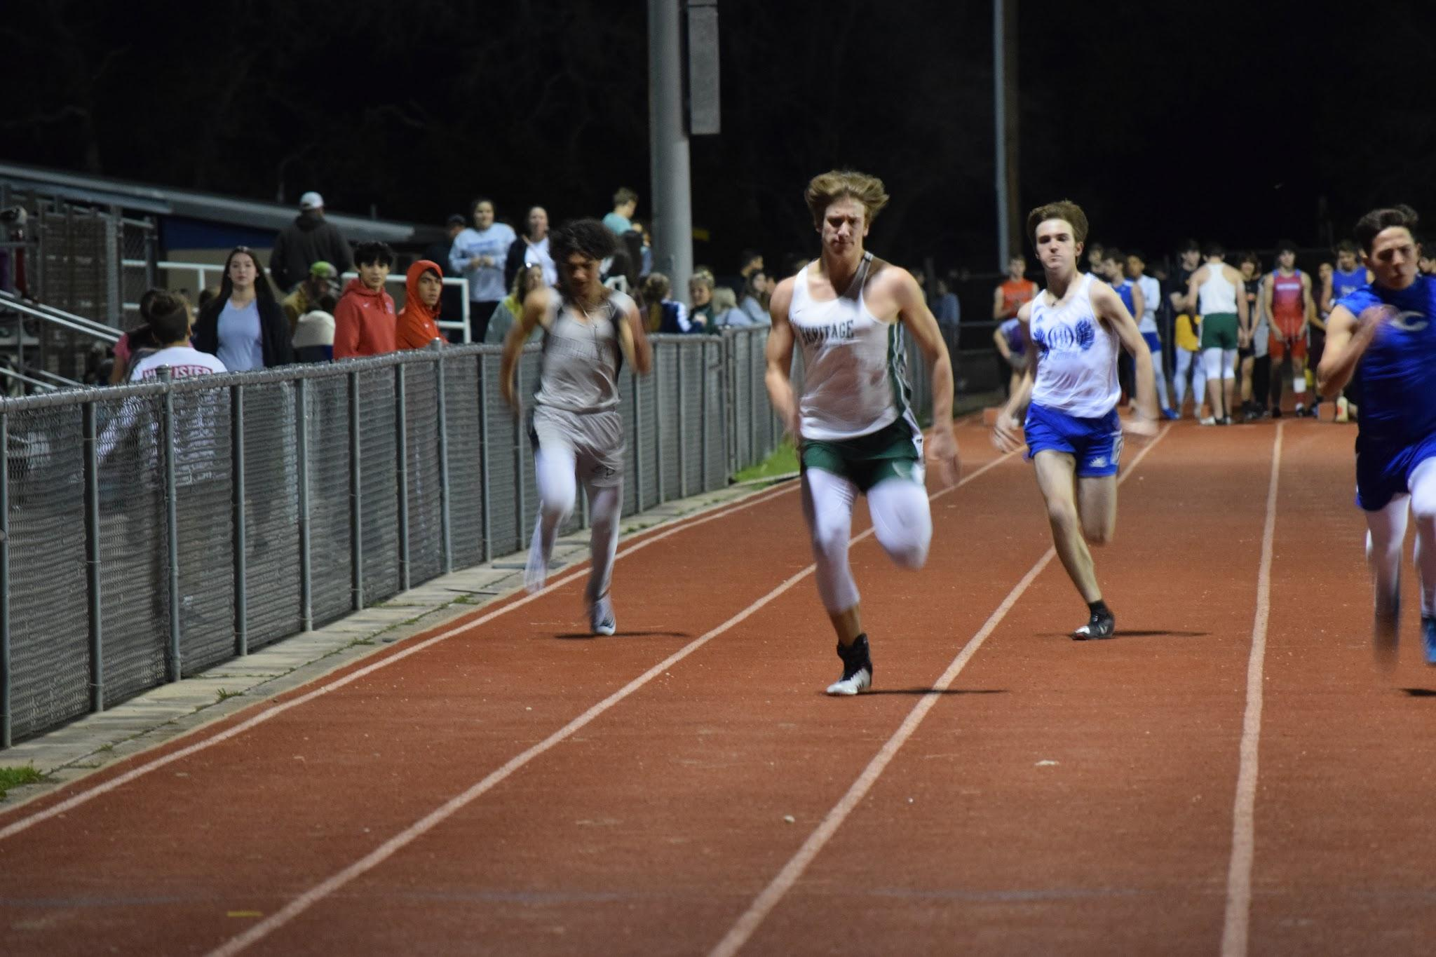

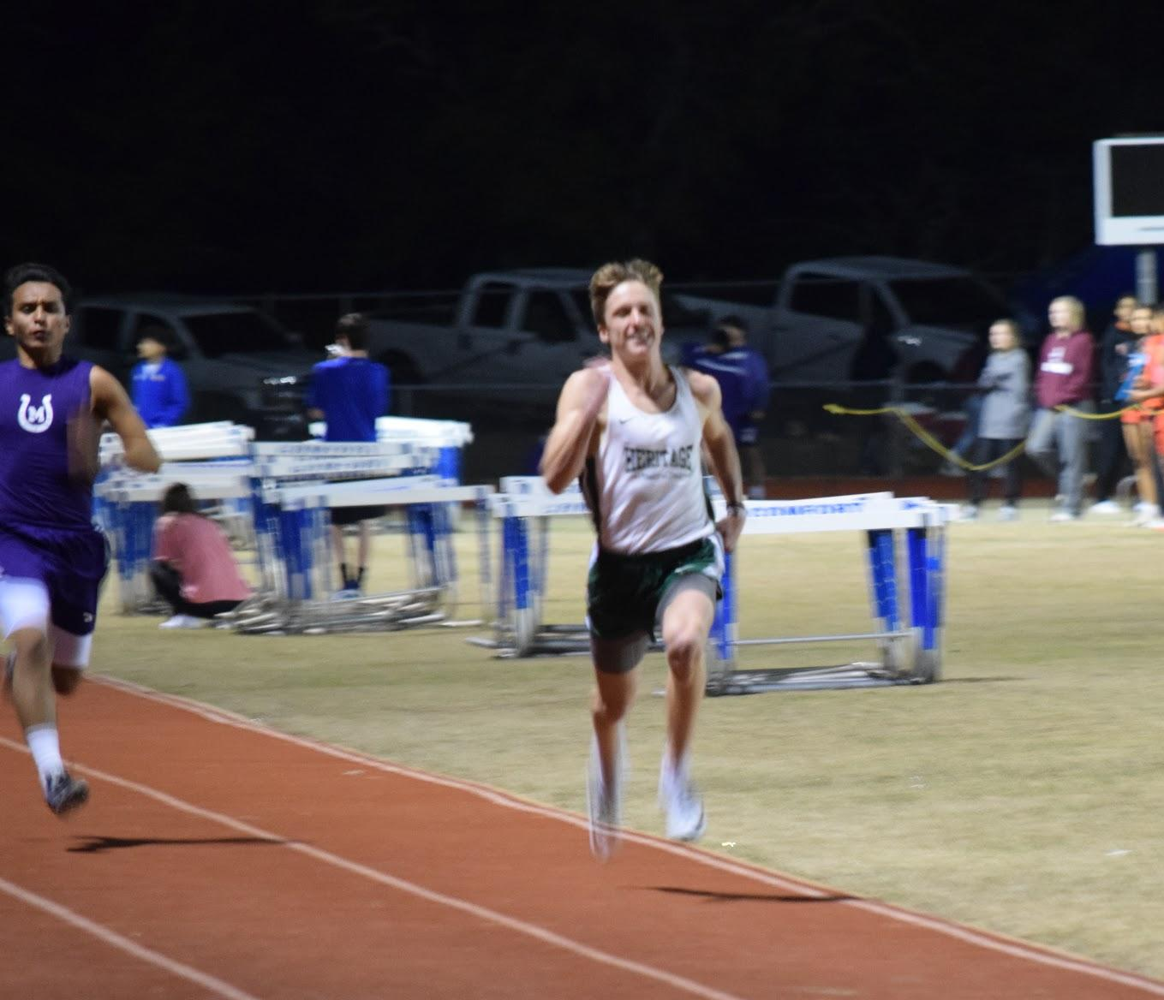

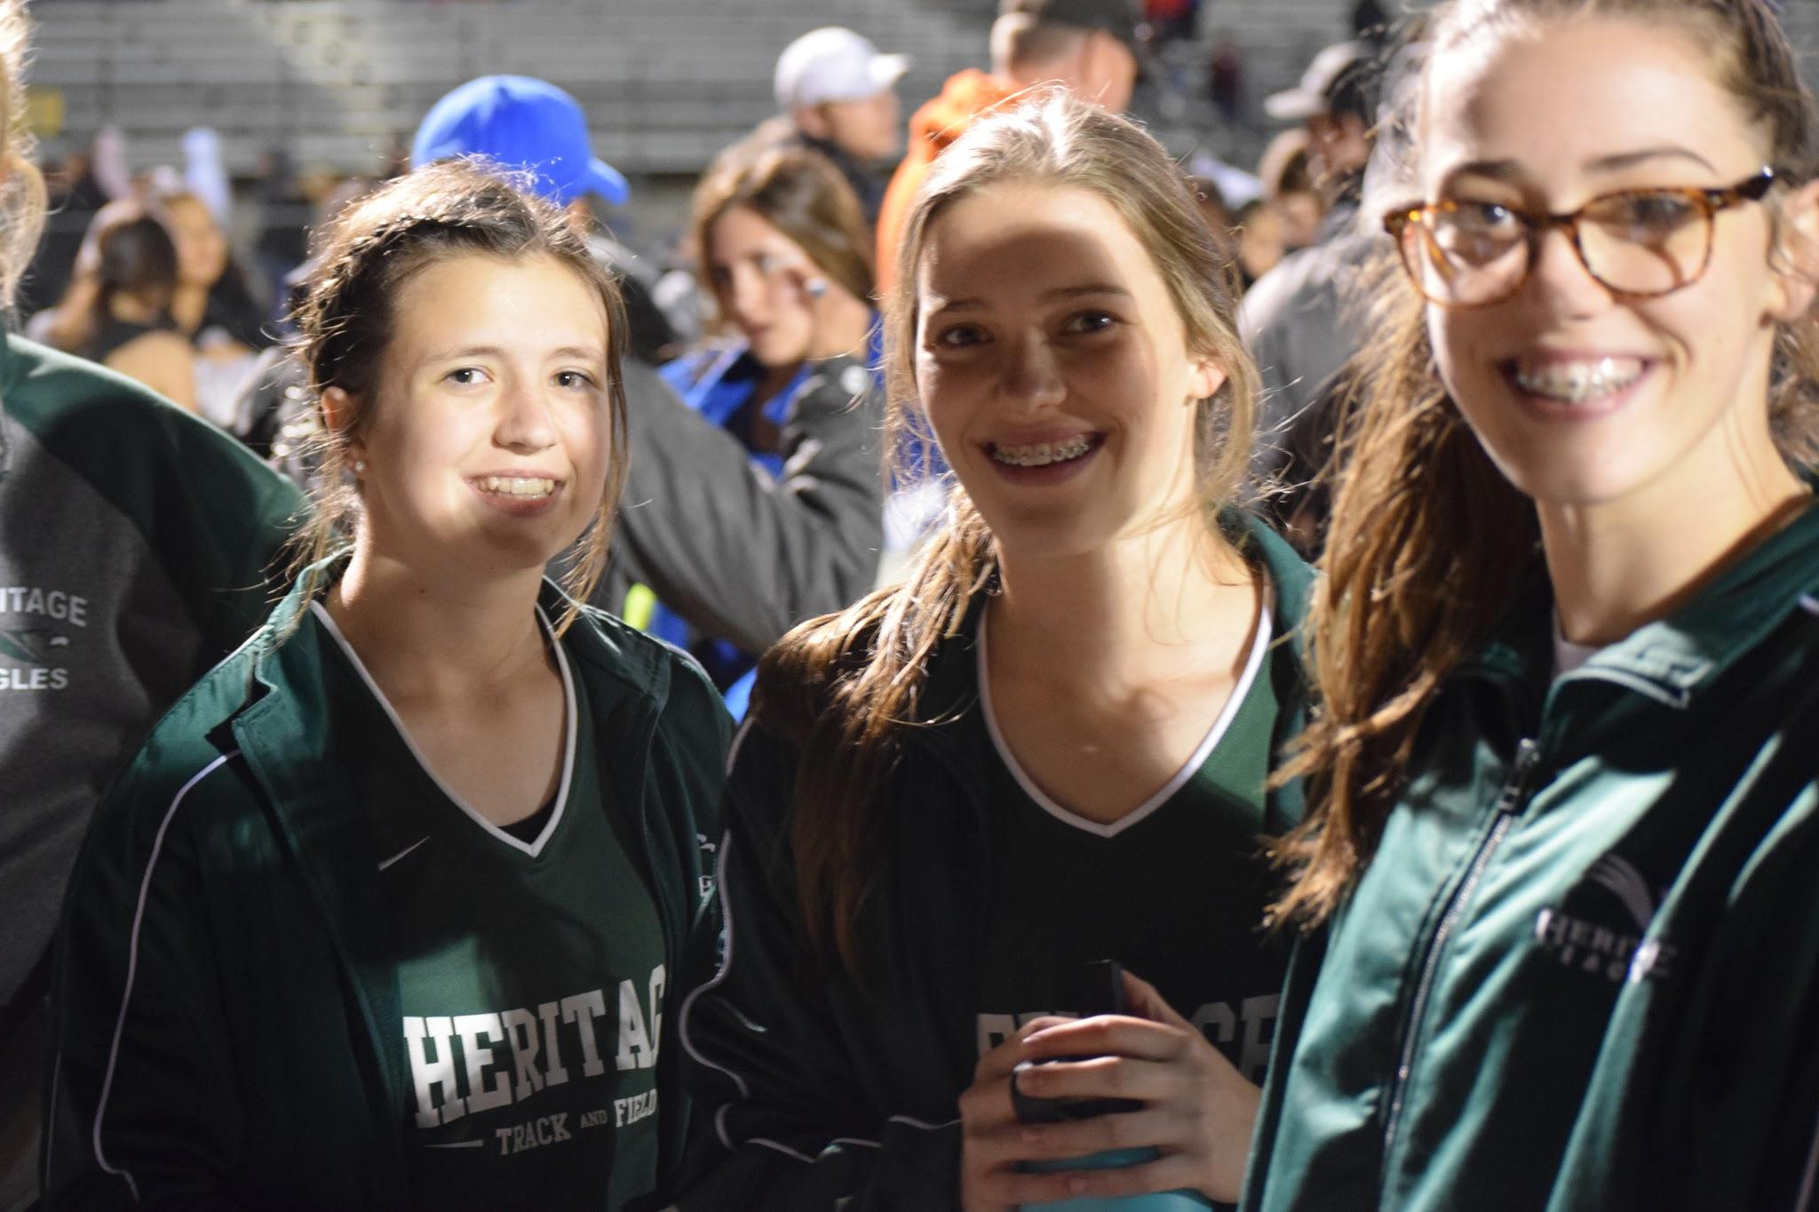
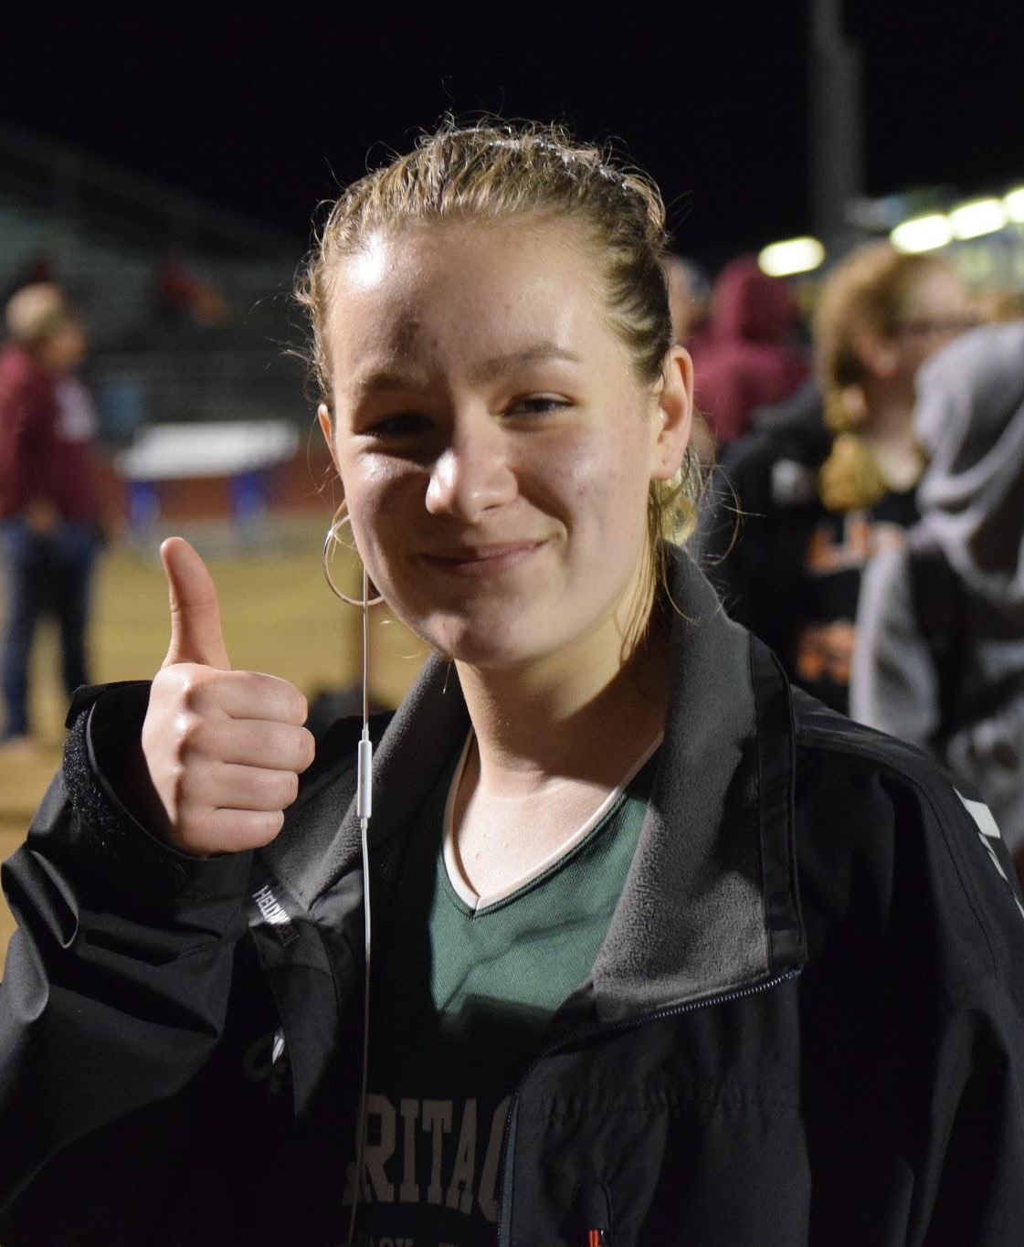

Logic Track Team

Maddie Smith
Annabelle Holster
Drake McKinney
Wyatt Burnett
Competed in one track meet at Comfort prior to Covid. No pictures available

Varsity Golf Team
Head Coach Jamey Parsons
Josie Fevig
Luke Roberts
Finn Sawtelle
Riley Nix
Unable to compete-Covid

Thank you Cheer Squad! You have been a beautiful example of ambassadors for our school. Thank you for your sacrifice of time and energy supporting our programs. 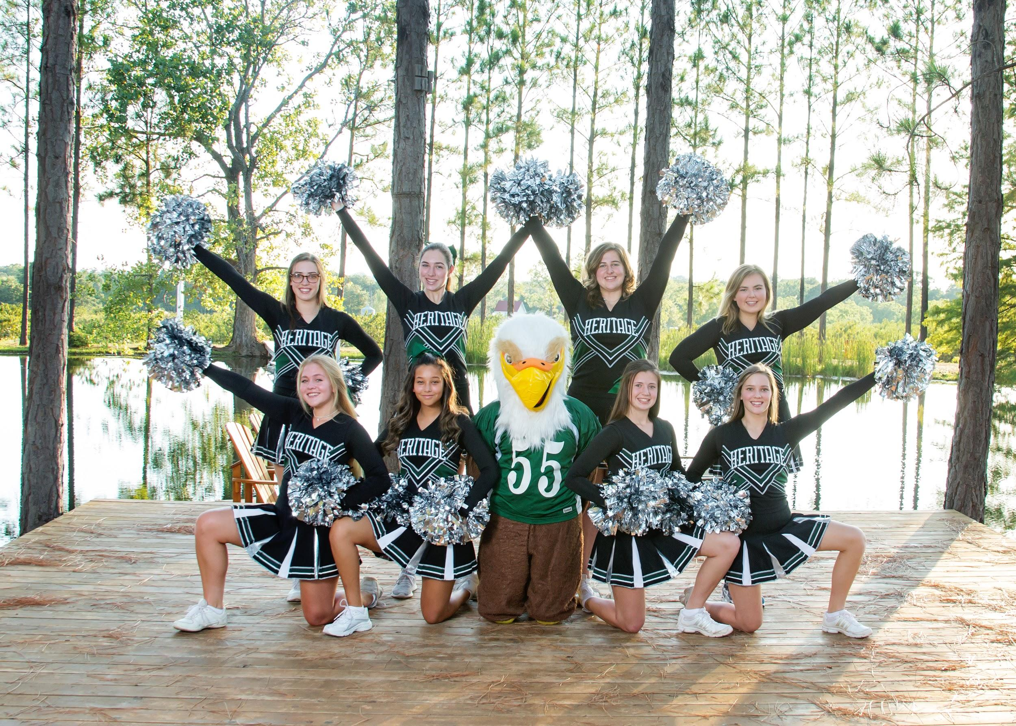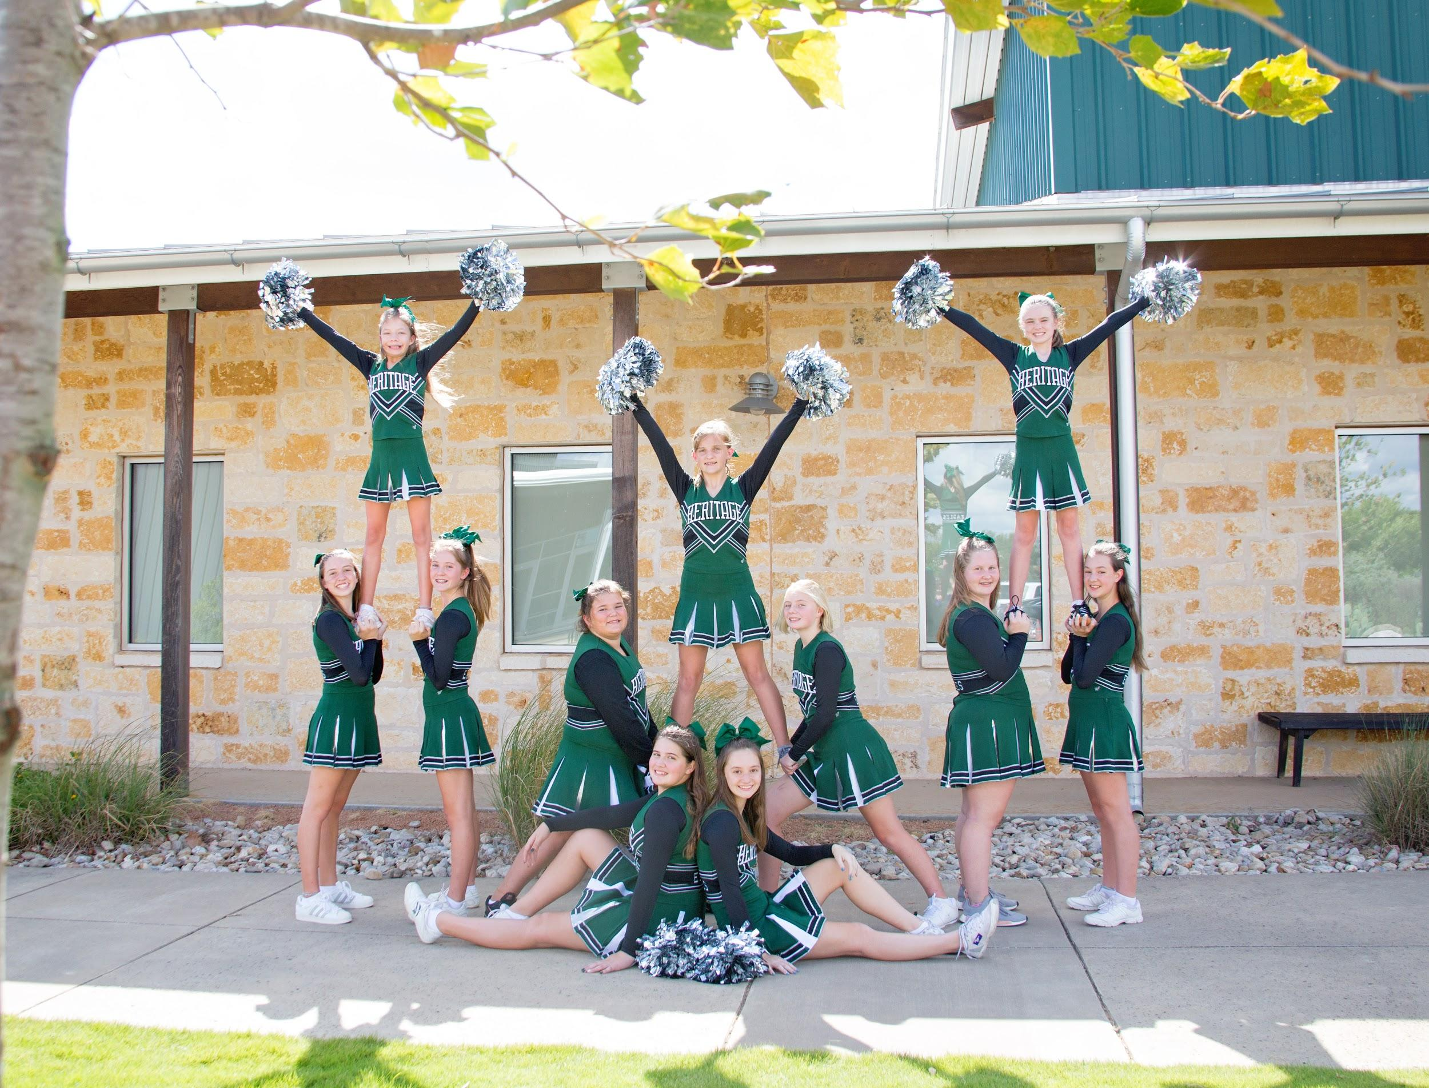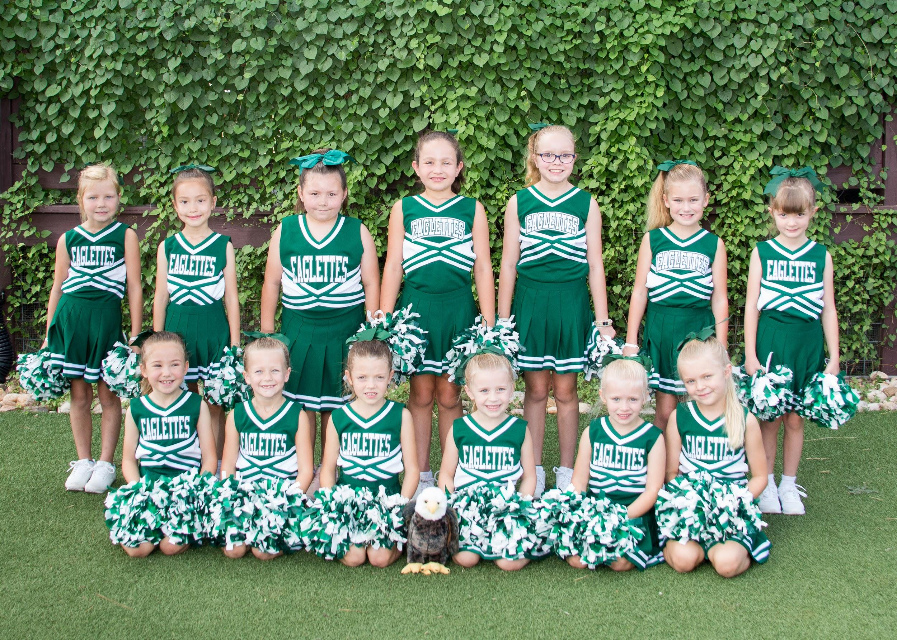

Goodbye to our Seniors! Good luck on your next adventure. Thank you for all your support and work within our programs. We are going to miss you!

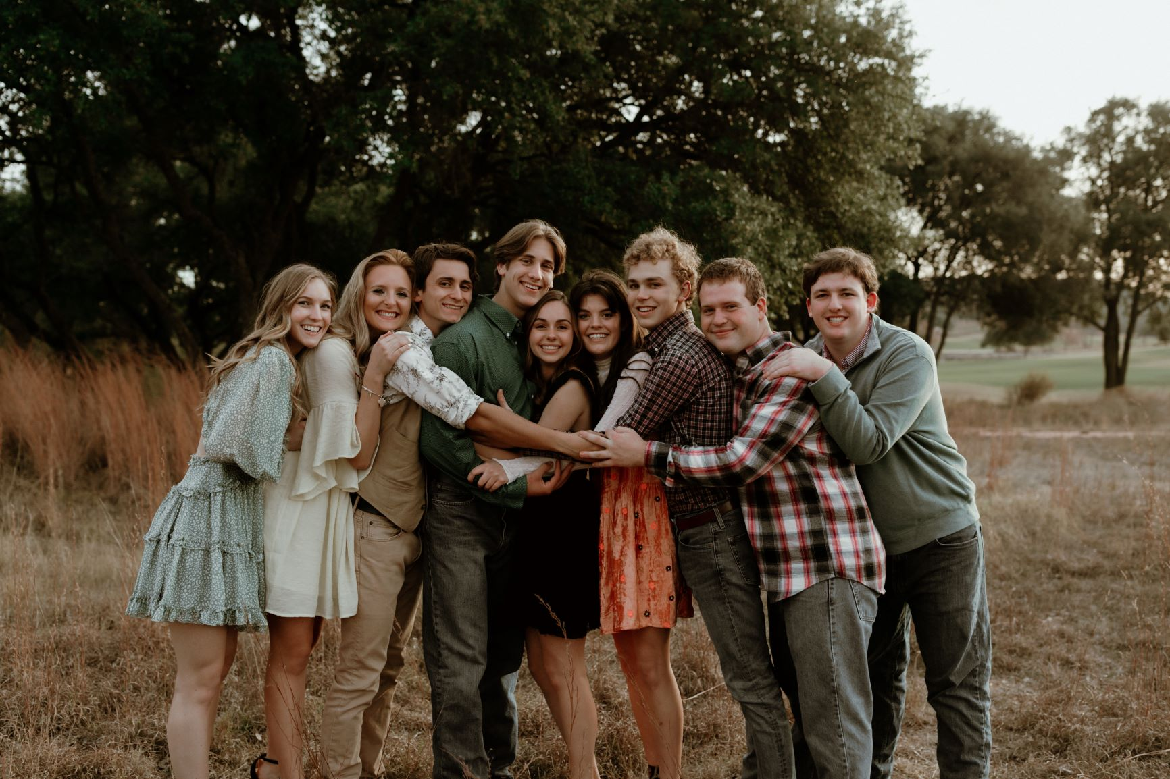

Thank you to the parents and grandparents who volunteered many hours serving within our programs. We appreciate the team parents, gate workers, announcers, music providers, game workers, food preppers, taxi drivers and gym cleaners. The list goes on! Our programs can’t exist without your support. We appreciate you!

Thank you to the coaching staff who put in hours of preparation to their practices and games but most important the sacrifice of time spent coaching and mentoring our kids. Our programs exist not just for the love of competing but all those extras that go along with developing the mind, body and spirit. Teaching our kids respect, discipline, adversity, disappointment, winning well and losing well. Some of the lessons can create tension within relationships so it’s tough navigating those opportunities. Thank you for being such an important part of their lives. Thank you for partnering with the families to help develop areas that we as parents might struggle with because we don’t have that opportunity. Thank you for pushing our kids to be and do their best!

Thank you God for Heritage School. We are truly blessed to have the opportunity to school and work together while openly learning and talking about our Creator. Though we never expected our year to conclude in this fashion, we can rest assured God has us covered. We have been blessed in so many ways and I am personally so thankful.

Hupomone!

